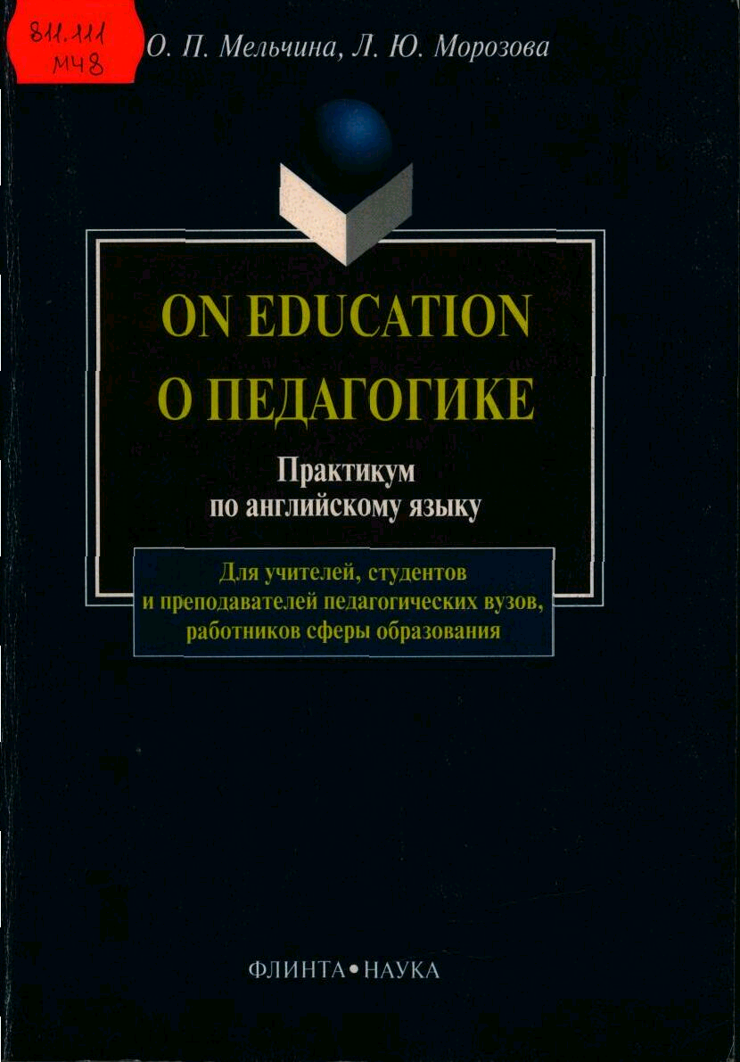

О. П. Мельчина, Л. Ю. Морозова

ON EDUCATION
О ПЕДАГОГИКЕ

Практикум по английскому языку

Москва
Издательство «Флинта»
Издательство «Наука»
1999
УДК 802.0
ББК 81.2 Англ
М48
Мельчина О. П., Морозова Л. Ю.
On Education. О педагогике: Практикум по английскому языку. – М.: Флинта: Наука, 1999. – 176 с.
ISBN 5-89349-136-Х (Флинта)
ISBN 5-02-022578-9 (Наука)
В практикум вошли тексты, посвященные истории педагогики, вопросам обучения в начальной, средней и высшей школе, общим проблемам психологии и воспитания, а также словарь педагогических терминов. Тексты сопровождаются различными заданиями, нацеленными на овладение педагогической терминологией, всеми видами чтения и разговорной речью, переводом со словарем, принципами реферирования и аннотирования.
Для широкого круга людей, имеющих базовые знания английской грамматики и лексики: студентов неязыковых факультетов, аспирантов, всех, кто интересуется проблемами воспитания и образования.
ISBN 5-89349-136-Х (Флинта)
ISBN 5-02-022578-9 (Наука) © Издательство «Флинта», 1999

Учебное пособие

Мельчина О. П., Морозова Л. Ю.

ON EDUCATION
О ПЕДАГОГИКЕ

Практикум по английскому языку
Изготовление оригинал-макета
000 «Симптрон»

Подписано в печать 25.01.99. Формат 60х88/16. Печать офсетная. Гарнитура Тайме. Усл. печ. л. 10,78. Уч.-изд. л. 10,3. Тираж 3000 экз. Заказ 611. Изд. № 144.
ЛР № 064625 от 06.06.1996 г. 000 «Флинта», 117864, ГСП-7, Москва В-485, ул. Профсоюзная, д. 90, комн. 326. ЛР № 020297 от 23.06.1997 г.
Издательство «Наука», 117864, ГСП-7, Москва В-485, ул. Профсоюзная, д. 90.
Великолукская городская типография Комитета по средствам массовой информации и связи с общественностью администрации Псковской области,
182 100. г. Великие Луки, ул. Полиграфистов, 78/12

ПРЕДИСЛОВИЕ

Настоящий практикум предназначен для широкого круга людей, изучающих английский язык: студентов неязыковых факультетов, аспирантов, всех, кто интересуется проблемами образования и воспитания в англоязычных странах. Пособие включает в основном оригинальные тексты, посвященные истории педагогики, целям, принципам и содержанию обучения в начальной, средней и высшей школе, а также общим проблемам психологии и воспитания.
Целью практикума является обучение людей, имеющих базовые знания английской грамматики и лексики, разным видам чтения, а также говорения на английском языке.
Книга состоит из следующих частей: основного курса с упражнениями и заданиями; текстов на английском языке для реферирования и аннотирования на родном или английском языке; текстов на русском языке для передачи их на английском языке; раздела "Things to Do", включающего творческие индивидуальные, парные и групповые задания; раздела "Supplementary Reading", куда вошли художественные тексты, шутки и стихи, и словаря педагогической терминологии.
Каждый текст основного курса сопровождается различными заданиями, нацеленными на овладение педагогической терминологией, обучение всем видам чтения, переводу со словарем, реферированию, аннотированию и говорению на заданную тему. Тексты и задания подобраны с учетом разного уровня подготовки учащихся. К некоторым текстам даются творческие задания, направленные на развитие навыков неподготовленной речи и мотивирующие учащихся к высказыванию собственного мнения о прочитанном.

HISTORY OF EDUCATION

The first major milestone in the history of education occurred in prehistoric times when man invented language. Language enabled man to communicate more precisely than he could by signs and gestures. But early man had only a spoken language. He had no system of writing or numbering and no schools.
Young people in prehistoric societies were educated through apprenticeship, imitation and rituals. Through apprenticeship a young man learned, for example, how to build a shelter by working with an older, experienced master builder. Through imitation, young people acquired the language and customs of their parents and other adults in their society. Through the performance of rituals, they learned about the meaning of life and the ties that bound them to their group. The rituals consisted of dancing or other activities. They were performed at times of emotional stress, such as death, warfare, or drought. The rituals usually involved myths, which dealt with such things as the group's history and its gods and heroes.
Today, in all societies, young people still learn through apprenticeship, imitation and ritual.But as a society grows increasingly complicated, teachers and schools take on more and more responsibility for educating the young.

The Beginning of Formal Education
About 3000 ВС*, the Sumerians,** who lived in Tigris-Euphrates Valley,*** and the Egyptians each invented a system of writing. Both systems included a method of writing numbers as well as language. The invention of writing was the second major milestone in the history of education. It made possible the beginning of schools as we know them today.
Before man developed writing, teachers had to repeat orally what was to be learned until the young had memorized it. A child could thus learn only what his teacher already knew, and had memorized. But by teaching the child to read, a teacher could make available the knowledge of many men, not only his own, yet reading and writing could not be learned while the child served as an apprentice, imitated the behaviour of his elders, or took part in rituals. In addition, the first writing systems, which were a kind of picture writing, were awkward* and hard to learn. As a result, special schools arose in which teachers taught reading, writing, and calculation.

_______________________
* ВС – до нашей эры
** the Sumerians  – шумеры
*** Tigris-Euphrates Valley  – долина рек Тигра и Евфрата

Sumerian and Egyptian Education
Shortly after 3000 ВС, both0 the Sumerians and the Egyptians established schools to teach boys the newly invented arts of reading and writing. The schools were taught by temple priests. Only exceptionally talented boys could attend the schools. Girls were not allowed to attend school, but some girls learned reading and writing in their homes.
A boy's training, which lasted from about the age of 5 to 17, was strict and monotonous. He learned to write by copying the same literary selections again and again. He learned arithmetic by copying business accounts. Boys who completed their education formed a separate social class called "scribes." Scribes were hired for any task that required a knowledge of reading, writing, or arithmetic.

Other Middle Eastern Education
Civilization spread from Sumer and Egypt to the eastern shores of the Mediterranean Sea.** Certain tribes in this region each spoke one of the closely related Semitic languages. Between about 1500 ВС and 1000 ВС, these tribes developed the world's first alphabet and so gave education another valuable tool. Alphabetic systems make writing easier than picture systems because they require far fewer symbols.
Certain Hebrew*** Semitic tribes developed a remarkably democratic educational system. Other educational systems had been designed mainly for the sons of upper-class families. But the Hebrews required boys of every social class to attend school. The Hebrew schools were religious -schools conducted by priests called scribes. They taught boys to read the sacred writings of the Hebrew people, which were collected in a volume called the Tarah. Hebrew girls did not attend school but were taught at home by their mothers.

________________________

* awkward – неудобный, затруднительный
** the Mediterranean Sea – Средиземное море
*** Hebrew 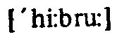– иудей; (древне)еврейский

Ancient Greek Education
Greek civilization flourished from about 700 ВС to about 330 ВС. During this period, the Greeks made the greatest educational advance of ancient times. In fact, Western education today is based on the ancient Greek model.
Ancient Greece was divided into independent city-states. The educational system of each city-state aimed to produce good citizens. Athens and Sparta, two of the most powerful city-states, had different ideals of citizenship. In Sparta, a citizen was judged largely by his political and military service. The government controlled education. Boys received physical and military training, but few learned to read and write. In Athens, unlike Sparta, a citizen was judged more by the quality of his mind. But Athenian citizens were also expected to develop their bodies and to serve the state.
Athens made the greatest educational advances of any Greek city-state. But Athenian education was far from democratic. Education was limited to the sons of Athenian citizens. Only about a fifth of the Athenians were citizens. Most of the rest were slaves, who were not considered worthy of an education.
Athenian boys started their education at about age 6. But they did not go to schools as we think of schools today. A trusted family slave simply took them from teacher to teacher, each of whom specialized in a certain subject or certain related subjects. Boys studied reading, writing, arithmetic, music, dancing and gymnastics. As the boys advanced, they memorized the words of Homer and other Greek poets. Boys continued their elementary education until they were about 15 years old. From about ages 16 to 20, they attended a government sponsored gymnasium. Gymnasiums trained young men to become citizen-soldiers. They emphasized such sports as running and wrestling and taught civic duty* and the art of war. Students held discussions to improve their reasoning and speaking ability.
Some Athenian gymnasiums became centres of advanced learning. By the 400s ВС, advanced learning in Athens consisted of philosophy and rhetoric. Philosophy included the study of logic, mathematics, morals, and science. Rhetoric included the study of government, history, and public speaking.
During the 400s and 300s ВС, Athens produced such great philosophers and teachers as Aristotle, Plato, and Socrates. About 387 ВС Plato founded a school of philosophy that became known as the Academy.
_________________________

* civic duty – обязанности граждан

Some scholars believe the Academy was the Western world's first institution of higher learning. Aristotle founded a similar school called the Lyceum* about 330 ВС.
Most young Athenian women received no formal education. The Greeks believed girls could learn all they needed to know from their mothers – that is, how to prepare food, make clothing, and care for infants. However, some women belonged to religious organizations through which they developed skills in music, poetry, and dancing.

Ancient Roman Education
By 100 ВС, the Romans had built the most extensive educational system of that time. Their system was patterned after** that of ancient Athens. But unlike the Athenians, the Romans provided schooling for girls as well as boys. The children of wealthy citizens were taught by a ludus (elementary-school teacher) from about the age of 7 to 10. They learned to read and write both Greek and their native language, Latin. Girls received only an elementary education. Boys from about 10 to 15 years old attended a secondary school run by a grammaticus (teacher of grammar). In secondary school, they continued their study of Greek and Latin grammar and literature. The Romans also established institutions of higher learning. These institutions were schools of rhetoric, which prepared young men for careers in law and government.
Assignments:
1. Give the English for:
происходить, изобретать, ученичество, приобретать, узы, связывать, иметь отношение к, сложный, включать, устно, запоминать, доступный, поведение, возникать, священник, переписывать, задача, племя, родственный, ценный, требовать, процветать, успехи, древний, основываться на, ограничивать, раб, делать упор на, рассуждения, предоставлять.
2. Form nouns from the following verbs:
invent, communicate, educate, perform, imitate, know, behave, calculate, discuss, develop, govern.
3. Form adjectives from the following nouns:
history, religion, emotion, east, west, value, education, alphabet, power, policy, democracy.
________________________

* the Lyceum – лицей
** to be patterned after – быть созданным по образцу

4. Join A and В in pairs of synonyms;
A. adults, to establish, talented, to arise,, hard, task, to complete, advances, ancient, to prepare.
B. difficult, gifted, elders, to appear, success, to found, to finish, aim, old, to train.
5. Complete the following sentences:
1) Young people in prehistoric societies were educated through...
2) The invention of writing was the second major milestone in...
3) Scribes were hired for any task that required a knowledge of ...
4) The Hebrew schools were religious schools conducted by
5) The educational system of each city-state aimed to produce ...
6) Gymnasiums emphasized such sports as ...
7) Students held discussions to improve their ...
8) Unlike the Athenians, the Romans provided schooling for ...
9) The Romans also established institutions of ...
10) These institutions were schools of rhetoric which prepared...
6. Ask 10–15 questions about the text. Be ready to answer them.
7. Prove the following statements:
1) Today, in all societies, young people still learn through apprenticeship, imitation and ritual.
2) As a society grows increasingly complicated, teachers and schools take on more and more responsibility for educating the young.
3) Alphabetic system makes writing easier than picture system.
4) Athenian education was far from democratic.
5) By 100 ВС, the Romans had built the most extensive educational system of that time.
8. Speak on the major milestones in the history of education. Give the advantages and disadvantages of each of the discussed educational systems.
9. Say what elements of ancient educational system you'd like to introduce in our system of education and why.

2. THE PEN STORY

A sharp flint... a finger dipped in blood or plant juice,.. these were the tools used by primitive man to record his experiences on cave walls and rocks. As he became more intelligent, man developed more complex writing systems – pictures, symbols' alphabets ... and more efficient writing instruments.
Two of the earliest implements were the brush, employed in China, and the stylus. The stylus, a sharp instrument made of bone or metal, was used by the ancient Greeks and Romans to inscribe signs and words on wax-covered tablets.
Meanwhile, the ancient Egyptians were writing on papyrus with pen and ink. The ink was basically a mixture of bamboo, soot, water and gum; the pens were made from the hollow tubular stems of reeds, split and sharpened.
Papyrus and parchment spread to other countries. So did the reed pen. The Romans made their version from bamboo but instead of splitting it, they cut one end t« a nib-shape, filled the hollow stem with ink; then squeezed it to force the ink onto the nib. That was one of the very first fountain pens.
The stylus was in fashion for some three thousand years; the reed pen for only three hundred because, with the introduction of paper, a much finer instrument was needed. It came in the form of a quill feather taken from the wings of swans, crows or, more often, geese. The new implement inspired the word "pen" (taken from "penna," the Latin term for feather).
From the sixth to the eighteenth century, the quill was the writing instrument of the western world.
The next major step in the pen story was taken in 1809 by Joseph Bramah, an English engineer. He invented a machine for manufacturing quill nibs which were then inserted into holders. Soon this type of pen was in common use. Within twenty years quill nibs had been replaced by steel ones.
The next chapter in the pen saga begins in 1884 in America... A young insurance agent, Lewis Waterman, tipped his inkwell over a contract just at the moment of signing and consequently lost a sale worth one hundred thousand dollars. This misfortune determined Waterman to design a pen containing its own supply of ink – the fountain pen.
While the fountain pen was gaining in popularity, another invention hit the writing public. The ballpoint. Although patents on ball-point pens date back to the 1880s, the world's first workable version was developed in 1943 by Lazlo Joseph Biro, a Hungarian living in Argentina.
Assignments:
1. Translate the text using a dictionary.
2. Give a summary of the text.

3. THE MIRACLE OF WRITING

Among all the achievements of human beings, the invention of writing is one of the greatest. But perhaps the time will come during our lives when reading and writing become out of date.
Writing was not invented once, but perhaps, six different times, in places as far apart as China and America. Each time it started with simple pictures and lines or dots – these were good enough to record objects or numbers. But something more flexible was needed to record language.
A kind of writing which had this flexibility was invented in Mesopotamia, in about 3000 ВС. The writing was made of triangular shapes* and we now call it "cuneiform"** writing. Like picture writing, it was used in trade, but it was also important for recording ideas about religion and philosophy. Though we don't know what the language these people spoke sounded like, we know a lot about them from their writing.
Meanwhile the Egyptians had developed another kind of writing – "hieroglyphics."*** These were a mixture of pictures and signs which were used by the kings and priests, Egyptian hieroglyphic writing is one of the most beautiful and complicated ways of writing that has been invented. But it was too complicated to become as widely used as cuneiform writing.
Around 1200 ВС writing began to make the last and most important step in its development; the beginning of the alphabet, signs which stand for sounds and which can be used to write any of the words we speak. Nobody knows when, where or by whom the first alphabet was invented. But by 1000 ВС Phoenician traders, from the area we now call Lebanon, were spreading their alphabet writing throughout the Mediterranean world. The Greeks, and later the Romans, changed it, and it grew into the alphabet of letters you can see on this page.
With the alphabet it was possible to write down anything that was said. There were all sorts of stories, myths and traditions waiting to be written down. The invention of paper and ink helped the alphabet to spread quickly, and many more people learned to read and write, though trie vast majority of people were illiterate until long after printing was invented. However, there was one great problem that lasted from Greek and Roman times until the Middle Ages– everything was written by hand. So it was slow and expensive to produce copies of books.

__________________________

* of triangular shapes – в форме треугольников
** cuneiform 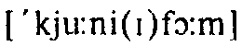 – клинопись
*** hieroglyphics  – иероглифы

Assignments:
1. In a few sentences give a short survey of the history of writing.
2. Translate the text using a dictionary.

4. CHILD PSYCHOLOGY DETERMINES TEACHING METHODS
(From "Invitation to Psychology" by J. Houston, H. Bee, D.C. Rimm)

A knowledge of the child is the most fundamental and important of the teacher's preparation. Many teachers with thorough knowledge of their subjects fail because they do not understand the boys and girls who are to be taught. Many assume that children are like plastic clay and can be moulded at the will of the teacher. Any observing parent or any intelligent teacher of experience knows better. Boys and girls are not passive lumps of clay; they are living, pulsating, developing, mysterious beings who must be studied and understood before they can be taught in the true sense.
We have come to realize that the most difficult factor in education to understand is the mind of the child to be taught. A knowledge of children's minds and the way they work is certain to convince one that in order to teach efficiently we must get the child's point of view. Many well-conceived aims in education do not bear fruit, simply because the teacher does not understand the workings of children's minds. The teaching is done in terms of adult thinking and means nothing to the child. The 'child's mind understands concrete things rather than abstractions. We must appeal to the child through his everyday experiences and on the plane of his stage of development. Instead of beginning with definitions, abstract principles and laws, the meanings of the things should first be made clear. Otherwise the statements are empty words. Every concept should have its concrete examples to which the mind can turn for illustrations at any time. Instruction of children should begin with experiences personally familiar to the particular children, and make the teaching radiate from those. The teacher's knowledge should be broad and thorough that if the pupils cannot understand one illustration, others can be given immediately. In addition to the knowledge of formal subjects the teacher should know their relation to the life outside the classroom, so the pupils must see the significance of the things they do at school.
Assignments:
1. Look through the text and briefly say what it is about.
2. Translate the text using a dictionary.

5. LET KIDS BE KIDS
(by Stephen R.C. Hicks)

The newspaper in Indiana town ran a contest for schoolchildren. The students were to create a picture on any topic; the best would be published in the paper.
A second-grader drew a sad-faced earth with the caption "I am weary. I am tired. Please quit wasting me!"* A third-grade girl depicted animals crying near a house under construction, with smokestacks in the distance; the caption read "We want our home back!"
Apparently many children are coming home from school frightened that the world is cold and inhospitable. All the furry animals are being killed and the nice green trees being chopped down. Even breathing air is dangerous.
Motivated by the best of intentions, most teachers want their students to become informed and independent thinkers. But in trying to convey a sense of urgency about such problems, they become frustrated and frightened. They begin to realize that we are living in a hostile world whose problems are too big to handle. And that's an attitude children often acquire early in life.
This does not mean educators and parents should pretend that problems do not exist. We need to take pains** to help children confront them on a scale they can grasp.
Frightened children are not going to grow into adults who can solve the world's problems. That requires a confidence in one's ability to find solutrons. And such healthy self-esteem*** requires nurturing**** over a long period, on a great number of small, day-to-day matters. Too much, too fast, can only destroy it.

__________________________

* «Я больше не могу. Я устала. Пожалуйста, перестаньте зря растрачивать меня!»
** to take pains – прилагать огромные усилия
*** self-esteem – самооценка
**** nurturing – (зд.) воспитание

Assignments:
1. In 3–5 short sentences give the main idea of the article.
2. Translate it using a dictionary.

6. THE FIRST DAY AT SCHOOL

Can you remember your first day at school? It was probably rather confusing. Now to avoid this confusion many primary schools have a special teacher who welcomes new pupils. In England she is called a reception-class teacher. On the first day it is her responsibility to "settle" the newcomers. The difficulty is that a lot of people give their children the wrong idea about going to school. The children are threatened with the idea of school, and if they have been good, they can't understand why they have to go to school. They imagine that school is optional.
When the child goes to school, on his first day, he has to watch his mother leaving. Often he thinks that she is deserting him. The teacher must convince him that at the end of the day his mother and his home will still be there. The children are not the only people that are disturbed by going to school. The teacher sometimes has just as much difficulty in coping with the mothers. They are just as upset as their children. They hang around and dislike leaving the child to his fate. All day they stay at home, wondering what is happening and how their son Or daughter is managing.
The best way to deal with the situation is to get the child used to the idea of school. Before the beginning of term the mother should take her child to see the teacher and to look round the school. The first day should be something to emphasize the regularity of school, and although the first day is difficult, the mother must remember that her child must be encouraged for a whole term at least.
Assignments:
1. Find in the text the English for:
суматошный (полный неразберихи), приветствовать, ответственность, новичок, давать неправильное представление о, пугать, представлять (себе), необязательный, покидать (бросать), убедить, справиться с чём-л., расстроенный, судьба, приучить кого-л. к чему-л., с нетерпением ждать чего-л., подчеркнуть (сделать упор на), ободрить.
2. Choose the best answer:
1) On the first day a reception-class teacher ... a) is a newcomer. b) teaches in a special way. c) establishes the children in the class.
2) A lot of people ... a) tell their children that school is wrong. b) misinform the children about theschool. c) have bad ideas about school.
3) The children think school ... a) is a punishment, b) is difficult to understand, c) is a good idea.
4) Often the children feel ... a) happy when their mothers leave. b) lonely, c) angry.
5) The teacher tells him that his mother ... a) has left. b) has deserted him. c) has left him temporarily.
6) The mothers are often ... a) as angry as their children, b) as difficult as their children, c) as nervous as their children.
7) They ... a) stay at the school for a long time. b) leave immediately. c) walk around the school.
8) The best solution is to ... a) get the child accustomed to school. b) use the school for some special purposes, c) give the child ideas about school.
9) The child should ... a) enjoy the thought of the first day. b) be frightened about the first day. c) prepare himself for the first day.
10) It is important to ... a) warn the child about the regularity. b) exaggerate the regularity, c) underline the regularity.
3. Say what should be done to avoid confusion on the first day at school.
4. Share your own suggestions as to what a teacher should do on the first day. Try to give some practical advice to a beginning teacher.
5. Say whether you remember your own first day at school and what you and your parents felt then.

7. HOW WELL DO OUR SCHOOLS PERFORM?
(From "Who Controls Our Schools?
American Values in Conflict" by Michael W. Kirst)

Our educational system, rooted in our history and our structure of values, has often been a source of justifiable pride. Whatever its limitations, the public educational system of the United States (including higher education) is the most egalitarian* system in the world.
Thomas Jefferson had counted on education to develop only that "natural aristocracy" of the few whose talents justly deserved to be developed for the benefit of society. But Horace Mann and the common school advocates wanted universal education, to them education was to be the "balance wheel"** of society. Mann proclaimed in 1848: "If one class possess all the wealth and education, while the others are ignorant and poor; it matters not by what name the relation between them may be called; the latter will be the dependants and subjects of the former, but if education be equally diffused, it will draw property after it, by the strongest of all attractions, for such a thing never did happen, as that an intelligent and practical body of men should be permanently poor. Education is the great equalizer of the conditions of men, the balance wheel of the social machinery."
The public schools were thought to by their supporters as a secure system for moderating social inequalities. The egalitarism of the American system distinguishes it from the school systems of the European countries. About 75% of our students graduate from high school, and some 44% go on to higher education. In most other Western nations, students are diverted into vocational and technical programs at age 14 or 15 and only 15 to 30% graduate from a secondary school. Considering the large percentage of teenagers the US schools enrol, the level of attainment of these students is surprisingly high. Our schools system has grown steadily more egalitarian. As recently as 1940 fewer than 50% of the pupils in this country completed high school. By 1984, the access to higher education among those least represented in the past – the minority groups – has increased. While college enrollment of white students grew slightly, the proportion of blacks in college more than doubled in the same period. In 1981 the percentage of black high school graduates who went on to college exceeded that of whites for the first time. The fact, that many of those students come from lower socioeconomic groups makes this achievement all the more remarkable. Recent sociological studies from Russia indicate that an unexpectedly high share of the places in most of its elite postsecondary institutions go to children of white-collar workers.
Lately, the headlines have warned us that our schools are not competitive with those of our economic rivals West Germany and Japan, and that current graduates of our secondary schools cannot match the records set by their predecessors. Now, when the performance of our schools is source of widespread dissatisfaction, we need to consider carefully how we measure that performance.
________________________
* egalitarian – поборник равноправия
** "balance wheel" – баланс

Assignments:
1. Find in the text the English for:
укоренившийся, могущий быть оправданным, ограничения, рассчитывать на, на благо общества, всеобщее образование, сторонники, провозгласить, невежественный, смягчать общественные неравенства, отличать что-л. от чего-л., представленные в меньшей степени, уровень знаний, превышать, указывать, служащие, быть неконкурентоспособным, подходить (соответствовать), предшественник, измерить что-л.
2. Give the derivatives from:
just, to depend, limit, to support, universe, to attain, equal, vocation, access, to enroll, sociology, to expect, to compete, to perform, surprise.
3. Arrange A and В in pairs of synonyms:
A. limitations, advocate, high school, vocational, share, intelligent, talent, to moderate, common school, permanently, attainment. B. to mitigate, clever, professional, drawbacks, supporter, proportion, secondary school, gift, constantly, ordinary school, achievement.
4. Answer the following questions:
1) How can you characterize the system of education in the United States in general?
2) What was T. Jefferson's point of view on the aims of education?
3) What did Horace Mann proclaim in 1848?
4) How were the public schools thought of by their supporters?
5) What distinguishes the American system from the systems of the European countries?
6) Is the level of attainment of US schools high?
7) What changes took place in 1984 in the field of higher education?
8) Who composed the majority of college students in 1981? Isn't the fact remarkable?
9) What do recent sociological studies in Russia indicate?
10) What is the source of widespread dissatisfaction of the press and public?
5. Compare the concepts of education of Thomas Jefferson and Mann.
6. From Mann's quotation choose one sentence to cover the main idea of it and translate it.
7. What can you say about the state of affairs in American educational system today as it is described in the text?

8. SCHOOLS OF THE FUTURE
(From "How American Business and Education Can Cooperate to Save Our Schools" by Dr Marvin Cetron)

The schools that will shape our nation's future in the 21st century – are being planned today, at a time when education is again in the national spotlight. Nearly 30 reports issued by commissions and individuals have made it clear to the American people that their nation will be "at risk" unless they pay attention to their schools. During the past several years dozens of panels, commissions and other experts have made recommendations on how schools can become more effective. Continuing to improve America's schools is the key to the United States' future. Schools must make their plans for the future with an understanding of the key issues that will affect education.
A major responsibility of schools in the future will be to prepare students to enter a rapidly changing job market. American workers will need to be more highly trained than at present.
Schools will be responsible for preparing students who are adaptable, who are able to respond quickly to the changing requirements of new technologies. Schools will train both young and adults; adult workers will need reeducation and retraining.
In the future, schools and business will need to work closely in anew business/education partnership.
Emphasis on such "traditional" academic subjects as reading, writing and mathematics will increase.
New technologies, such as computers, videodiscs and cable television will change the look of the "schoolroom." In the future, students may spend 1 or 2 days each week studying at home. Increased and well-planned use of these new learning technologies will enable machines and humans each to teach what they teach best.
Because of the additional responsibilities that will be imposed on teachers, they will archive greater status in society. In the future, they will be paid salaries that are comparable with other professionals. They will work in schools that offer continuing opportunities for professional advancement and training. As a result, education will once again attract the nation's brightest and most qualified students.
Assignment:
Read the text and say:
a) what changes the Americans are planning to introduce in their schools;
b) which of the changes you would like to introduce in our educational system.

9. THE ILLITERACY EPIDEMIC

In 1889, a person was judged literate if he could sign his name. In the machine economy of 1939, it meant completing the sixth grade. Today, the Information Age of computers and high technology requires a bare minimum of reading and writing skills at the high-school-graduate level.* Changes in workplace needs are so dramatic and unpredictable that people must be ready to adapt to jobs that did not even exist when they were in school.
There are 25 million Americans who cannot read or write at all. An additional 45 million are functionally illiterate without the reading and writing skills to find work – and that number is growing by more than 2 million a year.
Illiteracy is compounded by the attack on English as a national language, yet civilizations rise by literacy and a common language. Knowledge becomes accessible to all.
America, above all, drew inspiration from that ancient tradition of liberty and knowledge. Yet, curiously, we also have an anti-intellectual tradition of those who give the impression that they "know better." But in the post-industrial era, when the majority of people in the work force make a living with their minds, not their hands, it is education – more than coal or steel or even capital – that is the key to our economic future.
How can we restore America to preeminence by having the most educated work force in the world by the year 2000?
The first requirement is to organize schools that address the realities of modern life. Today, 60 per cent of women with children over the age of 3 work outside the home. Single-parent households and dual-income families* need year-round schools providing an extended school day and enriched day care to teach their children and keep them safe.

___________________

* high school– (амер.) старшие классы средней школы

America also must fund preschools on a massive scale. A human being is capable of learning more in the earliest years than in the rest of his or her lifetime.
The second requirement is to establish performance standards. Not enough is expected academically of American students, our most successful competitors, the Japanese, have much higher levels of educational achievement because they have a longer school day and school year and because more is required of students. As a result, Japanese high-school graduates academically are equivalent to the average American starting junior year at a good college.
America must set standards for a basic academic diploma. As an incentive to school districts, the federal government should underwrite a national test that would reveal a demonstrated mastery of a core body of knowledge, including the essential documents of citizenship, history and literature and the principles of science and mathematics. Using the test would be voluntary, but Washington might encourage its use through scholastic aid to schools and students who excel.
Finally, the federal government should vastly increase its funding of research and development in education. Given the introduction of computers and computerized teaching programs, only the federal government has the resources to determine which programs would work best to maximize teaching performance.
Assignments:
1. Find in the text the English for:
грамотный, поставить свою подпись, требовать, навыки, уровень, приспособиться к, нападать на, доступный всем, черпать вдохновение из, производить впечатление, зарабатывать на жизнь, ключ к, семья без отца (или без матери), группы продленного дня, ограждать от опасностей, финансировать, стимул к, выявлять, отличаться (превосходить), сильно повысить уровень преподавания.
2. Form the derivatives from the following words:
literate, computer, require, nation, inspire, industry, economy, organize, perform, achieve, know, introduce.
______________________

* dual-income families – семьи, в которых работают и отец, и мать

3. Answer the following questions:
1)What kind of person was considered literate in 1889?
2) What did literacy mean in 1939?
3)What kind of skills does the present age require?
4) America drew inspiration from that ancient tradition of liberty and knowledge, didn't it?
5) What is the key to America's economic future?
6) How can they restore America by the year 2000?

10. CULTURAL LITERACY AND THE SCHOOLS
(From "Cultural Literacy" by E.D. Hirsch)

School is the traditional place for acculturating children into our national life. Family, church, and other institutions play an important role, but school is the only institution that is susceptible to public policy control. In the modern age, the role assigned to our schools is to prepare our children for the broader activities of society and to train them in the literate public culture. Our schools have played this role less well than they should, chiefly because they have followed faulty educational ideas. The practical importance of ideas in human affairs, while not a recent revelation, is one that is too easily forgotten.
The decline of American literacy and the fragmentation of the American school curriculum have been chiefly caused by the ever growing dominance of romantic formalism in educational theory during the past half century. We have too readily blamed shortcomings of American education on social changes (the disorientation of the American family or the impact of television) or incompetent teachers or structural flaws in our school systems. But the chief blame should fall on faulty theories promulgated in our schools of education and accepted by educational policy-makers.
Why have we failed to give our children the information they lack? Chiefly because of educational formalism, which encourages us to ignore the fact that identifying and imparting the information a child is missing is most important in the earliest grades, when the task is most manageable. At age six, when a child must acquire knowledge critical for continuing development, the total quantity of missing information is not huge. The technical reading skills of disadvantaged children at age six are still on a par with those of children from literate families. Supplying missing knowledge to children early is of tremendous importance for enhancing their motivation and intellectual self-confidence, not to mention their subsequent ability to learn new materials. Yet schools will never systematically impart missing background information as long as they continue to accept the formalistic principle that specific information is irrelevant to "language arts skills."
Education formalism holds that reading and writing are like baseball and skating; formalism conceives of literacy as a set of techniques that can be developed by proper coaching and practice.
The trouble is that reading for meaning is a different sort of game entirely. Every text, even the most elementary, implies information that it takes for granted and doesn't explain. Knowing such information is the decisive skill of reading.
Assignments:
1. Translate the text using a dictionary.
2. Say whether you agree with the reasons for the decline of literacy the author gives.

11. A. AT THE ANGLO-AMERICAN SCHOOL

Like any school, the Anglo-American school in Moscow is filled with the hubbub of children, its pupils – 260 boys and girls from 30 countries, aged between five and 15– study here while their mothers and fathers work in the embassies and business centres. The children feel uninhibited, free-and-easy, but do not overstep limits and display any ill-breeding.
"We try to teach the children to be alert, to think critically, and to have a sense of responsibility and respect for other people's opinions," says Miss Vera Nordal, principal of the school. Teaching is conducted in English. Apart from general subjects, the pupils study Russian language and Russian literature.
"The pupil is the main person in our school," says Vera Nordal. "The teacher's task is not to 'put knowledge into their heads,' but to awaken interest in the subject, to teach them to look at phenomena from different viewpoints, not to divide everything into black and white."
Instruction at this school costs 6,000 dollars a year. Usually this is paid by the embassy.

В. MAKING FRIENDS

If you want to have lessons at a US school, you don't have to travel to the USA. Teachers at the Anglo-American School in Moscow decided to invite to their school 5th-formers from Dubna, "the physicists' town."
Eighteen boys and girls sat for three days on tables, chairs and the floors together with their US friends whom they met last year.
"I don't understand why Moscow teachers haven't yet made use of this splendid neighbourhood and 'made friends' with the Anglo-American School," says Galina Dolya, a teacher of English from Dubna. The idea of twinning* the two schools came to her and Susan Jones, an American, after the first Soviet-US seminar of teachers on overcoming stereotypes** in schools was held last year in Massachusetts.
It turned out to be very simple to organize such co-operation. With the support of Dubna's municipal authorities it was even possible to get consent from the director of the institute of Nuclear Physics for the US schoolchildren and teachers to stay a while at the homes of the institutes staff. Then children and adults from Dubnawere settled in apartments of US diplomats in Moscow, where they swam in the US Embassy swimming pool, played volleyball and had meals.
"We like the idea that at the US School you don't have to wear uniform and you can sit with whoever you like. True it isn't so comfortable on the floor," said Natasha and Lena, both 11, in unison. "After the meeting in Dubna last year, we wrote to each other and phoned."
"It's fun to go about with Russian kids," says Emma Quinn-Judge, 10, daughter of The Christian Science Monitor correspondent. "True, sometimes it is hard to say what you want and you've got to use sign language."
I don't want to argue with Emma, but I'd like to say that Dubna schoolchildren, nevertheless, know English much better than other schoolchildren who lack such contacts. And Yuri Valdo, 10, has even started to speak with a pronounced American accent.
Assignment:
Read the two articles and
a) say what skills children are taught at the Anglo-American school;
b) speak of the school rules.
_____________________

* twinning – породнение
** to overcome stereotypes – преодолеть стереотипы

12. NO PLACE LIKE HOME FOR GOING TO SCHOOL
(by Simon Midgley)

Jean Bendell chooses to teach her children at home rather than leave their education in the hands of a school.
She is one of a growing number of British parents – perhaps as many as 10,000 who are opting to educate their offspring outside the formal education system.
Mrs Bendell is a sometime art student with a "reasonable number of O-levels ... more than five," an A-level in English and a passionate interest in poetry. A born romantic, she left her Islington grammar school at 16 to elope with the man who was later to become her husband.
"Our major reason for not sending our children to school," she says in her book, was "what we call poetic awareness in life rather than specifically in literature. We felt this sense of wonder at the world would be lost very quickly with constant exposure to the routine of the classroom. We did not want our children to be engulfed by a mediocre, mass culture."
She recalls unhappy experiences with nursery schools and playgroups. "What really struck me was that I was forever having to take Hosanna away from things that were interesting and meaningful... a book, a snail trail gleaming in the sunlight, moss growing on a wall... and put her into an environment where things were set out in a structured way," she says.
When Hosanna was four, Mrs Bendell met another mum who belonged to a pressure group called Education Otherwise, which advises parents of their rights under the 1944 Education Act to have their children educated "either by regular attendance at school or otherwise."
Mrs Bendell chose otherwise. Today, after initial hostility from the local education authority, she "facilitates" her daughters' education at home by way of informal conversations and more formal "school work" sessions in the kitchen and bedroom. These tend to take place in the mornings after the dog and rabbits have been fed and watered.
She feels that the family can cope with primary education – reading, writing and mathematics – and that secondary schooling will be challenging. The Bendells consider that their reasonably broad spread of interests should be sufficient to prepare the children for up to 10 GCSE* subjects and the children can always use correspondence courses, take part-time classes at local colleges and draw on the skills and expertise of their friends. Every now and then, the children are visited by the education authority's primary school adviser who, says Mrs Bendell, has become increasingly complimentary about their achievements.
"Educating children," she says "is not filling them up with facts and figures. I see it very much as drawing out their interests and abilities. I think that the absolute strength of home education is that it gives the child an education that is very rich in ideas, and enables them to grasp concepts very easily."
"When it gets to a certain point the children will have to take on the responsibility for learning themselves. Obviously I could not coach a child through GCSEs and do it all for her and another child and another child. They have to be self-propelling to a great extent.
"We felt: 'why was there a magic age when you needed experts to educate the children?'. Although the teachers may be better qualified to teach individual subjects than I am, what if the children in those classes are spending the time doodling and looking out of the window? What real use are those history or geography degrees? It is the learning the child does for himself that actually makes the difference."
"Educational qualifications will be picked up I hope somewhere along the way," she says. "They might be useful to the children. Happiness is the important thing. You can be a successful nursery nurse without doing lots ofA-levels, you can be a successful window cleaner. I would be disappointed if I had failed to equip the children to do what they wanted to do."
At the moment Fiorin wants to be a vet, Hosanna a doctor.
Assignments:
1. Give Russian equivalents to:
to opt to educate smb outside the formal education system, poetic awareness in life, a sense of wonder at the world, the routine of a classroom, a mediocre, mass culture, unhappy experience with nursery schools and playgrounds, to put smb into environment, to set out smth irt a structured way, a pressure group, regular attendance at school, to choose otherwise, initial hostility, "to facilitate" one's education at home, informal conversations, to cope with smth, broad spread of interests, to prepare smb for GCSE subjects, correspondence courses, part-time courses, to draw on the skills, every now and then, to become complementary about one's achievements, to draw out smb's interests and abilities, the strength of home education, to be rich in ideas, to grasp a concept, to coach a child through GCSEs, to be self-propelling, to pick up educational qualifications.
____________________

* GCSE– the General Certificate of Secondary Education

2. Give the derivatives from:
reason, passion, aware, expose, meaning, attend, correspond, advise, achieve, able, responsible, differ, qualified, use, happy, success.
3. Arrange A and В in pairs of antonyms:
A. part-time, formal education, to loose, quickly, meaningful, initial, hostility, sessions, broad, to cope with, sufficient, strength, rich, individual.
B. poor, final, friendliness, to fail, full-time, weakness, to find, slowly, insufficient, classes, narrow, senseless, group, home education.
4. Answer the following questions:
1) Are there many parents in Britain who are opting to educate their children at home?
2) What is Mrs Bendell's main reason for not sending her children to school?
3) She had unhappy experiences with nursery schools and playgrounds, didn't she? What really struck her about them?
4) What does a pressure group called "Education Otherwise" advise parents?
5) In what way does Mrs Bendell teach her children? Is she successful?
6) How will her children be prepared for their GCSE examinations?
7) What are her ideas on home education?
5. Speak on your attitude to home education touching upon the following problems:
a) parents' reasons for choosing to teach their children at home;
b) advantages and disadvantages of home education;
c) the probability of its spreading in future.

13. A QUALITY EDUCATION? YES, FOR A PRICE

Thousands of Moscow parents, long accustomed to the notion of free education for all, are now having to dig deep into their own pockets to get all there is to offer from the capital's state schools.
As hundreds of city schools try to develop a modern curriculum on a limited budget, they are turning to parents to pick up the slack left by the government's limited coffers.
At state school No 1102 in southwestern Moscow, the student body is divided into two groups: A and B. Group A and Group В both arrive at 8:30. They both devote their mornings to studying all the basics: Russian, math, natural sciences, English. But by lunchtime Group A pupils slam shut their textbooks for the day, while the students in Group В – approximately half the class – face a full line-up of information technology, English conversation, physics, world culture, even ballroom dancing.
The parents of school No 1102 are lucky. They are paying the paltry sum for the supplementary programme. It may be a pittance, but it is enough to give Lida Studenkova, the school's director, the flexibility the city budget does not allow. "This money means I can pay quality teachers a little more," says Studenkova, adding that her teachers' salaries were "laughable."
While some school directors hire outside professors to teach supplementary programmes, Studenkova relies heavily on her own staff. Keeping quality English teachers on staff, however, is a particular problem. To give them the incentive they need to stay in the classroom, she dips into the extra funds.
Supplementary education is not new. For years parents have paid extra so their children could receive the afterschool instruction they needed to help them through a difficult subject, or to pass college entrance exams. But until recently the fee for these classes was within the means of any family. As the new system evolves, it is creating two distinct structures within state schools: one for students who pay, and one for those who do not.
While supplementary classes are by no means obligatory, they are becoming more popular for parents who worry that their children might otherwise be denied a proper education. "It doesn't mean that your kid will not get into university," says Jan Golf of the Institute of Public Education. "But for a good education these days you need money."
While the standard curriculum is still the same for all students, the supplementary programme varies from school to school, covering anything from computer science to marketing to etiquette. Just as programmes vary, so do fees.
The parents of school No 465, for example, have to dig a little deeper into their pockets. They pay the equivalent of $40 per month so their children can study computer science and German after school. And, according to Golf, fees may climb as high as $100. Even for the courses they share in common, Group A and Group В remain separated in different, classrooms.
While educators recognize that some students may be shut out of studying on the fast track because of their wallet and not their intellect, they consider this to be a natural development. "Before we all used to be the same," says Studenkova. "Now I've got some kids in Cadillacs and others in torn boots."
Since state schools first started offering these classes three years ago, they have been gaining in popularity. But Svetlana Korovi-na, of Moscow's Department of Education, has no idea just how many of the city's 1,336 schools have supplementary programmes. "That is their affair," says Korovina.
Studenkova claims the practice is widespread. "The demand is ripe," she says, adding that the parents association now plays an active role in developing new curricula. "If we don't fulfil the parents' demands," she says, "they will take their children to another school."
Assignments:
1. Read the text and decide if the following statements are true or false and explain why:
a) In trying to develop a modern curriculum on a limited budget city schools turn to government for help.
b) There is no difference between Group A and Group B.
c) To teach supplementary programmes the school director relies on her own staff.
d) Supplementary education is new.
e) Supplementary classes are not compulsory but they are very popular with parents.
f) The standard curriculum is the same for all students.
g) Parents association plays an active role in developing new curricula.
2. Express your attitude to fee-paying schools as an alternative to state-maintained schools.
3. Speak on the growing popularity of supplementary classes.

14. INDIVIDUAL EDUCATION
(From "Individual Psychology" by Patricia H. Elkins)

Individual Education (IE) is a new concept in schooling. The basic premise of IE is that education is a privilege and not an obligation. An IE school directs but does not demand, leads but does not drive, persuades but doesn't force, suggests but does not require. John Holt suggests that an alternative to authoritarian systems is to have schools in which each child can satisfy curiosity, develop abilities and talents, pursue interests, and obtain from adults and older children a glimpse of the great variety of richness of life.

Objectives of Individual Education
The objectives of IE are: 1) to generate motivation to learn the academic curriculum and to provide alternative ways of learning these subjects; 2) to offer guidance about how to best proceed in various ways of learning the academic curriculum; 3) to provide testing of learning at frequent intervals; 4) to provide opportunities for supervised social interaction with other individuals; 5) to provide opportunities to learn a variety of non-academic subjects.

Academic Curriculum
The academic Curriculum in an Individual Education school includes the usual elements such as language, arts, arithmetic, science and social sciences.

Creative Curriculum
The creative curriculum is a special means of fostering resourcefulness by helping the child locate and develop special talents and abilities. Teachers and students are invited to submit ideas for classes of special interest. Creative courses can motivate and reinforce learning in the academic subjects; to build a tree house or bake cookies, one must be able to read and measure.

Socialization
The socialization process is aided in an IE school through the concept of discipline, in the homeroom, and through advisement by the teacher/advisors. Education is seen as a voluntary association with equals that creates an atmosphere of mutual respect and regard.
IE has three rules that the child must understand, and agree to follow before being admitted to an IE school. After a third violation a child attends a conference with his teacher/advisor (ТА) and the school principal; after the sixth violation the parents of the child are brought into the conference session; suspension occurs after the ninth and to the eleventh violation; and after the twelfth violation the child is considered for expulsion. Expulsion or suspension is rare at IE schools because students eventually realize that they have little need to rebel in the school.
Advising is a function of every faculty member in IE school. The child chooses his teacher/advisor by petition. The TA's role is to listen, offer help and advice, give information, and allow the child freedom to make decisions and even to make mistakes.

Advantages of IE
The educators list six advantages of IE schools:
1) Children learn more academically in less time.
2) Children like this kind of school.
3) Schools are orderly and disciplined.
4) Children get a better education for life.
5) Teachers prefer teaching in IE schools.
6) Parents prefer IE to traditional schools.

Assignments:
1. Find in the text the English for:
обязанность, любознательность, цель, руководство, социальное общение, особое средство, изобретательность (находчивость), выдвигать идеи, добровольный, взаимоуважение, нарушение, временное прекращение, исключение, выбирать кого-л. по просьбе, предоставлять свободу, принимать решения, делать ошибки.
2. Form the derivatives from:
educate, resource, curious, guide, foster, create, motivate, choice, socialize, advise, violate, admit, inform, able, decide.
3. Arrange A and В in pairs of synonyms:
A. to break the rule, to lead, to require, abilities, talent, to obtain, an objective, curriculum, to foster, to aid, advisor, respect, principal, to occur, to realize, to guide.
B. headmaster, to understand, to lead, to violate, to take place, capacities, to get, syllabus, tutor, to regard, to demand, purpose, gift, to instil, to help, to direct.
4. Arrange A and В in pairs of antonyms:
A. children, advantage, voluntary, best, various, to include, respect, admission, frequent, little.
B. compulsory, much, to exclude, adults, worst, disadvantage, disregard, rare, expulsion, identical.
5. Answer the following questions:
1) What is the basic premise of individual education?
2) How does John Holt describe IE schools?
3) What are the objectives of IE?
4) What academic subjects are included in the curriculum of an Individual Education school?
5) In what way can the creative abilities of students be developed?
6) How is the socialization process aided in an IE school?
7) IE creates an atmosphere of mutual regard and respect, doesn't it? In what way?
8) Are there any punishments for violation in an IE school? What are they?
9) Why do you think that expulsion and suspension are rare in such schools?
10) How do children choose their teachers?
11) What is the teacher's role in an IE school?
12) What are the six advantages of IE schools?
13) Do you think that children enjoy studying at such schools and why?
6. Find the terms that correspond to the following definitions:
1)A school in which each child can satisfy curiosity/develop abilities and talents.
2) The aims which an IE school pursue.
3)To advise about how to best proceed in various ways of learning the academic curriculum.
4) Children's communication (contacts) with other individuals.
5) When people respect each other.
6) The process of breaking rules.
7) The head of the school.
8) The strong points of IE.
7. Suppose you are the principal of an IE school. Speak about your school, its aims, your students.
8. You are choosing a school for your child. Speak about the advantages of a IE school, and try to persuade other parents to send their children to this type of school.
9. Would you teach in a IE school? Explain why.

15. GRADE 3-4
(by {Carolina Bodner)

I listen and I hear,
I look and I see,
I do and I understand.

Our classroom environment and curriculum are organized to give children the opportunity to learn as much as possible through direct experience while reinforcing academic skills and concepts. The activity areas are designed to stimulate an awareness of the exciting world around them and to integrate their learning of writing, reading, math, social studies, art and environmental science. We believe this learning atmosphere naturally encourages and promotes a curiosity for learning, self-discovery, and individual expression of ideas.
The writing process is used in daily work, through journals, reports, and all forms of creative writing including poetry, story-telling and fiction. Each child publishes a number of original manuscripts each year.
The Laidlaw reading series* is the foundation of our language arts program. We also use Curriculum Associates spelling language activities, including SRA individual reading cards, and read individually chosen books during Quiet Reading** each week. Children are encouraged to bring in books from home or the library to read at this time.
We use the Scott Foresman Math program supplemented with "hands on" activities and games as much as possible to assure the understanding of concepts such as fractions, graphing, measuring and metrics.
Children are encouraged to feel a sense of pride in their family heritage, their city, state and country and to develop a sense of responsibility to each other and their community. Through our study of Somersworth and New Hampshire*** history and present day government, we hope they will develop a beginning understanding of our participatory democracy. At home this is a good age to follow daily news and begin to read the newspaper. Discussing relevant issues, locating places on maps, and using encyclopaedias can be a great family activity, while reinforcing important research and study skills.
Assignments:
1. Look through the text and say what level of education is described in the article.
2. Speak on the main way of teaching children in this school.
3. Find the paragraph where children are taught patriotism and translate it into Russian.
4. Say what the author advises to do in families while children are out of school.
________________________

* Laidlaw reading series – пособие для обучения чтению
** Quiet Reading– уроки, посвященные чтению про себя
*** New Hampshire– штат в США

16. WHEN YOUR CHILD COUNTS TO TEN, DOES HE HAVE TO USE HIS FINGERS?
(by Carolyn Davis)

It's painful, watching children struggle to "make friends" with numbers. Especially today, when number knowledge is so vital to success in school, college, and the workaday world itself.
Yet this struggle to master math needn't be. Not with the wonder-working teaching aids on the market today.* And the best of these, according to many parents and educators, is the brand-new** set from Reader's Digest called "I Can Count."
What is it? Fun and games, really: 79 in all***. And once you put them in the hands of a child you love, you'll marvel at the sudden joy he finds in numbers.
Did I say "marvel"? Yes. Because before you know it, that child of yours will be counting to 100. He will have learned how to add... substract... tell time... keep a calendar ... measure... make change for a dollar... and so much more...
What others say about "I Can Count"?
Hundreds of educators and parents have written to us, praising "I Can Count." Typical of this comment from Mrs Joseph S. Caleagno, Jr, of Santa Cruz, California: " 'I Can Count' holds the interest of all three of my children. My 2 1/2-year-old son is fascinated with the Number Bars and the Tall Chart, Claire, my five-year-old, is learning about the value of money from the Supermarket Game, and 7-year-old Kristen enjoys everything in the Kit. If anything, all three are playing with it more than they were two weeks ago!" (From "Reader's Digest")
Assignments:
1. Look through the article and say what it is about.
2. Read the article again and say what skills children acquire with the help of the new book.
______________________

* Not with the wonder-working teaching aids on the market today. – He с теми чудесными учебными пособиями, которые продаются сегодня.
** brand-new – совершенно новый
*** in all – всего, в общей сложности

17. WHAT TO DO ABOUT HOMEWORK
(From "The Harvard Education Letter")

Homework at the elementary school level is fast becoming a "damned if you do, damned if you don't" situation. Certainly, giving students more work to take home is one visible way for teachers to respond to public demands for higher standards. Many parents, students and administrators expect homework to be assigned regularly, at least by the third grade.
But teachers receive complaints if they give too little and complaints if they give too much or the assignment is too difficult. Similarly, parents worry when children say they don't have any homework, but may resent homework when it takes precedence over other activities or family needs. Harris Cooper of the University of Missouri concludes that homework does not begin to have positive effects on achievement until the junior high school years, and that its academic benefits double when students reach high school.
Boosting achievement, of course, is not the only reason for assigning homework. Other good reasons include developing children's initiative and responsibility and helping them see that learning can happen outside of school. Cooper recommends that homework be tailored to serve different purposes at different grades. Since the effects on achievement are negligible for younger students, the goal should be to foster positive attitudes, habits and character traits. Thus assignment should be short, make use of materials commonly found in the home, and give children success experiences.
At the junior high level, when homework begins to serve as academic function, students appear to benefit from working for one or two hours a night on material that is not too complex or unfamiliar. But the role of homework in developing motivation should not be overlooked. He recommends that teachers combine mandatory and voluntary assignments, giving students interesting projects or tasks to complete.
Such recommendations may prove difficult to carry out. In a recent study, Joyce Epstein of the John Hopkins Centre for Research in Elementary and Middle Schools found a complex relationship among students' attitudes about homework and school, parents' level of education, and parent-child interaction in the family.
Children who behaved badly in the classroom and failed to complete their homework tended to be ones who did not like talking about school with their parents and felt tense when working with a parent. Furthermore, their parents were less educated and their homes less likely to be stocked with books, dictionaries, globes or other materials that might be useful to them in completing assignments. Yet children whose parents have low education levels and low incomes may derive important benefits from homework. Jean Chaudler Catherine Show, and a team of researchers from Harvard University concluded that homework gave these parents a window on their children's school-work and sometimes led them to talk to the teachers. These contacts sometimes improved the children's chances for success at school.
Questions about how much and what kind of homework to give in the elementary and middle grades cannot be resolved by teachers alone. The need is great now for parents, children, teachers and principals to discuss the homework policies in their schools. The first step is to clarify the purposes of homework at each grade level, paying particular attention to whether assignments are having the desired effects on students' effort and motivation, as well as on communication between home and school.
Assignments:
1. Find in the text the English for:
откликаться на, давать домашнее задание, получать жалобы, возмущаться (негодовать), первоочередность, положительно влиять на, увеличивать вдвое (удваивать), приспосабливать что-л. к чему-л., незначительный, воспитывать, черта характера, получать пользу от (извлекать выгоду из), (не)знакомый, обязательный, выполнять что-л., иметь тенденцию, напряженный, выяснить (прояснить) что-л.
2. Form the derivatives from:
regular, to resent, to initiate, to recommend, common, familiar, to combine, to relate, tense, to use, to clarify, to communicate, grade, to assign, to achieve, response, research, high, to motivate.
3. Replace the underlined words or word combinations with the corresponding synonyms:
1) Giving students more work to take home is a way for teachers to react to public demands for higher achievements.
2) Many parents may resent homework when it dominates other activities.
3) Students' academic achievements increase twice when students reach secondary school.
4) Home assignments must be adapted to serve different aims at different grades.
5) Teachers must combine compulsory and voluntary assignments, giving students interesting projects or tasks to carry out.
6) Many students feel ill at ease when doing homework with a parent.
7) Many investigators came to the conclusion that homework gave parents a window on their children's schoolwork.
8) Home assignments should have the desired effects on students' effort and motivation, as well as on interaction between home and school.
9) Children who behaved badly in the classroom and did not manage to complete their homework tended to be ones who did not like talking about school with their parents.
10) Children whose parents have low education may profit from homework.
4. Fill in the blanks with prepositions if necessary:
1) Many educators say that homework does not begin to have positive effects ... achievement until the junior high school years.
2) Boosting achievement is not the only reason ... assigning homework.
3) Homework serves ... different purposes ... different grades.
4) Some assignment should be short, make use ... materials commonly found ... the home.
5) ... the junior high level students appear to benefit ... working ... one or two hours ... a night ... the material that is not too complex or unfamiliar ... them.
6) The role ... homework ... developing motivation should not be overlooked.
7) Many homes are not stocked ... books, dictionaries, globes or other material that might be useful ... children ... completing assignments.
8) The contacts ... parents and teachers help to improve the children's chances ... success ... school.
5. Ask all types of questions about the text. Be ready to answer them. (Work in pairs.)
6. Speak on the aims of homework at different grade levels.
7. Share your own ideas about the importance of homework at school.

18. OYSTER MVER MIDDLE SCHOOL

The middle school children are passing through a unique phase of life. The curriculum for these students should be carefully tailored to the specific needs of the age level and yet maintain continuity* from elementary school to high school. The academic program, which includes English, mathematics, reading or foreign language, science and social studies is designed to continue the development of basic concepts, skills and attitudes started in the elementary grades. New objectives are introduced that will also be useful in high school, college and life. The Middle School curriculum centers around the learning processes; factual matter is the base for the development of those processes.
The so-called "non-academic" or special area subjects such as art, home economics, industrial arts and music help to expand concepts, skills and attitudes but place greater emphasis on developing sensitivity to** and interest in the arts.
Physical education and afterschool sports enable middle school Students to develop athletically, and provide physical activity.
Informal activities such as student councils, yearbook committee, dances and other afterschool events also contribute to the social development of the middle school child.
Assignments:
1. Look through the text and say what new objectives are introduced in the middle school curriculum.
2. Read the text again writing out all the subjects that are taught at Oyster River Middle School.
3. Speak on the differences between the elementary and middle school grades.

19. CO-EDUCATION: A HIGH PRICE TO PAY

Research carried out in the Eighties strongly indicated that co-education was generally better for boys than for girls. The dangers of single-sex education for boys have often been stated, and there has long been an assumption that girls benefit from coeducation in the same way. Recent research tells us that this assumption is wrong. Girls studying in coeducational schools can, it seems, pay a high price in diminished career ambitions, poor self-confidence and under-achievement in academically rigorous subjects such as science and mathematics.
_________________________

* to maintain continuity – обеспечить преемственность
** sensitivity to – восприимчивость к чему-л.

Girls' schools are working hard to compete with the independent boys' schools that are currently increasing their intake. MarIborough, the pioneer, has increased its number of girls and begun admitting them at 13. The battle for girl pupils is growing fiercer all the time. Averil Burgess, headteacher of South Hampstead High School, believes parents needs to consider the effect of mixed classroom learning on reinforcing gender "stereotypes." She believes that in the halfway house type of co-education favoured by independent boys' schools, men become "macho" and girls are forced to be inarticulate and passive. This is inevitable, she says, when the school is still run by the male-dominated senior teachers with little insight into gender education issues. She points to a study by Professor Hoyle of London University showing how boys were allowed to jump the queue to gain access to limited computer facilities. As a result girls' choice of career of computing suffers.
The recent introduction of co-education by Oxbridge colleges seems to have had the same harmful effect on girls' academic performance as identified in schools. In 1958, 8.1 per cent of men and 7.9 of women won firsts. In 1973, the corresponding figures were 12 and 12.1 per cent. Since the mid-eighties, when both men and women's colleges have admitted members of the opposite sex, 16.1 per cent of men have gained firsts, but only 9.8 per cent of women. As Averil Burgess argues: "Maybe the girls fall too readily into the sock-washing and meal-providing mode for the benefit of male colleagues and to the detriment of their work. At least a single sex institution offers the freedom not to behave as a woman."
No one is suggesting that boys should be restricted to single-sex education; co-education is here to stay. But boys' schools with a minority of girls should take care to protect the latter from social domination by the boys. Parents should consider a single-sex school as a first option for their daughters, even if they choose co-education for their son. Maybe the implicit contradiction in that statement will only be resolved when girls' schools admit boys on gender-aware terms.
Assignments:
1. Read the text and make notes about how this type of education affects girls and boys under as many of the following headings as you can. An example has been done for you.
a) academic record– under-achievement in science and maths
b) self-confidence –
c) behaviour inside and outside the classroom –
d) attitude of teachers–
e) job prospects –
2. Speak on the main advantages and disadvantages of co-educational schools for girls/for boys.

20. VIDEO SCREENS: ARE THEY CHANGING THE WAY CHILDREN LEARN?
(by Patricia Marks Greenfield)

The video screen has become omnipresent in our society. Along with television, action video games are now a mass medium. In a recent survey of children in southern California, conducted by Sarah Rushbrook, 94 per cent said they had played video games either at home or in an arcade*.
When parents and educators worry about the amount of time children spend in front of video screens, they usually focus on the content of particular programs or games.
Traditionally the term "literacy" has been defined as the ability to read and write. Formal education itself grew up around the technology of print. The video screen is helping children develop a new kind of literacy – visual literacy – that they will need to thrive in a technological world.
In television or film, the viewer must mentally integrate diverse camera shots of a screen to construct an image of the whole. This is an element of visual literacy: an understanding of the code by which to interpret links between shots or views.
In an experiment at the University of Rome I compared children's responses to stories presented on television and on radio. The major advantage of television was that the combination of image and word led to better overall memory for information than did word alone. In addition, television led to better memory for action information in particular. On the negative side, television – with its visual images – was less stimulating to the imagination. After watching an incomplete story on TV, children were less likely to add new or original material than after listening to a similar story on the radio. We found that children exerted less mental effort after watching TV than after listening to the radio.
____________________

* an arcade– (зд.) магазин

In sum, the dynamic imagery shared by film and all of the video media produces a number of cognitive benefits: 1) an array of visual literacy skills, 2) better acquisition of information in general and 3) better acquisition of action information in particular. On the negative side, dynamic visual imagery leads to: 1) decreased stimulation of imagination, 2) a decrease in mental effort and 3) a decrease in attention to purely verbal information.
Among educators today, the general philosophy is that we should compensate for the large quantities of television and video games children are exposed to outside school by relying exclusively on other media – notably print – in school.
Each media has its strengths and weaknesses. No medium – not even print – is perfect for education. The implication for education is that each medium should be used to do what it does best. Schools need to learn how to use each medium to its best educational advantage.
Assignments:
1. Translate the text using a dictionary.
2. Give a short summary of the text in English.

21. CURING VIDEO ADDICTS*
(From "Newsweek")

Kids used to come home from school, throw their books on the floor and dash out for a few hours of fun. Now they rush home and plop down** in front of the Nintendo home-entertainment system, there to spend time with the Super Mario Bros and other Nintendo characters. Some parents and educators think that time might be better spent in front of an algebra problem. They cite studies*** showing that video-game addicts do less well in school than other students.
______________________

* curing video addicts – лечение видеонаркоманов
** plop down – плюхаться
*** they cite studies– они цитируют исследования

Hoping to capitalize on* growing concern about video-game addiction, an entrepreneur in Dundee, Illinois, had devised a lock that prevents kids from using a Nintendo machine. The product, called Homework First, consists of a simple J-bolt attached to a four-digit combination lock. The lock, which screws into the bottom of the control deck, blocks the chamber into which game cartridges are inserted. Tom Lowe, the inventor of the device, says it requires no tools, takes only seconds to install and does not harm the machine. "Parents need an effective way to control when and how much time their children play video games," says Lowe.
Assignments:
1. Read the article and answer the following questions:
1) What did kids do when they came home from school?
2) How do they spend their leisure now?
3) What do some parents and educators think is better?
4) What major reason do they give speaking against video games?
5) What for has Tom Lowe devised a new device?
2. Speak of the advantages and disadvantages of video games.

22. GAMES CHILDREN PLAY
(From "Toys Are No Joking Matter")

I'm 56 and for 25 years I've been teaching children so I think I know their psychology. I want to take issue with Holger Zscheyge's "What do you think about toy guns?" In his article he wrote: "Our country produces weapons for children's games. I mean toy pistols, submachine guns and such war game as "Sea battles." Of course these weapons are not real. They are made of plastic. Nevertheless, they greatly influence the way children think. Don't children have more interesting games than those arousing a desire to kill one another?"
Children of my generation had no toys. But we used sticks and tree twigs to make toy rifles and automatics and played at war anyway. My peers experienced war firsthand and some fought**.
_____________________

* to capitalize on– извлекать выгоду из чего-л.
** My peers experienced war firsthand and some fought. – Мои сверстники испытали войну на себе, и некоторые воевали.

We hate war because we know what it is, but we aren't very worried about toy guns. Toys are not the point.* It's a child's upbringing that counts. Did they become nazis in Germany because they played with toy weapons? They were raised and educated on a planned and efficient basis of Hitler's thugs.
In the 20s and 30s fairy tales were not published in this country. They were thought to distract children from reality. But fairy tales continue to exist and be enjoyed.
So long as there are armies, weapons, military parades and military service, there will be war toys. So long as boys must protect their land, they will play at war.
So we adults should fight against real weapons – not toy guns. This is the only way to save from war, violence and death.
I do agree with Zscheyge on one point. He asks: "Don't children have more interesting games than those arousing a desire to kill one another?" I can only say with bitterness that for boys our toy industry offers no other toys. Visit any children's shop and you will see plastic and metal pistols, submachine guns and tanks. Nothing else. So parents have a very limited choice.
Assignments:
1. Look through the text and in a few sentences say what it is about.
2. Read the article again and say which point of view you agree with. Speak on your own point of view on the issue.

____________________

* Toys are not the point. - Дело не в игрушках.

23. NEW DIRECTIONS IN VOCATIONAL EDUCATION
(by Alan Rumney)

Open Learning
Definitions of "open learning" are many and varied. This is partly because a wide range of open learning systems has developed from a variety of origins. These systems have then been adapted to suit the needs of particular learning centres. However, a generally accepted definition describes an open learning system as: "one which enables individuals to take part in programmes of study of their choice, no matter where they live or whatever their circumstances."
Open learning is a way of study which lets individuals learn: 1) what they wish, 2) in their own time, 3) in a place of their choice, 4) at a pace that suits them.
In many ways, open learning contrasts with traditional "closed" class or group-based systems. These require that enrolments take place at a set time, often at the start of the academic year. After enrolment the course lasts for a given length of time with regular, usually weekly or daily, group meetings. During these meetings, an important part of the tutor's role is to pass on knowledge of the subject to the learners. The tutor is in charge of the course. He or she decides what is to be studied and for how long. Generally we can think of this way of learning as a tutor-centred approach.
In a true open learning system, the learner can start a course whenever he or she wishes. There is no class to "keep up with" and so the speed of working entirely depends on the individual's wishes or personal circumstances. If study becomes difficult or even impossible for a time, the learner can stop working until ready to carry on again. There is no need, either, to travel to regular class meetings since the package of learning materials should contain all necessary information on the subject or skill being studied.
Unless there is a set examination syllabus, the learner can decide Which aspects of the subject he or she wishes to cover.
This does not mean that tutor or trainer help is no longer required. A few years ago some open learning enthusiasts believed that learning packages could stand alone without any further support. Very high drop-out rates strongly indicated that they were wrong. However, because the learner already has the subject material in the course package, the subject tutor's role is altered. He or she is no longer the main source of knowledge or information, but provides support, guidance and counselling for the learners as they work through the subject materials.
In general, an open learning approach is student-centred. The individual is in control of the content, pace and location of his or her learning process.
Assignments:
1. Find in the text the English for:
заочное обучение; отвечать потребностям; обстоятельства; со скоростью; установленное время; зачисление (прием); передавать знания; быть ответственным за что-л.; подход к обучению, где главное место отводится преподавателю и студенту; набор учебного материала; программа; существовать самостоятельно;
процент отсева; изменить; давать консультацию; главный источник чего-л.
2. Form the derivatives from:
to define, to learn, to develop, general, tradition, to require, to enrol, to inform, to examine, to train, to know.
3. Arrange A and В in pairs of synonyms:
A. varied, to suit the needs, to alter, to take part, to want, pace, to enrol, important, tutor, every week, to be in charge of, syllabus, to require, support, guidance, to continue. B. speed, weekly, to change, to carry on, counselling, to be responsible for, curriculum, to meet the needs, different, to admit, significant, to participate, to wish, teacher, to need, aid.
4. Arrange A and В in pairs of antonyms:
A. a tutor-centred approach, regular, to keep up with the class, right, pass on knowledge, to start a course, to accept, traditional (system), important, to acquire, to start, entirely. B. to get, to expel, alternative (system), to complete a course, to acquire knowledge, wrong, to fall behind the class, a student-centred approach, irregular, to finish, unimportant, partly.
5. Answer the following questions:
1) Why are there many definitions of "open learning"?
2) How does a generally accepted definition describe an open learning system?
3) Are there many differences between traditional and open learning systems?
4) When does enrolment take place in traditional system?
5) What is the role of the teacher in traditional way of learning?
6) When can a learner start a course in a true open learning system?
7) What does the package of learning material usually contain?
8) In what way does teacher's role in open learning system differ from that of the trainer (tutor) in traditional system?
6. Compare the traditional way of learning with open learning.
7. Complete the dialogue between two people:
A. – Nowadays more and more I start thinking about improving my qualification, but what embarrasses me most of all is my age and the difficulty of returning to student life. В. – Oh, that mustn't bother you. You may take up any course you like at the Open University. I think you know about the advantages of open learning system ...

24. GIVE YOUR CHILD THE HAPPINESS TRAIT
(by Caroline Jabs)

"This is the happiest day of my life," my six-year-old son says as he unwraps the new video game I've given him. He's at least as happy as last week when he said the same thing for another reason. In the last 48 hours, my son has also been miserable because I refused to let him snack before dinner, made him sleep in his own bed and insisted that he clean his room before playing outside.
Happiness is both a "state" and a "trait"*, according to Edward Diener, a psychologist at the University of Illinois at Champaign. The state of happiness is a need that comes and goes. I can induce it in my two-year-old daughter simply by making a silly face.
The trait of happiness is more stable. Diener describes it as a "predisposition" to feelings of well-being. I see it in my daughter when she gets out of bed with a smile, eager to take on the day. Even when life isn't so pleasant, she can sustain her optimism and hopefulness.
This is a skill that can be learned, preferably by coping with small difficulties in childhood. "You can have a very happy childhood and be an unhappy adult," says Dennis Prager, author of the forthcoming book "Happiness Is a Serious Problem." "In fact, a childhood without any pain or frustration is almost a recipe for an unhappy adulthood."
A recipe for a happy disposition through life is harder to come by, but researchers have identified key ingredients. By focusing on these, parents are more likely to raise children with the trait of happiness built into their character.
Give your child choices. Happiness can be linked to a sense of directing and controlling one's life.
This conclusion weakens the myth that childhood is or should be one of life's happiest times. Children are excluded from decisions about everything from the dinner menu to whether there will be other kinds in the household. The resulting sense of pow-eriessness may make childhood much less happy than adults think. Parents can watch for ways in which their children can participate. That can mean letting a two-year-old eat cucumbers instead of carrots at dinner, or allowing a six-year-old to decide which of several approved television shows he'll watch. Even at this level, children learn to make choices that affect their happiness.

________________________

* Happiness is both a "state" and a "trait."– Счастье– это и состояние, и черта характера.

Foster warm relationships. Although parents can't run a child's social life, they can nurture it by making their own relationship with each child warm and satisfactory. "If children are going to experience good relationships with other people," says Carol Ryff, associate professor of psychology at the University of Wisconsin, "they first need positive relationships with their parents."
Parents can also make sure their children get together regularly with other kids, perhaps by joining a play group or taking their child to the playground when others that age are likely to be there. It further helps if the home is a place where friends feel welcome.
Finally, parents can help their children develop empathy for other people. They can talk about what other people might be experiencing in the family, the stories they read, the TV shows they watch.
Resist the urge to spoil.* Common sense suggests– and research confirms – that people with adequate incomes are happier than those without. The key word is adequate. What is important is having enough to provide for basic needs and feeling content with what you have. "Giving children too much creates the illusion that acquisition is a source of happiness," says family psychologist John Rosemond. He discovered that his own children became much more resourceful – and happy – when he drastically reduced the number of their toys. Says Rosemond, "Kids who are not materialistic are capable of being quite content with less** because they are more creative about playing the cards dealt them." That doesn't mean children should never be indulged with presents. They simply should never feel that their happiness depends on a constant barrage of material things.
Encourage broad interest. "Happy individuals live a balanced life," says Michael Fordyce, author of "Psychology of Happiness," "so they have many sources of happiness. When happiness depends on one thing, you're on shaky ground."*** One child, for instance, may have his whole evening ruined because his favourite television show was reemptied. Another child with more interest might instead enjoy reading a book or playing a game. Although parents can't know what will win a child's attention, they can offer a variety of activities.
________________________

* Resist the urge to spoil. – He поддавайтесь искушению баловать детей.
** to be quite content with less – довольствоваться малым
*** to be on shaky ground – стоять на зыбкой почве

This may mean limiting the time allowed to watch television and play video games, which can choke down other interests*.
Cultivating diverse interests is especially important for children who are unusually good at one thing, often these kids get so much attention for their talent that they pursue it to the exclusion of other things.
Teach resilience***. "Happy people have their downs*** like everyone else," says Fordyce. "But they rebound quickly." Parents can help children learn this all-important skill by pointing out the silver lining in most clouds****.
Promote a happy home. One of the best ways to help a child find enduring happiness is for the parents to look for it in their own lives. "The finest thing you can do for your children is to become a happy fulfilled person," Fordyce explains. "The person who comes from a happy home has a ten to 20 percent greater chance of being a happy adult."
The connection may be partly genetic – there is evidence that the predisposition to happiness is inherited – but happiness also comes from the environment created by happy parents. Parents should practice in their own lives the values that produce happiness. Moreover, they should be sure to tell their children why they're happy.
Assignments:
1. Read the text and in a few sentences say what it is about.
2. Read it again and pay special attention to the advice different authors give so that our children should be happy.
3. Say whether you agree with the following statements:
1) Happiness is both a "state" and a "trait."
2) The trait of happiness is a skill that can be learnt.
3) Childhood should be one of life's happiest times.
4) Parents can nurture a child's social life by making their own relationship with each child warm and satisfying.
__________________________

* to choke down other interests – подавлять другие интересы
** resilience – способность быстро восстанавливать утраченные силы
*** happy people have their downs – и у счастливых людей бывают грустные моменты
**** Имеется в виду пословица: "Every cloud has its silver lining." – Нет худа без добра.

5) What is important is having enough to provide for basic needs and feeling content with what you have.
6) Giving children too much creates the illusion that acquisition is a source of happiness.
7) Happy individuals live a balanced life.
8) Cultivating diverse interests is especially important for children who are unusually good at one thing.
9) Happy people have their downs like everyone else.
10) The person who comes from a happy home has a much greater chance of being a happy adult.
4. What in your opinion is the most important thing for parents to do to make their child happy?
5. Speak of your own attitude to the problem of people's happiness. What does a person need to be happy? Can you give an example of an ideal happy family? A happy person? An unhappy person?
6. If you were a magician, what would you do to make all the people happy?

25. COLUMBIA AND NEW YORK, NEW YORK AND COLUMBIA
(From "This is Columbia University")

Columbia University and New York City have grown up together for more than 200 years. During this time, the University and the City have used their combined resources to advance the human interests to their community and of society as a whole.
At the turn of the last century* Pres. Low envisioned the Momingside Heights campus**, newly built in a style recalling Greek temples and Roman halls, as a place where "civic enterprise and independent scholarship would work together as equal partners for man's improvement and progress." His simultaneous interest in the growing University and the expanding City was typical over the years, 14 mayors of New York City and 10 governors of the state have graduated from Columbia. Today, approximately one-third of Columbia's 90,000 alumni*** live and work in the New York area as lawyers, journalists, scientists, publishers, business executives, artists, and financiers.
________________________

* at the turn of the century – на рубеже веков
** campus– университетский городок
*** alumnus (pi. alumni, alimnae) (Lat.) = a graduate– выпускник университета

Since its founding in 1754, Columbia University has attracted students interested in the issues of their times. Even before the revolution, King's College, renamed Columbia College in 1787, began to develop the impressive curriculum that resulted in its designation, in 1912, as Columbia University. Instruction in engineering, law and medicine, as well as liberal arts was available before 1800. By the turn of the century, Barnard College for women, the Graduate Faculties of Philosophy and of Pure Science, the schools of Architecture and the Political Science, and Teachers College had been established. Since 1900, the University has grown to include more than 20 schools and programs for undergraduate and graduate study in disciplines as diverse as the arts, business, health sciences, international affairs, liberal arts, library service, and social work.
Columbia University is a magnet for leaders in the arts and politics as well as for prominent scholars in all academic fields. Art exhibits, commercial and student-made films, poetry readings, concerts, dance recitals, and every other sort of musical experience are offered on the campus. Whether directly or indirectly related to the students course of study, participation in the City's activities stimulates the individual and narrows the gap* between learning and living.
Assignments:
1. Speak on the history of Columbia University.
2. Explain why the University today is a magnet for leaders in the arts and politics, for prominent scholars in all fields.
3. Say what particularly strikes you in Columbia University.
___________________
* to narrow the gap – уменьшить разрыв

26. TEACHERS COLLEGE

Teachers College, affiliated with Columbia University since 1898, is the world's largest and most comprehensive graduate school of education. Instruction, research and service activities are addressed to urban, national, and international specializations, preparing men and women for professional careers on every academic level as well as in government, industry, and service fields.
Teachers College offers degree programs leading to the Master of Arts, Master of Science, Master of Education, Doctor of Education, Doctor of Education in College Teaching of an Academic Subject, and, under the auspices of the Graduate School of Arts and Sciences, the degree of Doctor of Philosophy. The College also welcomes non-degree students.
Courses in more than 130 specializations are offered by a full-time faculty* of nearly 200, supplemented by an equal number of special lecturers and instructors. Various institutes and topical study center reflect the concern of society and the challenges to professions within the framework of traditional academic disciplines.
__________________

* faculty – преподавательский состав

Assignment:
Read the text and render it in English.

27. EDUCATION IN AUSTRALIA

Tuition in state schools is free of charge. Private schools charge fees, and high ones.
During the whole history of Australian education the various states have opposed the federal government's intervention in the organization of education, wishing to preserve the character and independence of their individual system.
The demand for centralized nation system to administer and organize education became especially strong in the 70s, and led to the separation of the Federal Ministry of Education from the former Federal Ministry of Science and Education.
However, the educational policy of the federal government left the school system practically untouched. There are still many differences in the structure and the curricula of schools in the various states, which hamper the development of a national educational policy.
The financing of schooling is a direct reflection of the policy of the ruling classes of Australia. The government assigns 47 per cent of its expenditure on education for state schools, and 53 per cent – for private schools.
It should be mentioned, that 80 per cent of Australian children attend the state schools, while private schools are attended by only 20 per cent.
School education is obligatory for all Australian children from 6 to 15 years old (16 in Tasmania). At present the school education scheme is "6-4-2" in New South Wales, Victoria and Tasmania*. In Queensland, South Australia and Western Australia the scheme is "7-3-2."
After finishing the six- or seven-year primary school all pupils pass to secondary school without examination. Then follows a four- or three-year obligatory course in the Junior High School.
Students completing the two-year Senior High School course may enter any higher education institution in the country. There is a trend to cancel final examinations in both Junior and Senior Secondary Schools, so that all pupils, irrespective of the academic abilities or material means should have the opportunity of receiving free, complete preschool, primary and secondary education.
Assignments:
1. Find in the text the English for:
обучение, взимать плату, противостоять, вмешательство, сохранить, централизованная государственная система, управлять, бывший, задерживать развитие, прямое отражение чего-л., затраты, государственные школы, посещать школу, обязательный, следовать за чём-л., отменить, независимо от, полное образование.
2. Arrange A and В in pairs of synonyms:
A. tuition, primary schools, abilities, to administer, trend, to wish, ' various, curriculum, to go to school, to finance, to pass to, to complete, scheme, institution.
B. to govern, education, different, structure, to want, syllabus, to subsidize, to attend school, to transfer, to finish, establishment, tendency, capacities, elementary school.
3. Arrange A and В in pairs of antonyms:
A. final examinations, private schools, weak, obligatory, to finish school, senior, free, high, adults, direct, to pass to, dependence.
B. strong, to enter school, optional, to stay at, state-run schools, junior, fee-paying, low, children, indirect, entrance examinations, independence.
4. Speak on the structure of education in Australia.
__________________________

* There are six states in Australia: New South Wales, Victoria, Queensland, South Australia, Western Australia and Tasmania.

28. CLAYFIELD COLLEGE
(From "Clayfield College Journal")

For more than fifty years, Clayfield College has provided the individual care and attention, the personal approach to the Christian-based values and all-round education which are the cornerstone of its philosophy. The fact that the College has had only two Headmistresses in its 50 (plus) years is a major factor contributing to that personal attention.
As an independent Church School, we provide a thorough academic and general education for girls from Pre-School (for 4 year-olds) to Tertiary Entrance*, and boys from Pre-School up to and including Grade IV.

Facilities
Clayfield College conveniently situated near public transport facilities, has the large classrooms splendidly equipped with carpets, heaters and fans, which face sea breezes of Moretan Bay. Reference Libraries, a Special Teaching Complex, Language and Science Laboratories, Homecraft and Pottery Centres** are well-used areas in the daily academic life of the College. Modern audio-visual equipment is used by all departments.
In 1978, Clayfield College was the first girls' school in Queensland to install a computer. The aim of the school is to teach various levels of computer understanding from Grade VII upwards, keeping in mind the demands of the world of tomorrow on Clayfield graduates.

Fine Arts
Special attention is devoted to Art, Pottery and Drama at Clayfield College and students may participate in Art Studies through all grades. A high music standard has been achieved by the choir and in annual music productions.

Boarding***
The modern three-storeyed brick Boarding School is entirely separate from the educational block and resident pupils have a full life in a happy atmosphere. The Principal carefully controls the general health and welfare of the boarders. Homework and Art of Speech and Music Practices are supervised. The boarders may listen to their favourite records; there is a special area for use in Arts and Crafts, and a laundry where they can wash personal clothing if they wish.
_________________________

* Речь идет о поступлении в Tertiary College, который заменяет старшие классы средней школы, где учатся дети от 16 до 18 лет.
** Homecraft and Pottery Centres – помещения для занятий домоводством и изготовления керамики
*** boarding – (зд.) обеспечение учащихся условиями для жилья

Great emphasis is placed on organized afterschool Club activities which range from Handicrafts and Car Care to Electronics and Deportment*.
Assignments:
1. Answer the following questions:
1)Is it a private school?
2) It's a boarding school, isn't it?
3)How old is the College?
4) What is the age range of the students?
5) What kind of facilities does the College have?
6) How is the life of boarders organized?
2. Speak on the history of the College.
3. What do you think attracts students to Clayfield College?
____________________

* deportment – обучение хорошим манерам

29. ST PATRICK'S COLLEGE
(From "St Patrick's College Journal")

The foundation Stone of this School was laid on 21st January, 1873. It is by Australian standards a very old school, being now in the 114th year of its existence.
It is an Independent School, supported by the fees paid by the parents of our students. I must tell you, though, that the Government of the Commonwealth of Australia and the State Government of New South Wales contribute in excess of one of million dollars a year to the day to day expenses of this school.
St Patrick's College is owned by the Christian Brothers, a religious order of the Catholic Church in which myself and eight other of the staff are members. Our total teaching staff numbers thirty seven.
This School has been since its inception a Boy's School. It has a total enrolment of 600. About half of this number are boarding or residential pupils who come mainly from the farming comrnunities of southeastern New South Wales as well as from Sydney and Canberra and overseas places.

We have only secondary pupils so that classes begin at Year 7 and conclude at Year 12 when there is a public examination. Attached to this is the issue of a Higher School Certificate which helps determine entry to universities and other institutions of higher learning.
There are no examinations associated with admission to this school – except that each pupil must be deemed capable of meeting the scholastic and other requirements for Year 7. This is done at an interview by me, with his parents and himself, in the year prior to his entry*.There are no religious barriers to membership, though this is a religious school with a Christian and Catholic philosophy as its basis. We aim to develop a young man to have respect and reverence for God and authority; to appreciate and try to achieve an academic excellence appropriate to his ability; we try to develop in him a regard for the arts and sciences, the development of his musical, his cultural, his physical talents, his spirit of work and physical labour. We hope he will develop especially a practical awareness of his loyalty to the important institutions of his life** and his attitude of caring concern towards his fellow men, especially those of his own family and within the community of this College.
We have a wide range of subjects taught – the Humanities and Languages, Mathematics, Modern and Ancient History, Economics, Geography, Physics, Chemistry, Biology, Agriculture, Art, Music, Industrial Arts, Woodwork and Metalwork, Computer Studies, etc. The motto of the College is "Age Quod Agis."***
Assignments:
1. Answer the following questions:
1)When and where was the College founded?
2) Is it a religious school?
3)Who supports the school?
4) How large is the teaching staff?
5) Who attends the College and how large is the enrolment?
6) What are the entrance requirements?
7) What is the main aim of the College?
8) What subjects are taught there?
2. Comment on the motto of the College.
3. Do you see any differences between an ordinary school and a religious school?
______________________

* in the year prior to his entry – за год до его поступления
** a practical awareness of his loyalty to the important institutions of his life – практическое осознание его верности основным жизненным устоям
*** Age Quod Agis (Lat.) = Whatever you do, do it well. – Что бы ты ни делал, делай это хорошо.

30. RENEWING THE TEACHING PROFESSION

The success of an educational system inevitably depends upon the judgement and ability of those who teach... It is in the classroom that the pupil experiences the educational process; if the interaction between teacher and child is not effective, even the most sound federal, state, or local policies will be useless. Reducing objectives for the schools and revamping the curriculum will improve public education only if teachers are of high quality.
Economically, too, teachers are the critical component of the system. About 85 per cent of all salaries in education go to teachers – 65 per cent of the total budget. To be productive and, in a sense, to invest public funds wisely, schools must recruit, retain, and reward corps of competent professionals, imbued with high standards of performance and capable of commanding the respect of their "clients" – their pupils, the parents, and the public.
In 1983 "declining teacher quality" suddenly became an issue for the American media. A number of negative trends affecting the profession are often mentioned; low pay, declining prestige, decreasing academic ability among the teachers themselves, poor working conditions and inadequate training are among the troubling complaints. Yet why so much concern now? After all, these problems, which result from an interrelated set of historical circumstances, have been building for years.
One reason for the present intense scrutiny of* the teaching profession is that trends in student enrolment are changing once again. After declining over the past decade, enrolment will increase by 2 million from 1985 to 1990. Moreover, from 1970 to 1982 very few new teachers were hired, so that the average teacher is older and is close to retirement**. In the 80s teaching will be one of the fastest growing professions. The student population is changing as well as growing; these new teachers will confront a higher proportion of pupils from disadvantaged*** and single-parent homes. By 1990 about two-thirds of the national student population will come from such households.
____________________________

* the present intense scrutiny of– (зд.) особо пристальное внимание сегодня к
** is close to retirement – скоро уйдут на пенсию, близки к пенсии
*** disadvantaged– (зд.) неблагополучный

There is an even more significant reason for looking closely at the teaching profession: fundamental changes in the labour market for teachers. Taken together the circumstances surrounding the work force in education compel a rethinking** of the very concept of the teaching process.

The Changing Labour Market
Women make up two-thirds of the total work force of teachers – and 80 per cent of all elementary school teachers. The dependence of the teaching profession on women is a major cause for concern, because the vast expansion of occupational choices*** for young women has correspondingly decreased the supply of superior teachers. Women who achieve high scores on academic tests have disappeared from the school employers' personal files**** over the past 15 years because teaching– like nursing, librarianship, and social work– is no longer one of the few places for them to go. Management, law, medicine – all the opportunities are open to them today.
The bright young woman who taught English 15 years ago is now carrying an attach case and heading for an office.
New opportunities for women affect teacher quality in another way. Women who withdrew from teaching to raise families once constituted a vast reserve army of teachers who could be called upon as their children grew up. But today, about 70 per cent of women between the ages of 25 and 65 are already employed, meaning that the reserve army no longer exists. Education must compete on its own merits as a desirable occupation.
_____________________

* compel a rethinking – вынуждают пересмотреть
** expansion of occupational choices– увеличившийся выбор профессий
*** personal files– картотеки работников

Assignments:
1. Find in the text the English for:
испытывать на себе, бесполезный, важнейшая составная часть, заработная плата, общий (суммарный), вкладывать (средства), нанимать (брать на работу), награждать, завоевать уважение, упоминать, падающий (снижающийся), достаточная подготовка большая тревога, совокупность обстоятельств, сталкиваться с, рынок труда, рабочая сила, основная причина, достигать высоких результатов, возможности, умный (способный).
2. Form the nouns from the following verbs:
to depend, to judge, to retire, to experience, to interact, to improve, to invest, to reward, to perform, to respect, to concern, to result, to enrol, to change, to choose.
3. Arrange A and В in pairs of synonyms:
- to recruit, productive, competent, bright, standard, interaction, child, household, total, pupils, fast, declining, reason, occupation.
- decreasing, to hire, effective, communication, efficient, lid, overall, students, level, quick, cause, family, clever, profession.
4. Arrange A and В in pairs of antonyms:
- useful, adequate, success, effective, poor, negative, fast, advantage, significant, superior, to appear, to increase.
- ineffective, to decrease, useless, slow, positive, insignificant, to disappear, failure, inadequate, rich, disadvantage, inferior.
5. Speak on the main reasons for the decreasing of the quality of teaching in the USA nowadays.
6. Say whether we have the same problems and suggest effective measures to improve the situation.

31. TEACHER'S WORK

Teaching brings many rewards and satisfactions, but it is a demanding, exhausting, and sometimes frustrating job. It is hard to do well unless you enjoy doing it. Teachers who do enjoy their work will show this in their classroom behaviour. They will come to class prepared for the day's lessons and will present lessons in a way that suggests interest and excitement in promoting learning. When students do achieve success, the teacher shares in their joy.

A Teacher's Main Responsibility Is to Teach
The teacher's job involves many roles besides that of instructing students. At times, a teacher serves as a parent surrogate, entertainer, psychotherapist, and record keeper, among other things. All of these are necessary aspects of the teacher's role. However, they are subordinate to, and in support of, the major role of teaching.
Some teachers become more concerned with mothering or entertaining students than with teaching them. In these classes, much of the day is spent in reading stories, playing games, singing and listening to records. Such teachers do not like to spend much time teaching the curriculum and feel they must apologize to children or bribe them when lessons are conducted. These teachers are meeting their own needs, not those of the students. By the end of the year, the pupils will have acquired negative attitude toward the school curriculum, and they will have failed to achieve near their potential.
The teacher is in the classroom to instruct. This involves more than just giving demonstrations or presenting learning experiences. Instruction also means giving additional help to those who are having difficulty, diagnosing the sources of their problems, and providing remedial assistance. For the teacher we see that it means finding satisfaction in the progress of slower students as well as brighter ones. If a teacher's method of handling students who finish quickly is to assign them more of the same kind of exercises, students will learn to work more slowly or hid the fact that they have finished. Teachers would do much better to assign alternate activities of the students' choice or to allow them to move on to more challenging problems of a similar type.
Another important indicator is the way teachers respond to right and wrong answers. When teachers have the appropriate attitude, they accept either type of response for the information it gives about the student. They become neither overly elated about correct answers nor overly disappointed about incorrect answers. They use questions as a way to stimulate thought and to acquire information about a student's progress.
Although praise and encouragement are important, they should not interfere with basic teaching goals. If a teacher responds with overly dramatic praise every time a student answers a simple question, the class will likely be distracted from the content of the lesson. A better strategy is to follow a simple correct answer with simple feedback to acknowledge that it is correct. Criticism, of course, should be omitted. In general, the teachers behaviour during question-and-answer sessions should say, "We're going to discuss and deepen our understanding of the material," and not, "We're going to find out who knows the material and who doesn't."

Students Should Meet Minimum Objectives
Although all students cannot be expected to do equally well, each teacher can establish reasonable minimal objectives for a class. Naturally, most students will be capable of going considerably beyond minimal objectives, and the teacher should encourage students' cognitive development as far as their interests and abilities allow. However, in doing so, teachers must not loose sight of basic priorities. Teachers with appropriate attitudes will spend extra time working with students who are having difficulty.

Students Should Enjoy Learning
When teachers do have the appropriate attitude toward school-work, they present it in ways that make their students see it as enjoyable and interesting. Teachers should not expect students to enjoy learning in the same way they enjoy a ride on a roller coaster. Instead, there should be the quieter but consistent satisfaction and feelings of mastery that come with the accumulation of knowledge and skills.
Teachers with negative attitudes toward school learning see learning activities as unpleasant but necessary drudgery. If they believe in a positive approach toward motivation, they will attempt to generate enthusiasm through overemphasis on contests, rewards, and other external incentives. If they are more authoritarian and punitive, they will present assignments as bitter pills that students must swallow or else. In either case, the students will acquire a distaste for school activities, thus providing reinforcement for teacher expectations.
Other evidence of inappropriate teacher attitudes toward school activities includes: emphasizing the separation of work and play, with work pictured as an unpleasant activity one endures in order to get to play; introducing assignments as something the class has to do, rather than merely as something they are going to do; the use of extra assignments as punishments, etc. Teachers with negative attitudes also discuss academic subjects in a way that presents them as dull and devoid of content. For example, they might say, "We're going to have history," instead of, "We're going to discuss the voyage of Columbus," or "Read pages 17 to 22," instead of, "Read the author's critique of Twain's novel."

Teachers Should Assume Good Intentions and a Positive Self-Concept
Teachers must communicate to all of their students the expectations that the students want to be fair, co-operative, reasonable, and responsible. This includes even those who consistently present the same behaviour problems. If students see that teachers do not have the faith in them, they will probably lose whatever motivation they have to keep trying. Thus, teachers should be very careful to avoid suggesting that students deliberately hurt others or enjoy doing so, that they cannot control their own behaviour, or that they simply do not care and are making no effort to do so. Such statements will only establish a negative self-concept and will lead to even more destructive behaviour.

Assignment:
Translate the text using a dictionary.

32. IDEAL TEACHER: WHAT IS HE LIKE?

Few of those engaged in training teachers would conceive of a teacher who would be ideal for all and any teaching circumstances. The art and craft of teaching is so diverse that no such paragon would be likely to exist. What is possible, however, is to conceive of an ideal which is redefined in terms of the particular kinds of teaching situations the teacher actually proposes to engage in. Such an "ideal" teacher would possess personal qualities, technical abilities and professional understanding of the following kinds:
1) Personal qualities. These include both inherent qualities and other qualities acquired through experience, education, or training. Equally, it is obvious that the teacher must be intelligent, have a non-discouraging personality, and display emotional maturity. Among the acquired qualities are to be included a wide experience of life, an adequate level of personal education and sufficient command of the subject he is teaching.
2) Technical abilities. These are of three kinds: first ability to discern and assess the progress and difficulties of his pupils, an unhesitating control of the teaching in his class so as to maximize the role of learning; secondly a fluent and responsive grasp of classroom skills and techniques; and thirdly a "creative familiarity" with the syllabus and materials being used in his classes.
3) Professional understanding. This refers to a sense of perspective that sees the teacher's own particular task in relation to all types of teaching situations, to an awareness of trends and developments in methods of teaching, and to an acceptance that it is in his professional duty to go on improving his professional effectiveness throughout his career.
Assignments:
1. Render the text in English.
2. Say whether you agree with the author's understanding of the importance of teacher's work. Add some other important qualities a good teacher should possess.

33.

(From "The Diary of a Young English Teacher" by Saw Ginsburg)

First Month
Sunday, February, 28
This morning I am not awakened by the buzzing of an alarm clock. I did not set it last night. I wanted to test if I could get up in time for the first period without the alarm clock's help. I look at my watch: 6.10. One hour and twenty minutes till the first bell – time enough and to spare.
I sit up in bed and drowsily recite from memory the little speech I am going to make in class tomorrow morning.
"Good morning, comrades. First of all, allow me to introduce myself– my name is Huang Pan. I am your new English teacher. I have just graduated from the Foreign Languages Department of our university. I have no teaching experience at all and my English is not very good. But I'll do my very best to help you master the English language. If there are any shortcomings in my work, I hope you'll point them out to me...
"The people of China are now working hard to modernize our great motherland. In order to accelerate carrying out this task, we have to learn from the advanced experience of other countries..."

Third Month
Saturday, May, 1
I'm tired and sleepy, but I want to put down a few thoughts before going to bed.
It's May Day, the first since I became a teacher, I feel happy and excited – it's my own holiday.
This morning I took my students boating in the park. The weather was lovely, and one could not help being in high spirits; the new clothes I was wearing for the occasion probably had something to do with it. Two of my students helped me into a boat. They rowed, insisting that Teacher Hung take it easy and leave everything to them, a suggestion to which Teacher Hung gracefully acceded.
I sat back and gave myself up to the bright sun and the gentle breezes blowing across the lake. While one of the girls rowed, the other began to hum a Taiwan folk song, accompanying herself on a guitar. She had a lovely contralto voice, and the song suited her voice to perfection.
We had lunch in the park, sharing what we had with the others. ц was a gay and noisy meal and we all enjoyed ourselves tremendously. The students were taking good care of me, offering me the choicest morsels. More than once, the thought occurred to me: "How wonderful our young people are!"
We got back to the university around three. I sat down to some reading. The book was "An American Tragedy." I was sleepy, but Theodore Dreiser's great story gripped me as usual, driving away my drowsiness.
Tomorrow is Sunday. I'll make up for the time spent reading and looking about.
Monday, May, 3
Instead of working with the textbook this morning, I have the students talk about the May Day picnic and about Youth Day, which is tomorrow.
To liven up the discussion on Youth Day, I let one group of students enact the role of foreign tourists in China, young women from different English-speaking nations. They ask the other students about their life, work, and studies; the latter in turn ask the "tourists" about youth outside of China.
It all goes fairly well. But I soon discover that our students know very little about foreign youth, and have difficulty therefore in formulating their questions.
Assignment:
Read the three extracts from a diary and
a) say what kind of teacher has written it,
b)what you think about her first speech,
c) in what way she spent May 1,
d) how she organized the lesson on May 3.

34. GOOD TEACHER

A good teacher:
keeps in contact with the parents of his or her pupils and lets them participate in the life of the school (in a primary or secondary school);
is able to maintain discipline and order;
lets the students share his or her own life with all its ups and downs;
works hard to remain up-to-date in his or her subject;
openly admits when he or she has made a mistake or does not know something;
is interested in his or her students, asks them about their homes and tries to help where possible;
makes the students work hard and sets high standards;
is friendly and helpful to his or her colleagues;
uses a lot of different materials, equipment and teaching methods and attempts to make his or her lessons interesting;
helps the students become independent and organize their own learning.

Assignments:
1. Look through the questionnaire and arrange the listed teachers qualities in the order you think most proper. Try to explain why you have done so. Agree or disagree with your groupmates.
2. Read the following quotations and comment on them.
1) Raising a child is very much like building a skyscraper. If the first few stories are out of line, no one will notice. But when the building is 18 or 20 stories high, everyone will see that it tilts.
2) Any man can be a good teacher.
3) Every teacher continues to be a student.
4) The teacher is a model and example to his students.
5) Good teachers are born, not made.
6) Teaching machines and computers can be substitutes for any teacher.
7) Teaching is a two-way traffic.
8) Experience is the best teacher.

35. ALTERNATIVE CERTIFICATION DEMANDS MINIMUM STANDARDS

The Association of Teacher Educators (ATE) is committed to excellence in teacher education. To respond to the very diverse practices existing in the states that allow alternative teacher certification (АТС) programs ATE recommends these guidelines:
1) Each graduate in а АТС program should have completed college courses which lead to a command of major concepts in written and oral communication, math, social science, physical science, humanities (including the arts and literature) and non-western contemporary culture.
2) State exams in basic skills required of students in regular teacher education programs should be required of АТС candidates.
3) АТС candidates should pass personal interviews assessing orientation to the nature of teaching, the nature of students and goals of school.
4) Candidate selection must include analysis of career and work histories, type and nature of previous careers, performance in former jobs, periods of employment (and unemployment), hospitalization, etc.
5) Selection should follow direct experiences with children and youth. This requirement can be met with a summer of paid work before employment. This enables some candidates to opt out or be selected out.
6) When possible, prior, direct experiences with children and youth should be in the same school building where candidates will begin as intern teachers.
7) АТС candidates should be paid for the direct, supervised experiences with state or district funds provided for them to be paid the same as beginning АТС teachers. A paid experience will be a recruiting mechanism.
8) Experienced teachers should serve as mentors, support teachers and coaches of АТС candidates throughout the first year at a ratio of 2 candidates to 1 teacher. In the years 2 and 3 the ratio might become 8 to 1. At least 20% of the experienced teachers' assigned load should be allocated to the mentor role. Mentors should be paid extra, based on a number of candidates supervised. A minimum of 500 dollars is recommended for each first year АТС candidate with whom a mentor works.
9) Mentors should receive special training in coaching and advising АТС candidates. Training might be offered by university personnel, consultants, highly-qualified classroom teachers, etc.
10) АТС candidates should not be required to take more than one three-credit course or more than 45 hours of instruction per semester – from any source – during their first year of teaching.
11) In the first semester of their first year, АТС candidates should be assigned less than a full teaching load. .
12) States should issue a temporary alternative certificate to individuals participating in these programs. There need to be official recognition of the status of АТС candidates.
Before achieving regular certification, АТС teachers should have to pass all state-mandated tests related to professional content and pedagogy required of individuals completing teacher education programs in universities.
АТС programs as represented here are more costly than regular programs. They should be offered to recruit new, talented personnel into teaching, not to save money.

Assignment:
Read the text and render it in Russian.

36. TEACHERS: A DYING BREED AS SCHOOL YEAR STARTS

Vera Yudina is one of an endangered species in Moscow – a school teacher. "Only those who cannot live without school stay on in spite of the difficulties," said Yudina, citing low salaries as the main incentive to leave. The average salary at school No 1259 – where Yudina has been teaching for the past 10 years – is just over 350 rubles ($80) a month.
With nearly 800 teaching vacancies throughout its 1,366 schools, Moscow's Education Department is struggling with a severe shortage – with teachers of foreign languages, and English in particular, in greatest demand. Some Moscow schools cannot provide instruction in some of the most basic fields, including Russian, English and social sciences.
Russia's teacher deficit is nation-wide, but it is more acute in Moscow and St. Petersburg, where those with a command of a foreign language have more opportunity to trade in their skills for a higher salary with Western firms.
While Education Minister Yevgeny Tkachenko announced that the exodus of teachers from the classroom has levelled off, the staff at school No 1259 do not see an end in sight even though it is a privileged school. And judging by the increasing number of disgruntled teachers who turn to Moscow's employment agencies to find new work, the vacancies are likely to spread.
At firms such as Eurospan and the Russian Connection, they are still redirecting a steady stream of former teachers and recent teaching graduates, finding them better paid work as receptionists, secretaries, or sales personnel.
"In some cases teachers can find work in human resources – like myself," said a representative of The Russian Connection, who gave up his job as a math teacher a few years ago. The teacher deficit has not only affected schools scrambling to fill the gaps, but the quality of education as well. As school administrators find it harder to fill teaching vacancies, they are forced to accept teachers with lower qualifications.
According to Education Ministry statistics, the percentage of teachers with only a secondary education in Russia last year rose to just over 11 per cent. At the same time, the number of pension-teachers rose by 20,000 last year to nearly 9 per cent of Russia's total staff of 1.5 million teachers and administrators.

Assignments:
1. Read the text and say:
a) why many teachers quit their jobs,
b) how teachers' deficit effects the quality of education.
2. Suggest effective measures to improve the situation.

37. TESTING TIMES

Exam stress doesn't occur most strongly during the actual exams but in the few weeks just before them. The climax is usually the night before, when last minute preparations confirm your worst fears. There are, however, some simple ways of dealing with the problem.
First, the dedicated student can suffer from anxiety, brainblocks and memory "gaps," just as much as the student who has left everything to the last minute. But the remedy is the same in each case. The night before is too late to do anything. Far better to go to dance, for a walk, to the pictures or play a game rather than increase stress by frantic efforts to plug in gaps in your knowledge.
The brain is a complex bioelectrical machine, which, like a computer, can be overloaded. It does not work continuously, but in fits and starts. As you read this, the relevant part of your brain receives the messages from your eyes, processes them, and you comprehend. All this occurs in a series of steps. When you study, your brain reaches its maximum efficiency about five minutes after you start work, stays at a plateau for about ten minutes, and thereafter it is all downhill. Indeed, after thirty minutes your attention wanders, your memory actually shuts off, and boredom sets in.
For this reason, the best way to study is in half-hour sessions, with gaps in between of about the same length. It even helps to change subjects and not keep at the same one, since this reduces the boredom factor.
Two drugs are often used by students – as they are by writers, mathematicians and scientists everywhere. I do not mean pills, which can result in serious fatigue, but coffee and tea. The active ingredient in each is caffeine, a drug which definitely stimulates the brain, making you more alert. Coffee is about five times stronger than tea, and if you drink more than ten cups, it has a depressing effect on memory and alertness. And large doses of caffeine can keep you awake.
During sleep, the message conveyed to your brain – the things you have been trying to learn – are either put into your permanent memory store, in which case you will remember them, or pass into your transient memory store, in which case you will have a vague idea, but no clear recollection.
We put data into permanent store when we think it is important. It will file jokes, soccer results, film stars, names or pop tunes with extreme accuracy, on the other hand, erase things which bore or unsettle us.
The lesson here is clear. To beat exam stress you have to feel that what you are doing is fun, and perhaps the best way to do this is to treat revision as a game. This gives your brain the best chance to excel this. If you tire it with long, boring study sessions, you'll find you can't remember much, but if you stimulate it with short, snappy sessions you'll he surprised how quick and sharp you are.
Assignment:
Translate the text using a dictionary.

38.

1. Religious Teaching in British Schools
(by Alan Osborn)

Britain has opened the way to a potentially significant extension of the teaching of Islam, Buddhism and other faiths to its schoolchildren. Reflecting the growing strength of non-Christian faiths and cultures in the UK, the official School Curriculum and Assessment Authority (SCAA) has proposed two models for teaching religion in schools which will ensure that by the age of 16 every child in England and Wales will have studied at least two faiths besides Christianity.
The announcement has been warmly welcomed by leaders of the five main non-Christian religions – Buddhism, Hinduism, Islam, Judaism and Sikhism.

Civic Life
But there are some observers who believe this could pose a long-term threat to Christianity as the spiritual foundation of civic life in the country. The debate was also fuelled by a recent remark of the Prince of Wales to the effect that if and when he acceded to the Throne he would wish to be known as the "defender of faiths" rather than the "Defender of the Faith" as at present.
Prince Charles' hint that he wished to rule over a nation of many faiths rather than just Anglican church caused a stir among traditionalists who are anxious about the prospect that Christianity will no longer command total devotion in classrooms.
But the Government's plans, announced in July, have been based on wide prior consultation. John Patten, the Education Secretary, outlined draft proposals six months ago which provided for Christianity to take up at least 50% of religious course time in schools.
The Church of England recommended that 75% of religious teaching time be reserved for Christianity, but the non-Christian groups lobbied to ensure that there is to be no specified minimum time for teaching Christianity. They argued that such a stipulation would send out "the wrong message" to people concerned about possible racial tension.

Traditionally Dominant
The Archbishop of Canterbury, Dr George Carey, nevertheless rejected the view that the failure to set a minimum time for teaching Christianity was a blow to the Church, noting that the traditionally dominant British religion had still been given "pride of place."
The new model syllabuses were drawn up after two years of work by representatives of the six faiths and others. Sir Ron Dearing, SCAA chairman, said there was almost unanimous agreement that the models "achieved the right balance between learning about religions and pupils' own personal search for the meaning and purpose of life."
He said all agreed that "in the early years the curriculum should 'draw particularly on the traditions the children bring with them to school, so that religious education can develop from the beliefs and insights the children already have."
It was accepted this would be Christianity in most cases, but other religions might predominate in some regions.
Commenting on the SCAA teaching models, the prominent political commentator and author Hugo Young said they meant "the redefining of Christianity's part in Britain's civic life."
But in all cases, whatever the background of the children, the legislation will require the curriculum "to reflect the predominantly Christian heritage of the country and it (Christianity) should therefore form an important part in the curriculum at every one of the key stages."

2. Where to Study

One major decision which faces the American student ready to begin higher education is the choice of attending a large university or a small college. The large university provides a wide range of specialized departments, as well as numerous courses within such departments. The small college, however, generally provides a limited number of courses and specializations but offers a better student-faculty ratio, thus permitting individualized attention to students. Because of its large, cosmopolitan student body (often exceeding 20,000) the university exposes its students to many different cultural, social, and extra-curricular programmes. On the other hand, the smaller, more homogeneous student body of the small college affords greater opportunities for direct involvement and individual participation in such activities. Finally, the university closely approximates the real world; it provides a relaxed, impersonal, and sometimes anonymous existence. In contrast, the intimate atmosphere of the small college allows the student four years of structured living in which to contemplate and prepare for the real world. In making his choice among educational institutions the student must, therefore, consider many factors.
English universities and colleges, because of their selective intake, are relatively small, American universities, which combine a number of different colleges and professional schools, are large, sometimes with 20,000 to 25,000 students on one campus. Teacher training colleges and polytechnics are alternatives to the university course for some students in England, being established for specific purposes. In contrast, virtually all schools of education, engineering and business studies, are integral parts of universities in the United States. In England, universities receive about 70% of their financial support through Parliamentary grants. Similarly, in the United States, public institutions receive about 75% of their funds from local, state, and federal sources, but private colleges and universities receive little or no government support.
In England, personal financial aid is provided by the government to over 80% of the students, through local education authorities, according to the parents' income. In the US, student aid is administered by the university or the sponsoring agency and is provided by private organizations, and the state or federal governments. Obviously, British and American universities have similar educational aims but different means for achieving these aims.

3. The University of London

In the early nineteenth century Oxford and Cambridge were the only two universities in England. The cost of education at these universities was so high that only the sons of the wealthier classes could afford to attend. But more restrictive still were the religious tests; only Church of England members could attend. It was to overcome these limitations that in 1827, in Gower Street, London, a non-denominational college, "University College" was founded. Its first years were years of struggle for survival against hostile forces of Church and State. The "godless" college was opposed by the Archbishop of Canterbury, Sir Robert Peel, and the Prime Minister, the Duke of Wellington, who in 1831 opened a rival institution – King's College.
In 1836 these two institutions. University College and King's through a typically English compromise joined forces. Each retained the control of its own internal organization, faculty, and. teaching, a separate body, the University of London, was created to "conduct the examination of, and to confer degrees upon, their students." Thus was born the University of London.
In the early years a candidate for the University of London was forced to attend either University College or King's, but in 1849 it became possible for an institution situated "anywhere in the British Empire to present students for degrees" – a unique provision. In 1858 the regulations were further broadened so that now anyone anywhere may sit for U. of L. examination provided that he satisfies Matriculation requirements. Consequently there are Africans who have U. of L. degrees who have never seen London.
The long reign of Victoria saw many and rapid changes in the University. Medical schools of the various teaching hospitals, Bedford College for women, Imperial College of Science and Technology, and many other schools and colleges became a part of the federal university. The famed London School of Economics was a newcomer in 1895.
Up until 1900 the University was only an examining body but in that year an Act of Parliament permitted that "The Senate... may provide lecture rooms, museums, laboratories, workshops, and other facilities for the purpose both of teaching and research." This allowed the first actual teaching on any level, however, the Senate has never invaded the undergraduate field, except specialized subjects.
In many ways the University has departed from the traditions of Oxford and Cambridge. London was the first to abolish religious tests, to admit women in England for degrees, to grant degrees without residence. The following names are associated with the U. of L.: Sir Alex Fleming, Thomas Huxley, Thomas Arnold, Michael Faraday, Lord Macmillan.

4. The School of Language Studies

The school of Language Studies at Ealing is one of the largest specialist language centres in Britain. The School has 50 full-time lecturers supported by 12 foreign language assistants (4 each for French, Spanish and German) and a large number of well-established part-time lecturers. In addition, a further 12 language lecturers are based in other schools of the College.
The College was the first public sector institution in the country to install a language laboratory and since then language teaching facilities have expanded to keep pace with the growth of language teaching at Ealing and with the requirements of rapidly evolving teaching methodology. Today the School has six modern language laboratories, arecording studio equipped to professional standards (most lecturers make their own teaching materials) and has access to the College's television studio and video recording and playback facilities. Direct television broadcast by satellite are received via the dish aerial located at Grove House, the School's modern premises near Ealing Broadway Centre. In 1985 the School was designated a National Centre for Computer Assisted Language Learning and was given a grant of 75,000 pounds to establish a software library and to develop software for use in language teaching and learning. The School has a 20 position microcomputer room with all necessary back-up facilities including the services of a programmer.

5. At the "Tech"

The young people who become students at colleges of technology (called "techs") come from an amazing variety of secondary schools at different ages between 15 and 17 years. Some of them are the adventurous ones who left school early and prefer to study in the freer atmosphere of a "tech," others are those who feel they do not fit into the school world any longer and want to get away, or those who have been sent away by the school authorities as nuisances. A few of them, a little older in years, are returning to full-time education after a time in industry, because they are hoping to gain a place in a university or in some other professional course of study.
In the last year or so there have been more and more students who are able to study to take an "external" degree (BA or BSc) or a university diploma in a series of subjects.
"External" means that you take a university degree without actually attending a university. Higher education in all its forms has been expanding rapidly in England and nowhere more suddenly than in the colleges of technology. These now have the widest possible range of subjects for study and immense resources of staff and equipment.
The lectures are each an hour long, starting at 9.15 in the morning and ending at 4.45 in the afternoon. There are also evening classes, and in between the students all mix to discuss their own special interests and to exchange ideas. In the canteen, for instance, we can hear the Arts students discussing the basic design of part of the building science, so that there is really no separation of the students into "the Arts" and "the Sciences."

6. Oxford

Oxford is like London: it is international, it is very old and it has great charm. It is also a town that grew up near the river Thames.
Oxford is international because people from many parts of the world come to study at its university. They come to study at one of the twenty-seven men's colleges or at one of the five women's colleges that are the university: they join the university "family" that has more than 9,000 members.
Oxford is old and historical. It has existed since 912. The university was established in 1249. The oldest of the twenty-seven men's colleges is University College.
You can see the charm of Oxford in the green fields and parks which surround the city and you can see it in the lawns and gardens which surround the colleges. You can see the charm of Oxford in the river Thames and its streams which pass near the city. Do you know that the name Oxford means the part of the river Thames where the oxen (cattle) forded (crossed)?

7. A Trip to Cambridge and Other Recollections

On arriving at Cambridge the first thing that strikes the eye is clean, paved streets, neat little brick houses with gardens, some Sectarian churches in quaint styles, and wonderful old Colleges that have outlasted many a century and defied all changes of weather. The streets are crowded with students of both sexes, many of them on bikes, in smart tennis suits, with the badge of their respective clubs, and a racket under their arm. Others carry cricket bats or golf clubs over their shoulders as they wend their way to the cricket ground or golf links.
Cambridge, just two hours from London, is named after the rivulet Cam, that flows through the place. It is not at all deep, and you can easily see the roots of the many water plants that grow in it. Rowing is thus quite impossible; but some ingenious person invented another sort of craft, the "punting" boat. A "punting" trip on the Cam is considered one of the finest pleasures a student's life can afford.
A punting boat looks like a Venetian bark, and is moved by means of a long pole, a "punting pole." One can only wield the pole standing. It is a lovely sight to see the nice crafts full of merry people, all in summer dress, drifting by. There is sure to be a supply of gay cushions on board, perhaps even a gramophone. While you are floating along, past old willow trees, green lawns, wonderful Colleges, and under fine arched bridges, you may listen to all the latest music-hall melodies, with now and then a Vienna waltz interspersed. You pull into a lovely creek, take out your luncheon baskets, and have a real English picnic.

8. Ealing College of Higher Education

The College has a 30 year tradition of developing and teaching undergraduate courses. At present it offers twelve degree courses which are validated by the Council for National Academic Awards together with a number of postgraduate Diplomas and two Masters degrees.
Eating's degree courses are run under the auspices of the CNAA, the largest organization in this country with the authority to award degrees. CNAA degrees are comparable in standard to university degrees and CNAA graduates are accepted by employers and professional institutions on the same basis as university graduates.
The College's achievements in the years since the Second World War have been especially impressive. It has- been one of a small number of colleges which pioneered the development of undergraduate education outside the universities. It has been at the forefront of developments in the fields of language studies, and business and management education. It has developed a wide range of courses serving the needs of particular professions ranging from Design to Librarianship, Accountancy to Transport. Its reputation in fields as disparate as Hotelkeeping and Catering and English as a Foreign Language, is known around the world.
In consequence, Ealing attracts students not only from all over the United Kingdom, but from the wider international community as well, including regular groups of students from the CIS, the European Community and the United States of America. Today there are approximately 2800 full-time and sandwich students in the College and over 4000 part-time students. They are served by over 300 members of the full-time academic staff and more than 250 part-time and visiting lecturers.
The College is situated in a pleasant area of West London only 20 minutes by Underground from Central London. Students have easy access, therefore, to libraries, museums, art galleries, concert halls and theatres.

9. US Offers Fellowships to Scholars

The US government has launched a 14 million dollars scholarship program to send 160 citizens of the former Soviet Union to the United States for graduate studies. The students will then return to their countries to promote democratic market economies.
Announcing the Benjamin Franklin Fellowship Program at a press conference, US Ambassador Robert Strauss called it a "very important program" enabling students to study business, economics, law and public administration at American universities.
"I can say to you very sincerely that I think this is a magnificent opportunity for 160 people to spend one or two years studying in the US," Ambassador Strauss said. When their studies are completed, "it will be mandatory that they return and use those skills in their home countries."
Candidates must be under 40, fluent in English, have a diploma, a minimum of two years work experience, a professional aptitude and leadership potential in their field of specialization.
Application centers in all Commonwealth republics and the Baltic states have initiated the program. Each has detailed information and application forms as well as lectures on the application process.
Applications must be submitted by April. Teams of specialists in the United States will select 2,000 finalists who will be given standardized tests in their home countries. Results are to be announced in late June or early July, and some of the students are to begin studies in August.
Recruitment in Russia is being handled by the American Council of Teachers of Russia and the International Research and Exchange Board. They will arrange placement at American universities for scholarship recipients. A complete list of addresses and phone numbers may be obtained from the Library of Foreign Literature.
The scholarship program will pay tuition fees, transportation, and a stipend. The US Congress appropriated 7 million dollars for each of the next two years to fund the program as part of its technical aid and grants to the former Russian republics.

10. The Birth of Writing

In what is now Iraq, the ancient Sumerian people developed a writing system called cuneiform, which used a small edgeshaped instrument to make marks or impressions in soft clay.
Chinese writing began as early as 2000 ВС.
The first real alphabet, in which one written symbol stood for one sound of the language, was developed by the Phoenicians.
Several ancient civilizations developed writing systems. All alphabetic writing has its origin in this Phoenician improvement in writing of about 1100 ВС.
No matter what language one speaks today, the writing system probably began with one of these ancient systems for recording the events of its speakers' lives.
Egyptians used papyrus as far back as 2500 ВС. In the Far East, the Chinese invented a system of writing which used picto-grams, that is simplified representations of familiar objects, peoples and animals.
The earliest known records from the Sumerians date back to 3500 ВС. The Egypt writing called hieroglyphics was recorded on a paper-like material called papyrus.

11. Do You Speak Ancient Greek?

The answer is – yes, you do. And it doesn't matter what your native tongue is – Russian, Spanish, English or Norwegian: whenever you use your telephone, sympathise with somebody, have symptoms of a stomach ache, go to school or to the zoo, get extremely exhausted, listen to a symphonic orchestra, study physics or chemistry, or just build your first pyramid of three bricks – be sure that you speak Greek. However, if you happened to be born Russian, you may live in happy ignorance about this to the end of your life, unless you start learning a foreign language.

Romans, Europeans and "New Russians"
Imagine a "new Russian." What does a person do, when he suddenly becomes rich? First, he buys things. Then he travels to other countries to get more things. Then he realizes it isn't enough, and tries to learn what other people know: he starts going to museums and theatres, to famous places and cities, tries to read and study more and if it's too late for himself, he looks for the best school for his children, making them learn foreign languages and study abroad. The most fashionable language in Russia is English, since it's the most popular one in international communication. But a hundred or two years ago it was French, and in Peter's times – German, and still earlier it was Greek. Keep that in mind, and let's have a look at the rest of Europe.
To be an educated person in Medieval Europe, one had to know Latin. Learned men spoke the language to each other and wrote manuscripts in it, although by that time Latin had long been a dead language. Still, it remained, so to say, the language of international scientific communication. Why? Let's move still further into the past, when Rome was a powerful empire. We know that the Romans conquered lots of lands and peoples, and moved as far as the British Isles, Africa and Asia. But if Egypt and oriental countries had already created their prominent and highly developed cultures, European nations remained on a rather primitive level. They were for the most part illiterate tribes. Therefore, wherever the Romans came, they brought their alphabet, calendar, laws and traditions. Afterwards the Roman Empire vanished, being ruined by some of the same tribes, but culture has its own ways of development that are always progressive, no matter who conquers who. Thus, the former European barbarians started to create national cultures of their own, basing them on what had already been invented by the Romans. They used the Latin alphabet for their native writing, and as to science and philosophy, they introduced only Latin-based terms, just to seem more significant and wise. Knowledge of Latin, due to sources of knowledge in general, became fashionable. That is how lots of Latin (actually, Greek) roots, Latin suffixes and prefixes as well as their inconvenient spelling filled European languages, remaining and working in them ever after. Whatever new terminology humanity invents on the way of its progress, the words of Ancient Greece live on m them: photosynthesis, anthropomorphous, telepathy, hydrodynamics, and so on.
But it isn't the answer to spelling yet, and we have to move further, when the same old story happened to the Romans themselves. In the beginning they were not at all philosophers, but brave soldiers. First, they built their Eternal City, then filled it with beautiful things and buildings and, having become rich and powerful, wished to be educated, as their neighbours. Just as our "new Russians." The educational base for the Romans was, no doubt, Hellas. That's where they took books and philosophy from, as well as teachers for the patricians' kids. Greek became the fashionable language to study. However, there was peculiarity about the fashion, since the Romans had already created their own alphabet and, therefore, had to rewrite Greek scientific terms and other words in Latin. That is when our problems began! The scrupulous descendants of Romulus and Remus did their best to copy strange Greek soundings. If only they could imagine, what they were doing! They started to spell the sounds, that seemed aspirated to them with their native letters plus "h": ph, th, ch, rh, but they couldn't, of course, make everyone pronounce them this way, so they finished by speaking as it was convenient: [f], [t], [k], [r]. Then, finding no more correspondences, they went as far as to invent three more letters especially to reproduce specific Greek ones: x, y, z, and put them at the end of the Latin alphabet after the last letter W. Just compare, by the way, the former Latin alphabet from A to W and Greek from A (alpha) to Д (omega). For instance, the letter "y" meant a sound like "ii" in German or "eu" in French, but as the Romans had no such a sound, they very soon started to read it as "i" and even called it "i-grec," that is "i Greek." Anyhow, we have to "thank" the Romans, whenever we have troubles in spelling words like "hypothesis," "anxiety," "sympathy," "horizon," etc. But what's the use of knowing it? Maybe, for a European student it's nothing, but for a Russian learner, it's half a clue. The other half has to be found in the history of the Russian language.

12. Study at Home

Another pre-Soviet way of life is returning to Moscow. Home education has recently been legalized by city authorities. Moscow News applied to the education department of Moscow's government for comment.
Natalia Shelakhina, head of the department for preschool and primary education, said that until recently only parents of sick and under-developed children were allowed to resort to home teaching. All parents who are not satisfied with the existing schools can hire private teachers or teach their children themselves.
Children learning at home will be formally registered in schools and their parents will get an equivalent of what the state annually spends on each student. The sum is officially estimated at 480 rubles (about $100).
Those who will want to improve their financial situation by skipping school will be disappointed. First, the amount is too small. Second, in order to get permission to educate a child at home the family must sign a contract with a school, after which its representatives examine the child's conditions. If that is approved, school representatives will provide a detailed curriculum and textbooks free of charge.
Parents, in turn, have to provide basic knowledge for their kids. The children will be tested once a month, term, or year, depending on the specific school. If a child fails the exams he or she will have to continue studying in an assigned school. The schools will issue certificates to those who satisfactorily pass the exams.
Only few families choose to tutor their children at home. The majority are affluent families whose children are studying music or preparing for careers in sports. Those parents usually are not interested in state money. The authorities refused to identify any of them.
The education department maintains that this form of education is unlikely to spread. Just like a century ago, only the rich can afford home education. When contacted by phone, education authorities in several of Moscow's districts could not say if any children were going to be educated at home, sounding rather perplexed.
In 1992 the new law on education cancelled the Soviet compulsory education system. Many children are now washing cars, selling newspapers or just begging, and their parents are satisfied that the children earn their living themselves.
Moscow's education department is presently trying to restore the old system of registering children of school age to ensure that all go to primary school. The police are looking up parents who do not let their children go to school.

13. For the Young Teacher

Are you the kind of teacher whose children groan or sigh when the bell rings, because they don't want their lesson to stop? "What fun" they say as they leave the room. "We had a marvellous lesson today" they tell their mothers and fathers. "Our teacher's terrific" they tell their friends. Or are you the sort of teacher who says to the class "Now I'm going to read you a funny poem" – and does so in a voice of gloom – like a man announcing the death of a close friend. Or the kind of teacher who kills a child's enthusiasm and interest by saying in reply to a pupil's honest comment ("I don't like that story, miss, I think it' stupid"): "If you talk like that, Alice, I'll put you outside the classroom door." Ah, well! It takes all sorts of teachers to make a world, I suppose. But I like my children to have fun – perhaps because I remember so well my Great-Aunt Edith who believed that "children should be seen and not heard" and was never tired of telling me so.
What then is fun in a lesson – fun for children in a classroom? Perhaps I'd better start by saying pretty what it's not! It is not chaos. It is not the teacher clapping hands for silence with no result. It is not children jumping out of their places without purpose 'or reason. It is not children talking to each other at the tops of their voices in competition with the teacher. All this would show a teacher who has no control and no discipline. Above all, this kind of thing would reflect a lack of personal discipline in the mind of the teacher.
Fun, then, starts in the mind of the teacher, long before he gets anywhere near his school, let alone his particular classroom. It starts with a feeling and belief that teaching children is one of the jolliest things anybody can do. Hard work, heartbreaking, exhausting, exasperating – yes. But worthwhile and exciting. The good teacher is the one who keeps his mind open to new ideas and new impressions. He is one who seizes on the realities of the world around him today and incorporates them in the lesson of tomorrow. He is one who comes fresh to even routine stuff– tables in Arithmetic – verbs in Languages – dates in History – dull old stuff, but given a new look by the alive, alert teacher. He is one who prepares carefully and doesn't merely turn up the stuff of his training college notes of twenty years ago – or two years ago. The first step towards fun in the classroom, then, is "mental preparedness" – what's in the mind of the teacher. Next there is his "physical" organization or preparation.
Organization is so important if a lesson is to be fun – if it is to go with a swing. Organization means having at hand the right books and the right number of them – the right tools for the job – pens, pencils, paper – the right apparatus for this lesson, not old junk covered with the dust of ages or "knocked up" to satisfy a training college examiner without any specific group of children or lesson for them in mind.
Now comes the all-important matter of the teaching manner. He should be alert and dynamic in voice and gesture. He should not have the desk as perpetual barrier between himself and his children. He should stand for his teaching and not lounge or sprawl in a chair. And finally, and of supreme importance, his voice should have variety in pitch, speed and volume. After all, the voice of the teacher is his supreme teaching aid. With it he teaches the subtleties of "grammar" that differentiate in English between this and these at the elementary level or the subtleties of "mood" in poetry, prose, and drama.
And so the teacher who is resolved that his lessons shall be fun reads and studies and listens daily and keeps himself "educated." So he goes through his lesson in advance and checks that all his "stores" are ready. Finally, he makes every effort to train his voice to be the servant of his will. The voice reflects the man and his mood. A man in his life, says Shakespeare, plays many parts. The teacher plays even more than many parts and his voice must be in tune with all the players and the play.
Given all this, the child has fun and the lesson is enjoyed. Teaching that is joyless and without fun lacks total effectiveness and it is certain that the teacher in only partly living!

14. British Teens Spend Sweetly

A recent survey of British teenagers' spending habits means good news for the sugar industry, but bad news for teens' teeth. UK teenagers spend 524 million pound each year on sweets, snacks, ice cream and soft drinks.
Where do they get the money? The Carrick James annual survey reports that pocket money, an allowance given by parents, usually in return for household chores, accounts for a small percentage of what young people spend. At age thirteen and fourteen, as many as one out of every four have a regular part-time job to earn extra money. By age fifteen to seventeen, average incomes are 20 pounds per week. Half of these teenagers hold part-time jobs, and fewer than half get pocket money from their parents. Those who still do are given between 2.50 and 5 pounds each week.
But while British teens are buying the latest issue of "The Face" or the latest "Talking Heads" record, they also manage t-o save quite a lot. Half of the fifteen to seventeen-year-olds surveyed say they save about 10 pounds per month. One out of every ten say they save at least 30 pounds.
Do you hold a part-time job? If so, do you save any of it? And would you admit, like seventy-five per cent of those questioned in the survey, to frequent spending on chewing gum, chocolate, and fizzy drinks? To keep you healthy, perhaps it's time governments banned the sale of sweets to people under the age of eighteen and printed the following public health warning on each packet: "Danger! Sugar can damageyour teeth and may cause ache!"
Assignment:
Render the texts in English (or in Russian).

39.

1. Где учиться

Негосударственная образовательная сеть начала развиваться в Москве с 1991г.
Появление частных школ – ответ на возникший спрос: время единой общеобразовательной системы, похоже, ушло безвозвратно. Получив возможность учить чадо в более приемлемых условиях, многие родители облегченно вздохнули – отныне их проблемные дети могли рассчитывать на иное отношение к себе. Часть мест в частных школах бесплатно отдается умным, но не способным вынести соседство тридцати пяти-сорока одноклассников.
В частном секторе условия, бесспорно, галантерейные: классы маленькие, 12 человек– редкость, чаще всего по 5– 7 учеников; хорошая трех-четырехразовая кормежка, развивающие занятия, нормальный отдых. Минимум мороки родителям: утром ребенка заберет школьный автобус, вечером привезет обратно. Более того, здесь целый штат логопедов, психологов, дефектологов, что дает повод для сравнения с реабилитационным центром.
Кто преподает в элитных учебных заведениях? Да те же школьные учителя, только высокого профессионального уровня. Там платят несколько другие деньги. Такое образование недешево стоит. Разброс цен значительный, но все же сумма в тысячу долларов в месяц (это, правда, максимум) впечатляет. Лишь в одной школе округа – православной – платить не надо. Бывает, что дети особо ценных преподавателей учатся бесплатно.
Признавая, что частные учебные заведения являются одним из проявлений социального неравенства, негосударственная сеть считается хорошим дополнением к государственной. Не согласиться с этим трудно: в совсем недавние времена решить проблемы нестандартных детей нельзя было ни за какие деньги.
A network of private educational establishments; ideal conditions; to have four meals a day; a staff of speech therapists (psychologists, defectologists); a rehabilitation centre; elite educational establishments; social inequality; a good supplement to smth; extraordinary children.

2. А двойку вам поставит старшекурсник

В конце 1996 г. руководители всех образовательных учреждений Москвы собрались, чтобы подвести итоги своей работы и наметить стратегию на будущее.
Сначала хорошие новости. Главная из них – подрастающее поколение будет кому учить. Педагоги перестали столь явно разбегаться из школ, и количество поступивших на службу учителей превысило количество уволившихся. А сохраняющийся дефицит историков, трудовиков, «англичан» и физруков решено восполнять, принимая на работу студентов старших курсов, «совместителей», пенсионеров и привлекая специалистов из других областей. Да и выпускники педвузов и педколледжей, судя по всему, перестают отлынивать от профессиональных обязанностей.
Во всех школах работают спортивные секции. Практически исчезли жалобы на качество школьных завтраков и обедов. А то, что они теперь «индивидуально упакованы», позволяет соблюдать все современные санитарно-гигиенические нормы питания.
В ответ на хорошее к себе отношение дети радуют взрослых развитым интеллектом.
Не забывают власти и о дошколятах: за последний год было дополнительно открыто 9 групп для ребят с затрудненной речью, 14– для тех, у кого нарушены функции опорно-двигательного аппарата, 12 – для ослабленных и часто болеющих малышей. Детям с проблемами в развитии и поведении помогают в психолого-медико-социальном центре «Малыш».
Если говорить о проблемах, то нетрудно догадаться, что их истоки – в недостатке денег. Впрочем, несмотря на все финансовые трудности, в планах руководителей образовательных учреждений – осуществление программ и проектов, цель которых– оказание помощи детям и подросткам, попавшим в трудные жизненные ситуации. Кроме того, планируется предпринять дополнительные меры по укреплению материальной базы образовательных учреждений и по социальной защите самих педагогов.

То outline actions; to quit the job; part-time teachers; to avoid (professional) duties; complaints about smth (the food, etc.); to ' correspond to hygienic requirements; children with speech problems; motor activity disfunction; developmental and behavioural problems; weakened children; lack of money; to strengthen; social welfare of teachers.

3. С российским дипломом – за границу

Как получить сертификат эквивалентности российского образования международным стандартам
На Западе ценится российское образование. А если диплом получен в Московском государственном университете или Политехническом университете, его владельцу обеспечено уважение в любой географической точке. Но то, что с российским дипломом найти работу на Западе нелегко, – тоже правда.
Дело в том, что система высшего образования строится в любом государстве таким образом, чтобы готовить специалистов для местных предприятий и учреждений. Человек, прошедший техническую подготовку, например, в Германии, не сразу сможет работать на заводе в Америке. Английский юрист будет беспомощным на судебном процессе в Италии или России. Для того чтобы полноценно вступить в свой профессиональный цех за рубежом, любому человеку нужно будет пройти курсы переквалификации, а то и заново получить высшее образование в той стране, где он решил обосноваться.
Российская образовательная система не совпадает с образовательными системами большинства стран. В Европе и Америке молодой человек оканчивает среднюю школу в 15– 16 лет и отправляется на два года в колледж (что соответствует нашему одиннадцатому классу и первому курсу института), затем– в университет еще на пару лет (по-нашему– неоконченное высшее образование). После чего он может пойти работать или продолжать учиться и получить звание магистра, что, скорее всего, может быть сравнимо с нашей аспирантурой.
Проблемы эквивалентности российских дипломов международным стандартам возникают из-за непохожести систем образования, а также из-за того, что в свое время СССР не заключил с большинством стран мира договор о признании советских дипломов. Особенно трудно приходится специалистам с дипломами медицинских, технических и юридических вузов. Для адаптации иностранных специалистов во многих странах предусмотрены специальные аттестационные экзамены. Старательным профессионалам с хорошим знанием иностранного языка обычно необходимы один-два года для изучения особенностей местной практики, чтобы сдать экзамен и получить соответствующий сертификат. Исключение составляют только дизайнеры, программисты и ученые в области теоретической физики, математики, археологии, то есть наук, давно ставших интернациональными.
В любом случае иметь диплом намного лучше, чем его не иметь. А получить сертификат или аттестационное подтверждение теперь не так трудно. В 1992 г. была создана Комиссия по эквивалентности Международной корпорации Инком -вуз, имеющая консультативный статус ЮНЕСКО. Члены комиссии документально подтверждают уровень полученного образования, ученых степеней жителей СНГ в соответствии с международными стандартами.

An equivalent to smth; to correspond to international standards; to have/to get a vocational (technical) training; to be trained for (a profession); to prove inadequate; to become a full-fledged specialist; to take retraining courses; to settle down in a .country; difference in educational systems; to sign a treaty with smb; to acknowledge smth; to adapt smb (oneself) to smth; peculiarities of local conditions; a confirmation of a certificate (diploma); a UNESCO status; the CIS countries.

4. Образование: заграница нам поможет?

Свободное владение иностранным языком за последние несколько лет превратилось в острую необходимость для многих. И прежде всего это коснулось молодого поколения россиян. Две трети приглашений на интересную и высокооплачиваемую работу помимо профессиональных навыков требуют от кандидата хорошего знания иностранного языка. К тому же все больше российских компаний предпочитают в качестве менеджеров лиц, получивших образование за границей или прошедших там стажировку.
В настоящее время на рынке образовательных услуг за границей работают компании, предлагающие академическое среднее и высшее образование, профессиональное обучение, языковые курсы и детские образовательные программы.
Академическое образование – самое основательное и перспективное для будущего ваших детей. Языковая и культурная среда, постоянное общение со сверстниками и преподавателями другой страны создают хорошую основу для последующего поступления в лучшие зарубежные университеты. На первом этапе для российских детей обычно предлагаются школы, которые принимают детей без предварительного тестирования, поскольку в них есть языковая поддержка для иностранцев.
Получив диплом о среднем образовании в России, можно продолжить обучение в зарубежных университетах или перевестись в него из российского вуза. Учебные заведения в каждой стране выдвигают свои требования к абитуриентам, но общим условием для зачисления является успешная (свыше 550 баллов) сдача TOEFL для англоязычных стран или соответствующего официального теста на знание языка данной страны. Выбор университета определяется вашими желаниями и бюджетом.
Профессиональное обучение чаще всего представлено краткосрочными (1–3 месяца) курсами по овладению относительно несложными профессиями (парикмахер, секретарь и т.п.). При этом от слушателя этих курсов требуется достаточное для обучения знание языка.
Наиболее популярны языковые курсы от нескольких недель до нескольких месяцев для людей, уже имеющих определенный уровень знания языка и стремящихся усовершенствоваться. Деньги, потраченные на месячный курс, полностью окупят себя потому, что языковая среда поможет вам за короткий срок получить те результаты, которых вы не сможете добиться в России за срок в несколько раз больший.
Детские каникулярные программы позволяют совместить отдых с отличной языковой практикой. Во время каникул дети помимо учебы имеют возможность общаться со сверстниками, заниматься спортом, участвовать в экскурсиях.

A command of a foreign language; professional skills; a probationer; to work on probation; second and perspective education; cultural environment; a preliminary test/interview; to transfer to another educational establishment; to put forward entrance requirements to applicants; to determine one's choice; short-term courses; to master (professional) skills; to improve one's knowledge; to compensate for the invested money; to combine smtn with smth; to communicate with peers.

5. Студент в тумане

Начало каждого учебного года в МГУ сопровождалось у меня мыслями: «Ну почему я до сих пор не студент Оксфорда или хотя бы Кембриджа?» Тем более что все больше моих знакомых отправлялось учиться за рубежи отечества.
Очередное депрессивно-послеканикулярное состояние заставило меня серьезно заняться изучением возможности обучения, как мне казалось, в райских условиях английского реализма... После ознакомительной поездки в Англию я решил продолжить учиться в родных стенах МГУ.
Сначала о главном. Выпускники Оксфорда или Кембриджа приобретают не только знания, но и однокашников, которые со временем превращаются в президентов, директоров компаний или королей. С такими друзьями, ясное дело, куда проще идти по жизни.
К русским студентам за границей относятся довольно сносно. Достаточно сказать, что академик Петр Капица значится в списке великих кембриджцев – лауреатов Нобелевской премии. Путь к Нобелевской премии начинается с малого. Прием в английский университет осуществляется на основании аттестата зрелости, который выдается по окончании английского колледжа – наш школьный аттестат для этого не годится. К нему нужно прибавить справку об окончании как минимум двух курсов любого высшего учебного заведения России. Никаких вступительных экзаменов нет – вы просто посылаете все документы в Центр по приему в британские университеты. Его специалисты рассылают ваши данные по учебным заведениям, в результате чего вы можете получить сразу несколько предложений из разных мест. Еще одно условие: предварительно вы должны сдать письменный экзамен по английскому языку в московском представительстве Британского Совета. Визит туда, пожалуй, самое сложное в процедуре поступления в заграничный вуз.
В случае положительного ответа вам будет предложено приехать для устного собеседования в английский университет. На собеседование следует появиться в максимально консервативной одежде. Для девушек – поменьше макияжа. Если вы молодой человек, не забудьте начистить ботинки и перед встречей с преподавателем снять серьгу. Ему вы должны будете рассказать о ваших планах на будущее: какую профессию выбрали, какие предметы хотите изучать. Интервьюера может интересовать и ваш психологический портрет: темперамент, характер, поведение, прилежание. Попытайтесь донести до собеседника, что вы самый хороший и перспективный студент и вообще многообещающая личность. Расскажите о своих грамотах и вымпелах, достижениях и похвалах.
Итак, вас взяли. Учеба начинается с конца сентября. Платить за обучение нужно в первую же неделю. Чтобы учиться, например, в Оксфорде, нужно подтвердить, что вы способны платить 20 тысяч фунтов в год (оплата по семестрам). В сумму предстоящих расходов не забудьте включить издержки на проживание. Вообще, иностранцам приходится платить в несколько раз больше, чем англичанам. Деньги незаметно уйдут на еду, жилье, одежду, коммунальные услуги, развлечения, книги и т.д. Кстати, о книгах. Бесплатных учебников английским студентам никто не выдает. Книги приходится покупать – стоят они 20–30 фунтов каждая. Среднестатистический английский студент в год обходится 5–7 учебниками. «Ботаники» покупают 10. Обычно в год изучают 7–9 предметов, что, согласитесь, по сравнению с нашими вузами кажется просто пустяком. Заявить о предметах, которые вы будете изучать, необходимо в самом начале учебного года. Причем вы значительно облегчите себе жизнь, если выберете предметы, которые не требуют экзаменов. В результате, когда другие студенты будут готовиться к летней сессии, вы спокойно поедете загорать куда-нибудь на Ла-Манш.
Иностранным студентам стипендия не выплачивается. Но российские студенты могут обратиться за финансовой поддержкой в местный орган образования. При этом нужно, во-первых, поплакаться о сложном финансовом положении, а во-вторых, продемонстрировать, что вы хороший студент. Независимо от того, насколько богаты родители, карманных денег у всех одинаково – по минимуму. Поэтому в английском студенческом городке русских студентов легко узнать по сотовым телефонам и толстым кошелькам. Английские студенты считают наших богатеями. Широкая русская душа частенько угощает английских сокурсников в пабах и кафе.
Студенту, отучившемуся три года, присваивается степень бакалавра. Бакалавр – это уже высшее образование. Чтобы получить профессию учителя или врача, нужно учиться 4 года. Четвертый год – это практические занятия и диплом. Студенту, окончившему четыре курса, присваивается степень магистра (если вы изучали философию, то доктора). Церемония посвящения выпускников в бакалавры, магистры и т.д. торжественна и, по признаниям выпускников, занудна. Для столь важного случая нужно купить или взять напрокат длинную черную мантию и шапку-четырехуголку. Понятие "красного диплома" отсутствует. Есть награды в виде талонов на книги. Главная награда – престижная работа – ждет вас на родине.

То make friends with one's groupmates; to treat smb well enough; to be on the list of Nobel Prize winners; to be based on the results of final exams; (not) to suit smth; a condition (requirement); to pass preliminary exams; to come to an interview; a promising personality; CV (curriculum vitae); a pennant (for achievements in sports); an honour certificate; praises; to confirm one's solvency; to provide lodgings (meal, etc.); an average student; to apply to smb for financial assistance; pocket money; a graduation ceremony; a university gown.

6. Британской системе образования 700 лет – что в итоге?

Британская система образования – это неоднозначный результат 700-летней непоследовательной эволюции.
Школы появились на Британских островах, когда монахи стали брать платных учеников, чтобы пополнить свой бюджет, и этот религиозный элемент до сих пор сохраняется во многих школах. Школы в Британии очень разные. Здесь и старинные частные школы, именуемые по непостижимой причине «публичными», и религиозные, и суперсовременные государственные (а значит, бесплатные) технические колледжи. Частных школ в Англии менее 10%, но многие состоятельные и влиятельные люди отправляют своих детей именно туда – ведь школы эти очень престижны.
С 5 до 11 лет британские дети идут в начальную школу, где учат английский, арифметику, письмо и начало естественных наук. Оценки выставляются по семибалльной шкале, только не цифрами, как в России, а буквами. Оценки от А до С считаются хорошими.
Для школьников после 11 лет, или, точнее, их родителей, существует широкий выбор школ. Одни предпочтут частные школы – там красивая форма, больше спорта и музыки, железная дисциплина, древнегреческий и латынь.
В государственных школах порядки посвободнее, форму обычно можно не носить, хотя почтительность к учителям и дисциплина насаждаются здесь не менее строго, чем в частных заведениях.
В какой бы школе ни учился юный британец, в 16'лет всем положено сдавать одинаковые экзамены по 7–10 предметам. На этом обязательное образование кончается. Затем можно идти работать – или продолжить образование. Но чтобы поступить в университет, нужно проучиться еще два года в своей школе или колледже и сдать экзамены по трем предметам по собственному выбору.
Правительство постоянно стремится поднять уровень школьного образования. Учитель в Британии – почетная и уважаемая профессия. Когда появляется преподавательская вакансия, то недостатков в претендентах никогда не бывает. Зарплата рядового учителя в Англии, Уэльсе – около 20 000 фунтов в год. Директору школы, как правило, положено сорокатысячное жалование (для сравнения: британский премьер-министр получает чуть более 70 000).

Monks; wealthy and influential people; the fundamentals of sciences; to be assessed according to smth; a wide choice of smth; to have more freedom; to induce smb to do smth; to raise the level of school education.

7. Где учиться в Англии

Хайгейт – это традиционная английская академическая частная школа для мальчиков. Школа была основана в 1565 году по велению королевы Елизаветы I, и ее главный плюс, по словам ее директора, – это превосходные спортивные площадки и близость к одному из лучших столичных парков Хэмстед-Хиту.
Это дневная школа, предназначенная для мальчиков от трех до восемнадцати лет. Она делится на три ступени: подготовительную (3–7 лет), начальную (7–13 лет) и старшую.
Хайгейт – школа религиозная, христианская. Мальчики раз в неделю ходят на службу в школьную часовню, многие поют в церковном хоре. Языки, литература и другие гуманитарные предметы – в учебной программе на первом месте. Помимо обязательного французского языка, в Хайгейте можно факультативно изучать латынь, древнегреческий, немецкий, испанский и даже русский. Для старшеклассников каждую неделю устраивают встречи с видными политиками, деятелями искусства и культуры.
В школе свой оркестр, драматическая и художественная студии, фотолаборатория и центр компьютерной графики.
Как и в любой другой частной школе, здесь поощряется занятие спортом. Особенно популярны среди воспитанников бадминтон, баскетбол, гребля на байдарках, фехтование, каратэ, парусный спорт и водное поло. У школы есть собственный летний лагерь в горном районе Уэльса, куда ученики выезжают на практические занятия по биологии и географии.
Школа Лейз в Кембридже – это небольшая школа с домашней атмосферой, где преподаватели видят свою основную задачу в развитии индивидуальных способностей и талантов каждого ученика. В прошлом она была основана как школа для подростков, представляющих разные религиозные течения. Но эта школа известна не только религиозным воспитанием. Здесь превосходно оборудованная драматическая студия, свой симфонический оркестр и современные спортивные сооружения. Две трети учащихся живут на территории школы, остальные каждый день утром выезжают из дома и остаются в школе до половины девятого вечера. Для поступления в школу иностранцы должны сдать экзамены по английскому и математике и представить отзыв от директора своей последней школы. Плата за семестр – 4000 фунтов, включая проживание в школьном интернате.

То attend a (religious) service; a school chapel; compulsory/ optional subjects; a drama club (society); to encourage sports activities; different religious beliefs; well-equipped; sports facilities; the school grounds; to have (give) recommendations; fees; to include board.

8. Колледж Сент-Лоуренс в графстве Кент

Религиозный колледж Сент-Лоуренс основан в 1879 году в соответствии с евангелическими традициями англиканской церкви. Однако сейчас школа принимает представителей разных вероисповеданий и культурных традиций, включая иностранных учеников.
Среди почти 600 учащихся (это дети в возрасте от 7 до 18 лет) иностранцев немного – 60 человек. 200 воспитанников не только учатся, но и живут в школе.
Единственное требование к иностранцам – способность общаться с англичанами и жить в стране. Разумеется, гораздо более жесткие требования предъявляются к кошельку родителей. Стоимость обучения – 3720 фунтов стерлингов для старшеклассников на интернатном содержании и 2485 фунтов для младших детей. Дешевле обходится дневное обучение без проживания. Ежегодно в среднем 12 особо одаренных учеников получают стипендии, предусматривающие бесплатное обучение.
Несмотря на высокую плату, с точки зрения уровня знаний школа не может похвастаться особыми достижениями. Лишь 24% выпускников получили в прошлом году высший балл «А» по итогам экзаменов, зато большое внимание здесь уделяется воспитанию молодых людей в духе высоких моральных принципов. Школа стремится привить воспитанникам «уверенность в себе и здоровую любознательность, а также умение ценить национальное наследие». Они должны честно и решительно выступать в защиту обездоленных, отстаивать традиционные ценности, такие как честность, трудолюбие, ответственность, и научиться наслаждаться радостями жизни.
Эти принципы прививаются через стиль преподавания, организацию учебного процесса и различные факультативные мероприятия. К примеру, за хорошее поведение в качестве награды присуждается «галстук добропорядочного гражданина».
В добровольно-принудительном порядке студенты занимаются военным делом – в свободное от занятий время. Они учатся стрелять, ориентироваться на местности. Ученики даже сдают экзамен по одной из дисциплин – вроде принципов ведения боя, метеорологии, навигации для ВВС. «Мы находим в каждом ученике что-то хорошее и стремимся это развить», – подчеркивает директор школы.

The Anglican Church; representatives of different denominations; a boarder; to boast of high achievements; to foster smb's interest in smth; self-confidence; curiosity; the national heritage; to defend deprived people; traditional values; industry; out-of-school activities; an honourable citizen; to have military training; to learn orienteering.

9. Родителей не выбирают?

В соответствии с новым законодательством детские дома семейного типа, созданные Детским фондом в Подмосковье, переводятся в этом году в категорию «приемные семьи». Причем дети, достигшие 10-летнего возраста, должны письменно подтвердить свое согласие проживать в приемной семье.
Всего в таких домах воспитывается 49 детей школьного возраста– по 9–12 человек в каждой семье. В основном это дети, чьи родители лишены родительских прав или ограничены в них.
Необходимость перевода этих детских домов в категорию «приемные семьи» связана прежде всего с отсутствием законодательной базы для детских домов семейного типа и юридической неразберихой в отношении ряда вопросов (в частности, оплаты труда приемных родителей).
К тому же при создании детских домов был допущен ряд ошибок: в семью объединялись дети из разных районов области, количество детей не ограничивалось. В некоторых районах по полгода не выплачивались деньги, полагающиеся детским домам семейного типа для оплаты коммунальных услуг.
В соответствии с законом приемный родитель будет ежемесячно получать минимальную зарплату на каждого ребенка. Эта сумма вырастает на 50% в двух случаях: если ребенок инвалид или если он не достиг трехлетнего возраста. Раз в год предусмотрена материальная помощь в размере двух минимальных зарплат каждому родителю за каждого ребенка.
Конечно, хочется верить, что новый статус «приемной семьи» хоть как-то облегчит жизнь детей и родителей.

According to the new legislation; orphanage; a foster home; to give a written confirmation; to be deprived of parents' rights; a fosterer; a minimal salary; an invalid child; under the age of 3; to improve smth.

10. Хотите вырастить гения? Принимайтесь за дело накануне Рождества

Такова рекомендация британской исследовательской организации, по заключению которой дети, рожденные летом, учатся обычно хуже, чем одноклассники, появившиеся на свет осенью.
Самое удивительное, что эта разница сохраняется, даже когда дети вырастают до 18 лет. По данным того же исследования, проведенного британским Национальным фондом по проблемам образования, дети, которые идут в школу раньше, обычно и успевают хуже одноклассников. В младших классах их отставание объясняется разницей в жизненном опыте и развитии между учениками разного возраста, хотя, как это ни удивительно, это обстоятельство продолжает действовать на протяжении всей школьной жизни.
По мнению авторов исследования, всему виной психологический фактор: как только ребенок решит, что он попал в категорию плохих учеников, он уже сам не верит, что может учиться лучше, и перестает стараться. И наоборот: более старшие дети, ощущая превосходство над одноклассниками по физическому и психическому развитию, чувствуют себя увереннее – и добиваются больших успехов.
Лучше всего учатся дети, родившиеся между сентябрем и декабрем, поскольку они идут в школу, когда им почти шесть – в Британии в школу принимают мальчиков и девочек, которым исполнилось пять лет. За зимними идут весенние дети. Самые худшие академические результаты показывают несчастливчики, у которых день рождения приходится на май и на все летние месяцы.
Но, предупреждают английские психологи, сами летние дети ни в коем случае не должны знать, что они потенциально в невыгодном положении, – иначе они могут впасть в уныние.

According to the survey; to do well/badly at school; to lag behind smb; to feel superior to smb; self-confident; to achieve good results (progress); the unlucky children; those whose birthday falls on May; to be potentially inferior (to smb); to be frustrated (depressed).

11. Как сформировать талант

Трудно ли сформировать талант? Теоретически не только просто, а «очень просто». Чтобы подготовить слесаря, чему нужно учить человека? Слесарному делу. Токаря? Токарному. Учителя? Учительскому. Ну, а чтобы сформировать творческого работника? Научить творчеству: писательскому, художественному, изобретательскому и т.д. Но так как в нашем рассмотрении «талант» – это не просто творческий работник, а творческий работник высшей квалификации, то, понятно, из каждого человека талант не сделаешь, как не сделаешь из каждого человека высококвалифицированного слесаря, токаря, учителя. Следовательно, сначала надо выявить профпригодного к творческой деятельности человека, потенциально способного достичь уровня высшей квалификации. Затем, применяя эффективные системы обучения, научить в теории и практике к 22–24 годам тому, что знают люди, работающие в этом направлении.
Но наш разговор касается школьников, и поэтому мы можем говорить только о потенциальных талантах, так как в школе профессионала подготовить невозможно и к тому же к 17 годам сформировать талант полностью (кроме музыки) нельзя по той причине, что мозг «созревает» к 22–24 годам.
Выявить потенциальный талант в школьные годы можно только одним способом – приобщить всех школьников к многосторонней творческой деятельности, то есть учить всех детей и сочинять литературные произведения, и изобретать, и конструировать, и проводить исследования. Учить всех, но не заставлять всех делать все! Пусть каждый делает то, к чему у него есть природная предрасположенность. Все конкретные работы, выполненные учащимися, зарегистрировать в творческой книжке. Уже к 14–15 годам достаточно четко проявятся склонности и потенциальные возможности каждого. Вот на основе записей в книжке и можно выявить потенциальные таланты, после чего учить их в профессиональных учебных заведениях.
Талантливость может проявиться только в конкретном продукте: литературном произведении, картине, изделии и т.д., нет продукта – нет таланта! Наличие же просто общеобразовательных знаний, даже энциклопедических, прямого отношения к проявлению одаренности не имеет. Чтобы сделать даже элементарный творческий продукт, нужен практический минимум профессиональных знаний и умений. Наличие профессиональных знаний и умений и есть тот фундамент, на котором может вырасти или проявиться талант.
Современная же общеобразовательная школа профессиональных знаний и умений вообще практически не дает ни по какому направлению. Простой пример. Ученик учит литературу все одиннадцать лет. Но программа по литературе не предполагает обучения написанию литературных произведений, да еще разных жанров. Следовательно, при существующей системе образования, независимо от ее модификаций, талант и не может проявиться. В случае же, если в силу каких-то обстоятельств ребенку удается получить эту профессиональную подготовку, то и получается тот самый «одаренный» ребенок, которых мы сейчас видим так редко.

A metal worker; a turner; a creative worker; an inventor; to bring out professional orientation; a potential ability in smth; to give smb access to smth; inborn aptitudes/dispositions; to record in a book; a record; to have nothing to do with talent; to envisage smth; to become apparent; under certain circumstances.

12. Отцы и дети

Дразнить непослушных детей советует доктор педагогических наук Академии наук РФ Наталья Кудрявая. Ведь для детей чуть ли не самое страшное, когда их дразнят на улице. Подразните и вы их, но только дома. Например, сядьте облокотившись на стол, согнувшись на стуле, поиграйте, размахивая ножом или вилкой. Ребенок при этом с удивлением вас спросит: «Что это ты делаешь?» А вы ему отвечаете: «Это ты так ведешь себя за столом». В этом случае ребенок, как правило, «выпадает в осадок». Ведь он увидел себя в зеркале, хотя и кривом. И этого бывает достаточно.
«И конечно же, – считает ученый, – полезно, если мы сами будем служить хорошим примером».
Чрезвычайно важно, как и вообще в вопросах воспитания, проявлять максимум терпения. Никто не может за один день научиться правильно вести себя. Обязательно следует хвалить ребенка, если он сделает что-то правильно. Этим мы добьемся гораздо большего, чем постоянными замечаниями.

Отцы глазами детей
Хоть и редко, но все же не перевелись пока мужчины, с удовольствием убаюкивающие, пеленающие и моющие своих младенцев, а после этой утомительной работы еще и находящие отдых в играх с ними. Однако таких мужчин немного. Сотрудники кафедры психологии МГУ провели обширные исследования в детских садах и школах города. Они разложили мужчин по полочкам в соответствии с тем, какими они предстают в глазах собственных детей.
Папа под каблуком. Правом голоса в таких семьях обладает не супруг, а его жена. В данном случае в глазах ребенка папа – сам ребенок, поскольку мама всегда говорит ему, что нужно делать. Поэтому папа также нуждается в маме, считают малыши.
Папа-клоун. Родитель этой группы ждет-не дождется конца недели, стремясь поиграть с ребенком во все игры, которые ему нравятся. Игры эти продолжаются до полной потери сил. Однако позднее дети говорят: «Мы не младенцы! Будьте добры, воспринимайте нас как взрослых, так как у нас тоже существуют свои проблемы!» Совет психолога: роль отца заключается не в том, чтобы строить из себя клоуна и развлекать семейство. Необходимо расти вместе с собственным ребенком, вовремя реагируя на его изменяющееся мировоззрение.
Отцы вне семьи. В эту группу входят разведенные мужчины, которые могут встречаться с детьми лишь в выходные дни или еще реже. Если у отца и ребенка нет постоянных общих интенсивных впечатлений, они становятся чужими друг для друга. Совет для разведенных отцов: даже если у вас и очень напряженные отношения с бывшей супругой, систематически разговаривайте с ней о детях. Такая практика себя оправдывает, поскольку вы редко встречаетесь со своим ребенком.
Отец у телевизора. Это тип отцов, которые, вернувшись с работы, тут же садятся к телевизору или утыкаются в газету. Подобное поведение главы семейства ущемляет самоуважение детей, их достоинство, поскольку они прекрасно чувствуют, что меньше значат для отца, чем газета или телевизор. Подобный образ жизни ведет к тому, что дети могут стать такими же пассивными, как и вы.
Отец-мазохист. Такие отцы готовы пойти на все ради детей. Они провожают до дома с дискотеки в три часа ночи двадцатилетнюю дочь или сына, платят штраф за разбитое стекло и т.д. Главное, чтобы у их отпрысков не было никаких проблем. Мнение психолога по данному вопросу:
у вас было трудное детство или вы боитесь потерять любовь своих детей? Надо уметь сказать «нет», так как ребенок должен чувствовать ответственность за совершенные им поступки.
Отец-трудяга. Родитель проводит много времени вдали от семьи, часто находится в разъездах, на работе. Редкое и несистематическое пребывание отца в кругу семьи дети воспринимают болезненно, поскольку общение с ним просто необходимо. Во время редкого пребывания его в семье дети ведут себя благовоспитанно, так же, как и в присутствии гостей, стараясь беспокоить его как можно меньше. Поэтому, даже если вы в отъезде, старайтесь поддерживать связь с детьми, например, по телефону. После возвращения из поездки подробно расскажите детям, какие вопросы вы решали вдали от дома. Однако никогда не навязывайте себя детям, лучше подождите, пока они сами проявят интерес к вашим служебным делам.
Отец-карьерист. Вы живете только работой, все остальное, включая семейные проблемы, отходит на второй план. Мечтаете, чтобы ни у кого в семье не было никаких проблем, чтобы вас не вывели из равновесия, предоставив возможность спокойно трудиться и делать карьеру. Дети получают от вас любую игрушку или одежду, о которой могут только мечтать, чувствуя тем не менее, что отец не обращает на них должного внимания, так как работа для него превыше всего. Это также ущемляет самоуважение детей. Совет психологов: пускай вы живете лишь работой. Тем не менее у каждого есть выходные. В это время старайтесь как можно интенсивнее проводить время со своими детьми. Если есть возможность, сводите их к себе на работу, покажите, в чем заключаются ваши служебные обязанности.
Суперотец. Такой отец всегда находится в распоряжении детей, когда в этом есть необходимость. Он со всей серьезностью относится к воспитанию детей, у которых есть мечты, желания и чувство ответственности. Дети верят в него и знают, что всегда могут рассчитывать на поддержку отца, который вселяет в них уверенность. Они рады тому, что отец воспринимает их как взрослых. Оставайтесь таким, какой вы есть, поскольку такие родители – явление крайне редкое.
Папа-товарищ. Вы систематически ходите с детьми на футбол, в кинотеатр, вместе мастерите. Естественно, дети рады совместным программам, счастливы и горды тем, что папа может находиться рядом. Но иногда дети хотят побыть в одиночестве или в кругу своих друзей. Совет психологов: такой отец любит детей, с удовольствием проводит с ними время, но иногда подобная практика может иметь отрицательные стороны. Дети, как и взрослые, иногда предпочитают уединиться, чтобы порисовать, почитать, поиграть с друзьями, то есть заняться тем, что им ближе.

То bully smb; naughty children; to lean against a chair; to be stunned; to see oneself in a false mirror; to be a good example for smb; to be patient; to behave properly; to lullaby a baby; to swaddle a baby; to classify fathers; a hen-pecked father; to treat smb as adults; world outlook; to become estranged of one's children; to infringe on smb's pride; a masocnist father; offspring; to feel responsible for one's actions; an industrious; to take smth close to heart; to disturb smb; to keep in touch with smb; to improve oneself on smb' a careerist; to make a career; to rely on smb's help; to be left to oneself.

13. Образование, нужное всем и всегда

В наше время не так-то просто устроиться на хорошую работу. Но и у компаний-заказчиков существуют свои трудности: крайне мало профессионалов, особенно в областях продаж, переговоров и ситуаций, где необходимо разрешать конфликты.
Сегодня люди, только начинающие свое профессиональное обучение, и те, кто получает второе образование или меняет профессию, сталкиваются с одной и той же проблемой.
Предлагаемое образование дает очень хорошую теоретическую базу знаний, но в то же время почти полное отсутствие практических умений. Как известно, невозможно стать боксером, изучая бокс в теории, или же научиться танцевать, прочитав описание позиций. И то, и другое требует личного непосредственного участия, приобретения конкретных навыков, отработки до автоматизма технических приемов. Любая организация, приглашающая специалиста на работу, требует от него практического владения профессией, а не просто знаний.
Бизнес-консультант. Человек, получивший эту профессию, в совершенстве владеет знаниями и практическими умениями и способен решать задачи в таких областях, как менеджмент, психология рекламы, презентации и экспозициониро-вание, переговоры, продажи, самоменеджмент, организация бизнеса, деловой этикет, public relations и создание имиджа.
Где и кем могут работать те, кто получил профессию бизнес-консультанта?
Используя эту подготовку, люди могут достичь в своей карьере стремительного роста, занять пост руководителя любого уровня.
Легко организовать свой бизнес.
Работать в качестве менеджера по персоналу, имиджмейкера-психолога, менеджера по организации и проведению продаж, тренинг-менеджера, специалиста по разрешению конфликтов, пресс-секретаря и специалиста по производству и проведению рекламных кампаний.
Что дает приобретение этой профессии на личном уровне?
Способность негласно влиять на вышестоящее начальство и незаметно управлять окружающими, изменять их убеждения, ценности и морально-этические нормы.
Возможность самосовершенствования и сознательного развития интуиции, интеллекта и эрудиции.
Разрешать внутренние и внешние разногласия и проблемы.
Быстро перенимать способности, навыки, таланты, мастерство любых удачливых людей, которые достигли успеха в самых разных сферах жизни и видах деятельности.
Специфика этой профессии такова, что не каждый человек способен успешно работать в этих областях, поэтому желающие пройти обучение сначала участвуют в конкурсном отборе по результатам собеседования с психологом.
Обучение ведется на основе современных высокоэффективных методов, занятия проходят как в традиционной лекционной форме, так и в форме специализированных профессиональных тренингов.

Salesmanship; to settle conflicts; participation; to master professional skills; to succeed in one's career; to influence smb indirectly; to manage smb self-improvement; to solve internal and external problems; to adopt smb's skills; to meet competitions.

Assignment:
Render the texts in English. Use the words and phrases given below each text.

40. THINGS TO DO

A. Individual Work

1. Use the following proverbs in situations of your own. (Give Russian equivalents if possible.)
1) Knowledge is power.
2) Live and learn.
3)It's never late to learn.
4) There is no royal road to learning.
5) Learn to walk before you run.
6) Never do things by halves.
7) Experience is the teacher of fools.
8) Well begun is halfdone.
9) Where there's a will there's a way.
10) Zeal without knowledge is a runaway rose.
11) Jack of all trades is master of none.
12) To know everything is to know nothing.
13) A tree is known by its fruit.
14) Too many cooks spoil the broth.
15) Every oak must be an acorn.
16) Children should be seen and not heard.
17) Spare the rod and spoil the child.
18) Don't teach your grandmother to suck eggs.

2. Comment on the following quotations. (Say whether you agree or not and why.)
I)" It is only the ignorant who despise education." (Syrus)
2)"0nly the educated are free." (Epictetus)
3) "The secret of education lies in respecting the pupil." (Emerson)
4) "Self-conquest is the greatest of victories." (Plato)
5) "Everybody is ignorant, only on different subjects." (W. Rogers)
6) "As for me, all I know is that I know nothing." (Socrates)
7) "Knowledge is like money, the more he gets, the mote he craves." (J. Billings)
8) "A little learning is dangerous thing." (A. Pope)
9) "When children are doing nothing, they are doing mischiefs." (H. Fielding)
10) "Let the child's first lesson be obedience, and the second will be what thou wilt (you will)." (B. Franklin)
11) "People seldom improve when they have no other model but themselves."
(0. Goldsmith)
12) "Men learn while they teach."
"Difficulties strengthen the mind, as labour does the body." (Seneca)

3. Speak on the "typical" kind of school in your country.

4. If you could be any age, what age would you be? Why?

5. Compare two of your teachers.

6. Compare education in your country with education in Great Britain/the USA.

7. Talk about your last year in school.

8. Do you (dis)agree that private schools are better than public schools?

9. Explain how to study for a test.

10. Here are some decisions that British students have to make:
at 16 – stay on at school? look for a job? apply for a place on a Youth Training Scheme? go to the Sixth Form College?
at 18 – go to university? get a job? start a training course? do voluntary work? travel and work abroad? move away from home?
Make a list of decisions that students have to make in your education system.
11. Number these reasons in their order of importance from I (most important reason) to 12 (least important reason).
to acquire general knowledge
to prepare for a job to meet other young people
to train one's memory
to learn something about subjects one will not deal with again
later
to find out what one is really interested in
to give one's parents some peace and quiet
to test one's intelligence
to learn how to study and work with books
to have a good time
to be kept dependent
to learn discipline and order

B. Pair Work

1. You want to quit school and start work, but your parents feel it is important to finish high school. Talk to them.
2. Your child has very good grades and wants to go to college. You feel that you cannot afford to send him/her. Tell your child this.
3. You want to stay in the US/Great Britain and study but your family wants you to return. Call them and ask them to permit you to stay.
4. Describe some of the teachers at this school to a student who is just beginning the programme.
5. Ask your partner what qualities he/she (dis)likes in a teacher.
6. Discuss with your partner how important you think a college education is nowadays.
7. You are at interview. You want to get into a very prestigious school. Explain to the Dean of Admissions why you think you should be accepted.
8. Ask your friend which he thinks is more practical – dropping out of school and getting a job or continuing at school and having very little money.
9. Ask the school receptionist for some information and a school entrance application.
10. Tell your teacher that you want to apply to a university in Great Britain/the USA and ask if he/she would write you a recommendation.
11. Even though your grades are not very good, you think you want to go to university. Talk to your school counsellor about the possibilities open to you.
12. You just took a very difficult exam. You feel the exam was unfair because there were several things on it that your class had not studied. Complain to the teacher.
13. Exchange opinions with your partners on the problems:
there should be no tests in school; children get a better education outside the classroom; parents should be stricter with their children.
14. Your student is constantly late and has been absent for several tests. Ask him/her to come into your office. Tell him/her to "shape up."
15. Imagine, your partner is a student at a London school. Interview him/her about a typical school day.

C. Group Work

1. Work in groups of 3–4. Imagine that you have to choose a place to study at 16. Make a list of possible educational establishments you'd like to enter. Now discuss your list with the other members of your group.
2. Read the text and do the assignments given below.
a) Imagine that you are one of the people chosen for the survey. What did you actually say?
Make your criticisms like this:
I wish I had had a better Maths teacher or I wish I hadn't wasted so much time at school.
Work through all the criticism and regrets in the same way.
b) Now link possible causes to these consequences. Complete the sentences in any way you like:
I would have got into university if ...
I might have passed my exams if ...
I could have gone to medical school if ...
I would have got a much better paid job if ...
c) Work in pairs. Ask your partner if he/she has any criticism or regrets about his past life, anything that he would or might have done differently in different circumstances.

Does a Good Education Really Matter?
We went along to Wandsworth Job Centre and surveyed some people to find out how important they felt that a good school education was.
The results showed that many people were disappointed in their education. They put the blame sometimes on themselves. Many felt that their teachers were not good enough, that many of the textbooks were out-of-date, especially when it came to science, and that they should have had more or better careers advice. They also felt that they should have been made to work harder, either by the teachers or by their parents. But people seemed equally ready to put the blame on their own shoulders. Many felt that they had chosen the wrong subjects when they started to specialize, or that they had wasted time at school. Others felt that they had left school too early in their eagerness to get a job and earn money. A few even thought that their failure was due to the type of school they went to, and that they would have been better off somewhere else.

D. Project Work

1. Collect as much information as possible about college and university education in your country. Organize a discussion which will touch upon the following questions:
Is college and university very expensive in your country?
Which college/university degrees are most common?
What opportunities are there for college graduates?
Is it difficult for young people to find a job?
2. Choose a university you are interested in. Pick up information about it in encyclopaedias and other reference books as the basis for your discussion.
3. Collect information about different types of secondary schools in your country. Great Britain/the USA and compare it. In your group decide:
which type of school is the best one and explain why you have chosen it;
which types of schools you consider out-of-date and why;
what your idea of a perfect school is.
4. Plan the perfect "core" college curriculum using the following information:
The trustees of your university are very upset by recent studies that show that the average graduate from your school is less competent than the average graduate of 50 years ago. As a result, the trustees have insisted that the entire educational approach be changed. Instead of having students take only elective courses, they must take three years (144 units) of "core" courses. Only during their senior year may they take electives in their major.
According to the trustees, the core courses must be designed to "give the student a broad background in the general humanities and sciences with the result that the student possesses analytical skills and written and verbal ability necessary to be a leader in society."
Each course is four units. You may require a person to take more than four units (or no units) in the following subjects:
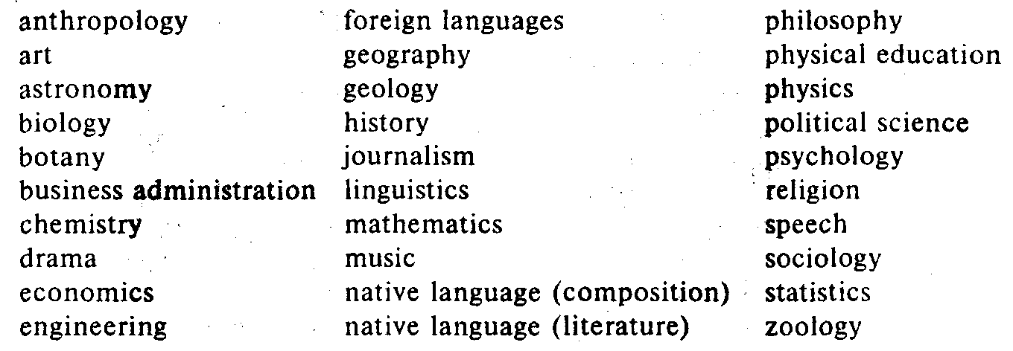
5. Study the following chart and make a chart of the Russian/ British System of Education. Consult the reference material.

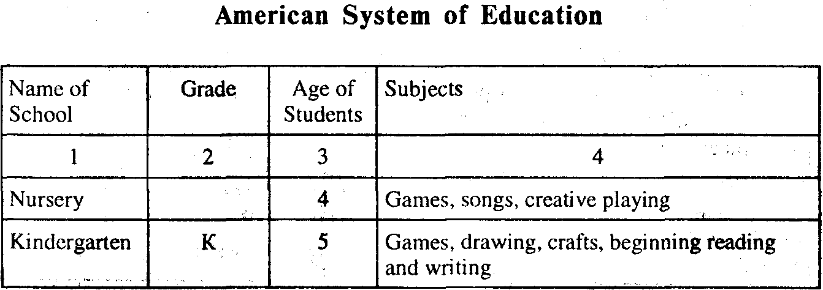

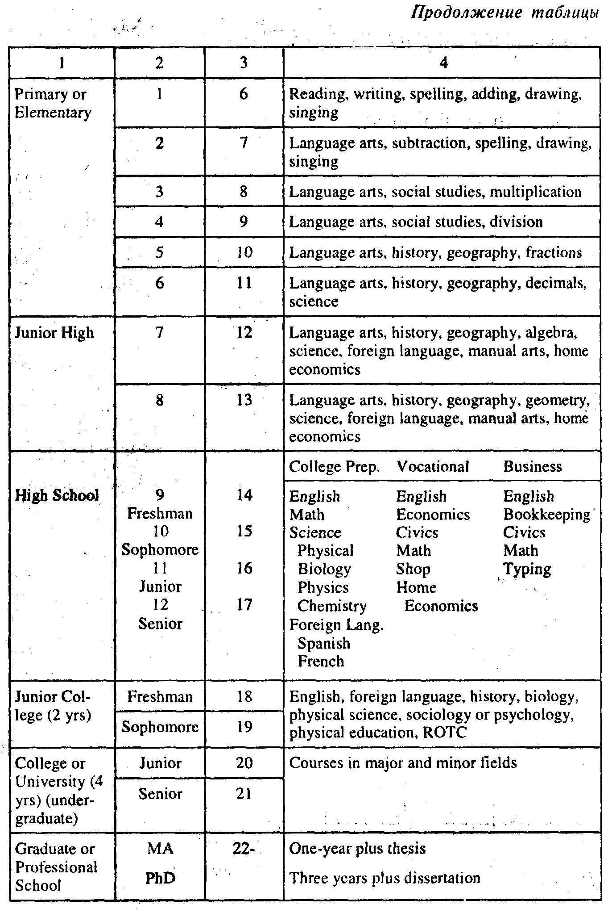

41. SUPPLEMENTARY READING

(by P.P. Dunne)

§ 1. On Education

Mr Smith was worried. His little Bobbie was already six years old and it was time for the family to decide his career. It was difficult, however, to choose a suitable school for little Bobbie Smith. The boy was such a bright little chap. At last Mr Smith made up his mind to drop in* on Mr Brainer, his neighbour, and ask him for advice. Everybody in the neighbourhood believed Mr Brainer to be a very clever old gentleman.
"It's a serious question," Mr Brainer said, "and it seems to worry people more than it used to. Nowadays they start talking about the education of the child before they choose the name. It's like this: 'This kid talks in his sleep. He'll make a fine lawyer.' Or, 'Look at him fishing up in Uncle Tom's watch pocket. We must train him for a banker.' Or, 'I'm afraid he'll never be strong enough to work. He must go into the church.'
"To my mind, Smith, we are wasting too much time, thinking of the future of our young, and trying to teach them... what they ought not to know** till they are grown-up. We send the children to school as if it was a summer garden*** where they got to be amused instead of a reformatory**** where they are sent to be reformed. When I was a kid I was put at my ABC the first day I set foot in the school; and my head was sore inside and out***** before I went home. Nowadays things seem to be quite different. Now the first thing we teach the future businessmen and politicians of our nation is waltzing, singing and cutting pictures out of a book. In my opinion it would be much better to teach them toughness******, that's what they need in life."
_____________________

* to drop in on – to go to a person's house for a short visit
** what they ought not to know – чего они не должны знать
*** a summer garden – sort of kindergarten
**** a reformatory – исправительное заведение для малолетних преступников
***** my head was sore inside and out – у меня просто разламывалась голова
****** toughness – жесткость; упорство

§ 2. The Kindergarten

"I know what will happen," Mr Brainer went on to say. "You'll send Bobbie to what Germans call a Kindergarten. And it's a good thing for Germany, because all a German knows is what one tells him; and his graduation papers are a certificate that he needn't think any more. But we have introduced it into this country, and one day I dropped in on Mary Ellen and saw her Kindergarten. The children were sitting around on the floor and some were molding dogs out of mud and wiping their hands on their hair, and some were carving figures of a goat out of pasteboard, and some were singing, and some were sleeping and a few were dancing. And one boy was pulling another boy's hair.
'Why don't you punish the little savage, Mary Ellen?' said I.
'We don't believe in corporal punishment,'* said she. 'School should be pleasant for the children,' she said. 'The child whose hair is being pulled is learning patience, and the child that is pulling the hair is discovering the futility of human endeavour.'**
'Oh, well,' I said, 'that's very interesting, indeed. Times have certainly changed since I was a boy,' I said. 'Put them through their exercises,' I said, 'Tommy, spell "cat," I said.
'Go to the devil,' said the little angel.
'Very smartly said***," said Mary Ellen. 'You should not ask him to spell,' she said. 'They don't learn that till they go to college,' she said, 'sometimes not even then,' she said.
'And what do they learn?' I said.
'Playing,' she said, 'and dancing, and independence of speech, and beauty songs, and sweet thoughts, and how to make home homelike,' she said.
'I won't put them through any exercise today,' I said.
'...whisper, Mary Ellen,' I said. 'Do you never feel like whipping them?'****
'The teachings of Freebull and Pitzotly***** are contrary to that,' she said. 'But I'm going to be married and leave school on Friday the 22nd of January and on Thursday the 21st I'm going to ask a few of the darlings to the house and stew them over a slow fire.'"******
_____________________

* corporal punishment – телесные наказания
** the futility of human endeavour – тщетность человеческих усилий
*** very smartly said – очень умный ответ
**** Do you never feel like whipping them? – И вам никогда не хочется отшлепать их?
***** искаженное от Froebel – немецкий педагог, основатель детских садов, Pestallozi – выдающийся швейцарский педагог
****** to stew over a slow fire – зажарить на медленном огне

§ 3. College

"Well, after they have learned at school they are ready for college. Mamma packs a few things into her son's bag and the lad trots off to college. If he is not strong enough to look for high honours as a boxer he goes into the thought department.* The President** takes him to his study, gives him a cigarette and says: 'My dear boy, what special branch of learning would you like to study to become one of our professors? We have a Chair of Beauty and a Chair of Puns, a Chair of Poetry on the Setting Sun, and one on Platonic Love, and one on Sweet Thoughts and one on How Green Grows the Grass.*** This is all you will need to equip you for perfect life, unless you intend being a dentist; in which case,'**** he says, 'we won't think much of you but we have a good school where you can learn that disgraceful trade,' he says.
And the lad makes his choice, and every morning when he is up in time he takes a glass of whiskey and goes off to hear Professor Marianna tell him that if the data of human knowledge must be rejected as subjective, how much more must they be subjected as rejective..."*****
"I don't understand a word of what you are saying," said Mr Smith.
"Nor do I," said Mr Brainer. "But believe me it is as my father used to say: 'Children shouldn't be sent to school to learn but to learn how to learn. I don't care what you teach them, so long as it is unpleasant to them.' It's training they need, Smith. That's all. I never could make use of what I learned in college about trigonometry and grammar; and the bumps I got on my head from the schoolmaster's cane I have never been able to make use of either. But it was the being there and having to learn things by heart, without asking the meaning of them, and going to school cold and coming home hungry, that made the man of me you see before you. Our children must be taught toughness, that's what they need in life."
_________________________

* the thought department– (зд.) философский факультет
** the President – the Head of the College
*** Перечисляются вымышленные названия кафедр.
**** in which case– в таком случае
***** Дается сатирическая иллюстрация высокопарного псевдонаучного стиля философского факультета.

The Prime of Miss Jean Brodie*

(by Muriel Spark)

The boys, as they talked to the girls from Marcia Blaine School, stood on the far side of their bicycles holding the handlebars, which established a protective fence of bicycle between the sexes, and the impression that at any moment the boys were likely to be away.
The girls could not take off their panama hats because this was not far from the school gates and hatlessness was an offence. These girls formed the Brodie set.** That was what they had been called even before the headmistress had given them the name, when they had moved from the Junior to the Senior school at the age of twelve. At that time they had been immediately recognizable as Miss Brodie's pupils, being vastly informed on a lot of subjects irrelevant to the authorized curriculum, as the headmistress said, and useless to the school as a school. These girls were discovered to have heard of Mussolini, the Italian Renaissance painters; the interior decoration of the London house of the author of "Winnie-the-Pooh" had been described to them, as had the love lives of Charlotte Bronte and of Miss Brodie herself. They were aware of the existence of Einstein and the arguments or those who considered the Bible to be untrue. They knew the rudiments of astrology but not the capital of Finland. All of the Brodie set, save one, counted on its fingers, as had Miss Brodie, with accurate results more or less.
By the time they were sixteen, and had reached the fourth form, they remained unmistakably Brodie, and were all famous in the school, which is to say they were held in suspicion and not much liking.*** They had no team spirit and very little in common with each other outside their continuing friendship with Jean Brodie. She still taught in the Junior department.
______________________

* Мисс Джин Броди в расцвете сил и энергии.
** the Brodie set – окружение Мисс Броди
*** they were held in suspicion and not much liking – к ним относились с недоверием и недолюбливали

Miss Brodie never discussed her affairs with the other members of the staff, but only with those former pupils whom she had trained up to her confidence. There had been previous plots to remove her from Blaine, which had been foiled.
"It has been suggested again that I should apply for a post at one of the progressive schools, where my methods would be more suited to the system than they are at Blaine. But I shall not apply for a post at a crank school.* I shall remain at this education factory. Give me a girl at an impressionable age, and she is mine for life."
Often, that sunny autumn, when the weather permitted, the small girls took their lessons seated on three benches arranged about the elm.
"Hold up your books," said Miss Brodie quite often that autumn, "prop them up in your hands, in case of intruders.** If there are any intruders, we are doing our history lesson... our poetry... English grammar."
The small girls held up their books with their eyes not on them, but on Miss Brodie.
"Meantime I will tell you about my last summer holiday in Egypt... I will tell you about care of the skin, and of the hands... about the Frenchman I met in the train to Biarritz... and I must tell you about the Italian paintings I saw. Who is the greatest Italian painter?"
"Leonardo da Vinci, Miss Brodie."
"That is incorrect. The answer is Giotto, he is my favourite."
"If anyone comes along," said Miss Brodie, "in the course of the following lesson, remember that it is the hour for English grammar. Meantime I will tell you a little of my life when I was younger than I am now, though six years older than the man himself."
"I was engaged to a young man at the beginning of the War but he fell on Flanders' Field," said Miss Brodie. "He fell like an autumn leaf though he was only twenty-two years of age. When we go indoors we shall look on the map at Flanders, and the spot where my lover was laid before you were born. He was poor. He came from Ayrshire, a countryman, but a hard-working and clever scholar. He said, when he asked me to marry him, 'We shall have to drink water and walk slow'! That was Hugh's country way of expressing that we would live quietly. We shall drink water and walk slow. What does the saying signify. Rose?"
"That you would live quietly. Miss Brodie," said Rose Stanley who six years later had a great reputation for sex.
The story of Miss Brodie's felled fiance was well on its way when the headmistress, Miss Mackay, was seen to approach across the lawn. Rose Stanley had now begun to weep.
______________________

* a crank school – школа с причудами (речь идет о современных школах)
** in case of intruders– если кто-нибудь придет

"What are you little girls crying for?" asked Miss Mackay.
"They are moved by a story I have been telling them. We are having a history lesson," said Miss Brodie, catching a falling leaf in her hand as she spoke.
"Crying over a story at ten years of age!" said Miss Mackay to the girls. "I am only come to see you and I must be off. Well, girls, the new term has begun. I hope you all had a splendid summer holiday and I'd like to see your essays on how you spent them. You shouldn't be crying over history at the age often. My word!"
"You did well," said Miss Brodie to the class, when Miss Mackay 'had gone, "not to answer the question put to you. It is well, when in difficulties, to say never of word, neither black nor white. Speech is silver but silence is golden."
Assignments:
1. Give the Russian proverb corresponding to the English one given at the end of the extract.
2. Give the character sketch of Miss Brodie.

In One Ear and Upside Down*

(by Parke dimming)

The instructions and commands given by parents are endless in variety. Therefore it is impossible to make a list of them. Neither can you foretell exactly how they will be misinterpreted.
Yet, as a help to inexperienced parents I shall be happy to supply them with a short list of mixed-up instructions. They are sure to find it very helpful.
1. Instruction: "Clean up properly before you come to table. And don't use those guest towels!"
Result: The child goes and wipes its hands on a guest towel.
2. Instruction: "Will you kindly turn that radio down lower?"
Result: Usually none. After the words are repeated several times the child may turn off the radio and turn on the television.
3. Instruction: "Bring me the duster, please. I want to remove the dust from the piano."
Result: The child walks out of the room and returns in some time either with the vacuum cleaner or with a pail of water.
4. Instruction: "Clear the things off the dining room table and then get down to your homework so that you can finish it in time. I'll do the dishes."**
Result: The youngster clears the table after the request is repeated twice. Then he starts to do the dishes. He is greatly surprised when Mother tells him to start studying. He begins to complain that Mother is always telling him one thing and then changing her mind.
5. Instruction: "There is going to be trouble if you go on leaving the front door open every time you go in and out of the house."
Result: The child obviously alarmed quickly goes to the door and opens it.
6. Instruction: "Don't forget you have a dentist's appointment at three o'clock on the fourth."
Result: After reading the preceding examples, the reader is expected to figure this out for himself.*
I suppose there is no need to go on with list. A smart parent will now see a way out. As the child's natural tendency is to get a request mixed up, you simply first mix it up yourself.
For instance the other morning we wanted John to wash his neck, but we hesitated a long time before we finally worded the command. It was as follows: "Scrub the soap with a towel and then hang up your neck."**
Result: The cleanest neck we have seen in six months. You see how simple it is if you know how to do it.
Assignments:
1. Think of a continuation to this sketch.
2. Tell a funny story about your little brother or sister, or your own child.

__________________________

* Обыгрывается поговорка "In one ear and out of the other."
** to do the dishes – мыть посуду
*** The mixed up instruction for: "Scrub your neck with the soap and then hang up your towel."
**** at least so far as children are concerned – по крайней мере, что касается детей

What's Wrong with the Kid?

(by Parke Cumming)

Recently a well-known psychiatrist stated that modern psychiatry has made us change our opinions of what must be regarded as normal behaviour.
He may be absolutely right, for all I know. I am not going to argue with him anyhow. I should like, however, to point out that the best way to get an idea of normal behaviour (at least so far as children are concerned*) is to get married and raise** a few. As I look back on my bachelor days, I'm surprised at the wrong views I held on the matter.
________________________

* to figure smth out for oneself– представить что-л.

Well, the best way to make myself clear, I think, is to take a few examples.
Example 1. A young boy in his early teens*** works for his neighbour, cleaning out the cellar, fetching wood, mowing the lawn and running errands in order to earn the money for a new tennis racket. Finally he gets the hard-earned money and buys a tennis racket.
Result:
Abnormal behaviour (i.e. the behaviour expected by an unmarried person or inexperienced parent): the boy practices regularly, and in some time becomes accomplished tennis player.
Normal behaviour, two days after buying the tennis racket, he removes all the strings and converts them into a line for a "Telephone" system. A short time later, the frame of the racket is converted into a giant slingshot.****
Example 2. A small girl – let us say aged three – is presented with a new pail and shovel for her sand box.
Abnormal behaviour, the child takes the toys to the sand box and plays with them day after day.
Normal behaviour, the child plays with the toys for ten minutes after which she throws them into a dustbin. She then makes several trips to the house and starts making sand pies with the following tools: one silver spoon, her father's best crystal cocktail shaker, her mother's favourite roasting pan.
Example 3. A five-year-old child shows interest in the neighbour's police dog, an animal the size of a mountain lion and with much sharper teeth. His parents seeing his interest in dogs, buy him the cutest little two-month-old spaniel puppy you ever saw.
Abnormal behaviour, the child is crazy about the new pet.
Normal behaviour, the child is crazy with terror as seeing the puppy and attempts to run next door to the police dog for protection.
Example 4. Six year-old Effie raises bell***** when her mother doesn't invite Susie Connors to her birthday party, and continues to do so until the mother finally yields.
Abnormal behaviour. Effie greets Susie affectionately when she appears.
Normal behaviour. Effie attacks Susie furiously, scratches her face and pulls her hair until Susie's mother caring away the screaming child.
Example 5. By means of hard work and considerable skill a 10-year-old boy succeeds in making an excellent pair of skis, but then he has to wait three weeks until there is snow.
Abnormal behaviour, the boy is crazy with joy, rushes outdoors and tries his skis.
Normal behaviour, the boy stays the entire day at home teasing the cat and driving mother mad.
I believe these five examples could be sufficient to enable practically anybody to foretell what a child will do under certain circumstances.
___________________

** to raise smb = to bring smb up
*** aged thirteen or fourteen (teens–the year of one's age from 13 to 19), teenager – a boy or a girl in one's teens
**** a slingshot – рогатка
***** to raise bell (Am. colloq.) – поднять скандал

Culture

(by Bob Consedine)

One of our kids gave a blood-curdling scream in the middle of the night. Dear Mother rushed into the child's room and found him sitting up in bed.
"Can't sleep," said the young man. "It's my fairy tales."
This seemed somewhat strange to me. I thought of Mary and her Litttle Lamb* and Hickory Dickory Doc**, or whatever that rat's name was, and the other gentle tales of my early youth.
The next day, however, I got down to reading some of my little boy's fairy tales. I must have missed them as a kid. Either that or a merciful forgetfulness wafted over me. Because, ever since I started reading our kid's books, I've been sleeping with the lights on and the bedroom door locked.
Goodness Gracious!*** What frightening stuff when read in retrospect!
Let's take "Hansel and Gretel" by the Grim brothers, for instance. It opens with a charming little scene between the father and mother of the kids. They are starving during famine.
"What's to become of us?" the father asks. "How are we to feed our poor children when we have nothing for ourselves?"
"I'll tell you what, husband," answers the fond mother. "Tomorrow morning we shall take the children out quite early into the thickest part of the forest. We shall light a fire and give each of them a piece of bread. Then we shall go to our work and leave them alone. They won't be able to find their way back."
______________________

* "Little Lamb"– a sentimental nursery rhyme
** Hickory Dickory Doc – начало детского стиха
*** Goodness Gracious! – Господи, помилуй!

For some reason or other the father thinks that's an unkind thing to do, so he says, "Wild animals would soon tear them to pieces."
In the face of this weakness* the wife grows furious and snarls. "What a fool you are! Then we must all four die of hunger. You may as well plane the boards for our coffins at once."
And so they take the kids off and lose them.
Then there is that charming little tale called "The. Wolf and the Seven Kids" in a book named "The Bedtime Nursery Book."
There's an old goat, and she's got seven little kids. She goes out to get home food for her kids and says: "Look out for that bad old wolf. If you let him inside, he will eat you up – hair, skin, and all. Sometimes he disguises himself**, but you will know him by his hoarse voice and big black paws."
The wolf shows up in various disguises, which the kids see through but finally he's too smart for them and they let him in... The frightened little kids tried to hide. But the wolf found them all, except the youngest, who had hidden in the clockcase. One after another he swallows the six little kids.
Later the old lady comes home, sees the deserted house and wanders outside in her grief. There she finds a wolf snoring under a tree and "noticed that something was moving and struggling inside his body."
"She sent the youngest kid back to the house to get her scissors and a needle and thread. Then she cut open the wolfs stomach..."
Let us dismiss the utter terror contained in Little Red Riding Hood,*** because some passing woodcutters heard her scream and she was about to be consumed for her tender faith in human nature.**** The trouble is, my kid doesn't know any woodcutters. He's convinced, too, that none want to know him, or rescue him from the ominous things that take shape in his room after the twilight session with Beddy-Bye Tales.*****
Now you probably remember Hans Christian Andersen's tale "The Little Match Girl" – just the thing to read to a child who has been warned through most of his life never, never to play with matches.
This tale opens with a little girl, limping barefooted through a New Year's blizzard. She has lost her slippers and as a result her feet are red and blue. The kid can't go home because she hasn't sold her matches yet, and that means her old man will beat her black and blue.
So she begins lighting her matches and sees one vision after another. Finally she lights the whole box and sees her grandmother, who passed away in 1709.
"In the cold morning light the poor little girl sat there with rosy cheeks and a smile on her face – dead," the story reads. "Frozen to death on the last night of the year. New Year's day broke on the little body still sitting with the ends of the burnt -out matches in her hand."
I'm going to make my kid read something light and frivolous, like Poo, or "Arsenic and Old Lace."
In the meantime, if the kid lets loose another shriek in the middle of some moonless night, he's better move out. For Dear Father will be under the covers with him.

Assignments:
1. Formulate the author's views on fairy tales.
2. Tell a fairy tale thatyou like best.
_____________________

* in the face of this weakness – видя его слабость
** to disguise oneself - маскироваться
*** Little Red Riding Hood – Красная Шапочка
**** she was about to be consumed for her tender faith – ее чуть не съел волк за ее доверчивость
***** Beddy-Bye Tales = bedside fairy tales

Adolescence*

(by Bertrand Rassel from "Autobiography")

My childhood was, on the whole, happy and straightforward, and I felt affection for most of the grown-ups with whom I was brought in contact. I remember a very definite change when I reached what in modern child psychology is called "the latency period."** At this stage I began to enjoy using slang, pretending to have no feelings, and being generally "manly." I began to despise my people, chiefly because of their extreme horror of slang and their absurd notion that it was dangerous to climb trees. So many things were forbidden me that I acquired the habit of deceit, in which I persisted up to the age of twenty one. It became second
_________________________

* the time between childhood and manhood (from 13 to 21), adolescent = "teenager"
** The author refers to his early teens, the period between childhood and adolescence (latent– скрытый, невидимый).

nature to me to think that whatever 1 was doing had better be kept to myself, and I have never quite overcome the impulse to concealment which was thus generated. I still have an impulse to hide what I am reading when anybody comes into the room, and to hold my tongue as to where I have been and what I have done. It is only by a certain effort of will* that I can overcome the impulse of concealment which was thus generated by the years during which I had to find my way among a set of foolish prohibitions.**
The years of adolescence were to me very lonely and very unhappy. Both in the life of the emotions and in the life of intellect, I was obliged to preserve an impenetrable secrecy towards my people.
Assignments:
1. Say what a boy of his early teens is like, what problems he often has.
2. Discuss what is usually referred to as a "problem child,"
3. Tell the class about your own childhood.

Clean Up Your Room

(by Art Buchwald)

You don't really feel the generation gap in this country until a son or daughter comes home from college for Christmas. Then it strikes you how out of it you really are.***
This dialogue is probably taking place all over America this week.
"Nancy, you've been home from school for three days now. Why don't you clean up your room?"
"We don't have to clean up our room at college, mother."
"That's very nice, and I'm happy you're going to such a freewheeling institution.**** But while you are in the house, your father and I would like you to clean up your room."
"What difference does it make? It's my room."
_________________________

* it is only by a certain effort of will – это вошло в привычку
** I had to find my way among a set of foolish prohibitions – мне пришлось искать выход из глупых запретов
*** Then it strikes you how out of it you really are. – Вы внезапно понимаете, насколько мало вы знаете свою собственную дочь.
**** a free-wheeling institution – заведение без всяких правил, где вы можете делать все, что хотите

"I know, dear, and it really doesn't mean that much to me. But your father has a great fear of the plague.* He said this morning if it's going to start anywhere in this country, it's going to start in your room."
"Mother, you people aren't interested in anything that's relevant. Do you realize how the major corporations are polluting our environment?"
"Your father and I are very worried about it. But right now we're more concerned with the pollution in your bedroom. You haven't made your bed since you came home."
"I never make it up at the dorm**
"Of course you don't, and I'm sure the time you save goes toward your education. But we still have these old fashioned ideas about making beds in the morning and we can't shake them. Since you're home for such a short time, why can't you do it to humour us?"
"For heaven's sake, mother, I'm grown-up now. Why do you have to treat me like a child?"
"We're not treating you like a child. But it's very hard for us to realize you're an adult when you throw all your clothes on the floor."
"I haven't thrown all my clothes on the floor. Those are just the clothes I wore yesterday."
"Forgive me. I exaggerated. Well, how about the dirty dishes and empty soft-drink cans*** on your desk? Are you collecting them for a science protect?"****
"Mother, you don't understand us. You people were brought up to have clean rooms. But our generation doesn't care about things like that. It's what you have in your head that counts."*****
"No one respects education more than your father and I do, particularly at the prices they're charging.****** But we can't see how living in squalor can improve your mind."
"That's because of your priorities. You should rather have me make up my bed and pick up my clothes than become a free spirit who thinks for myself."
_____________________

* your father has a great fear of the plague – папа страшно боится чумы
** dorm = dormitory– здание, где живут учащиеся колледжа
*** soft-drink cans – банки от безалкогольных напитков
**** for a science protect = for scientific research
***** It's what you have in your head that counts. – Принимается во внимание то, что в вашей голове.
****** particularly at the prices they're charging – особенно если учесть плату, которую они берут

"We are not trying to stifle your free spirit. It's just that Our Blue Cross has run out, and we have no protection* in case anybody catches typhoid."
"All right I'll clean up my room if it means that much to you. But I want you to know you've ruined my vacation."
"It was a calculated risk I had to take. Oh, by the way – I know this is a terrible thing to ask of you, but would you mind help me wash the dinner dishes?"
"Wash dishes? Nobody washes dishes at school."
"Your father and I were afraid of that."

Assignments:
1. Speak of the generation gap.
2. What do you think is the ideal approach to the younger generation? (Discuss this problem in class.)

From "The Sandcastle"**

(by Iris Murdoch)

I. It was fine clear evening. Мог closed the door of the Sixth Form room and escaped down the corridor with long strides. He had just been giving a lesson to the history specialists of the Classical Sixth.*** Donald, who was in the Science Sixth,**** had of course not been present. It was now two years since, to Mor's relief, his son had ceased to be his pupil. Мог taught history, and occasionally Latin, at St Bride's*****. He enjoyed teaching, and knew that he did it well. His authority and prestige in the school stood high, higher, since Demoyte's departure, than that of any other matter. Мог was well aware of this too, and it consoled him more than a little for failures in other departments of his life.
_________________________

* Говоря это, мама имеет в виду, что они больше не могут платить за услуги Голубого креста, а значит, не смогут получить бесплатного лечения в больнице.
** «Замок на песке» – роман Айрис Мердок
*** The Sixth Class is a period of preparation for A Level exams taken at the age of 18 either in humanities or in science (the choice of subjects is optional).
**** The Classical Sixth is a class with a bias in humanities, the Science Sixth– in science.
***** St Bride's – название школы

Now, as he emerged through the glass doors of Main School* into warm sunshine, a sense of satisfaction filled him, which was partly a feeling of work well done and partly the anticipation of a pleasant evening. This evening there would be the strong spicy talk of Demoyte. If he hurried, Мог thought, he would be able to have one or two glasses of sherry with Demoyte.
Demoyte lived at a distance of three miles from the school. Demoyte was a scholar. For his scholarship Мог, whose talents wore speculative rather than scholarly, admired him without envy; and for his tough honest obstinate personality and his savage tongue Мог rather loved him. His long period as Headmaster of St Bride's had been punctuated by violent quarrels** with members of the staff, and was still referred to as "the reign of terror."
Demoyte had not been easy to live with and he had not been easy to get rid of. Ever since Мог had come to the school, some ten years ago, he bad been Demoyte's lieutenant*** and right-hand man.
What Demoyte cared about was proficiency in work. As for morality, and such things, Demoyte took the view that if a boy could look after his Latin prose his character would look after itself.****
Very different was the view taken by the Demoyte's successor, the Reverend Giles Everard. The training of character was what nearest to Everard's heart and performance in Latin prose he regarded a secondary matter.
II. The chief buildings of St Bride's were grouped unevenly around large square of asphalt which was called the playground. Although the one thing that was strictly forbidden therein was playing. The building consisted of four tall red-brick blocks: Main School, which contained the hall, and most of the senior classrooms, and which was surrounded by the neo-Gothic tower; Library which continued the library and more classrooms, and which was built close against Main School, jutting at right angles from it; School House, opposite to Library, where the scholars ate and slept; and "Phys and Gym"* opposite the Main School, which contained the gymnasium, some laboratories, the administrative offices, and two flats for resident masters.** The St Bride's estate was extensive, it lay along the slops of a hill. There was a thick wood of oak and birch, cut by many winding paths, deep and soft with old leaves, the paradise of the younger boys. On the fringe of this wood, within sight of the library, stood the Chapel. Beyond this, hidden among the trees, were the three houses to which the boys other than the scholars*** belonged, where they lived and took their meals and, if they were senior boys, had their studies. Beyond the wood lay the squash**** courts and the swimming pool – and upon the other side, were the music rooms and the studio.
__________________________

* Main School – (зд.) the building which contained the gymnasium, some laboratories, the administrative offices, and two flats of resident masters.
** had been punctuated by violent quarrels – был отмечен бурными ссорами
*** lieutenant– (зд.) заместитель
Обыгрывается английская пословица: "Take care of the репсе and the pounds will take care of themselves".

III. What Мог did see, at the corner of the playground near the far end of the Library, was his son Donald.
"Hello, Don," says Мог, "how goes it?"
Donald looked at him, and looked away at once. He was tall enough now to look Мог in the eyes. His resemblance of his father was considerable. He had Mor's crisp dark hair, his crooked nose and lop-sided smile. His eyes were darker though, and more suspicious. His face was soft, however, still with the indeterminacy of boyhood. His mouth was shapeless and pouting, not firmly set.
Donald was long in growing up – too long, Мог felt with some sadness. He could not but grieve over his son's strange lack of maturity. At an age when he himself had been devouring books of every kind in an insatiable hunger for knowledge, Donald appeared to have no intellectual interests at all. He worked at his chemistry in a desultory fashion,*****sufficiently to keep himself out of positive disgrace; but apart from this Donald seemed to do, as far as Мог could see, nothing whatever. He spent a lot of time hanging about, talking to Carde and others, or even, what seemed to Мог odder still, alone. This mode of existence was to Мог extremely mysterious. Donald's reading, such as it was, seemed to consist mainly of "Three Men in a Boat," which he read over and over again, always laughing immoderately, and various books on climbing which he kept carefully concealed from his mother. During the holidays he was a tireless cinemagoer. As Мог looked at him now, he felt a deep sadness that he was not able to express his love for his son, and that it could even be that Donald did not know at all that it existed.
_______________________

* Phys – a physics room, a room used for lessons in natural science, Gym– gymnasium, a hall used for gymnastics.
** a resident master– преподаватель, живущий при школе
*** a scholar– a holder of a scholarship
**** the squash – игра, включающая в себя элементы тенниса и гандбола
***** in a desultory fashion – бессистемно, урывками

Assignments:
1. Read passage I and
a) say what you have learnt about the teachers of St Bride's Mr Мог, Mr Demoyte and Mr Everard;
b) describe St Bride's School;
c) give a character sketch of Donald and say why his father was displeased with him.
2. Discuss in class the new facts you learnt about the educational system in England.

From "Oxford Life"

(by Dacre Balsden)

1. Lectures Start on Monday

Lectures start on the first Monday of term. Lecturers are sometimes in fashion; lectures as such are never in fashion.
Why take notes when you could as well read it all in a book? The question is unanswerable.
In some subjects the lecture-list is itself carefully organized by the Faculty, so that all the necessary lectures are given and given in the terms in which undergraduates need them. In other faculties the freedom of the lecturer is not so rigidly curtailed.* Let a lecturer lecture on whatever subject he chosen. If he hopes for an audience, he will choose a subject useful to undergraduates, and he will lecture on it twice a week. If he does not care about the size of his audience and prefers to lecture on some small field of learning on which he is researching or writing a learned paper, he will lecture one hour a week. "Thursday at 11, Mr Smooth, 'Plutarch, On the Virtue of Women.' "**
Dons*** in general hate lectures as much as undergraduates. That is why they lecture so badly. Nobody has ever taught them how to lecture well. There is a Delegacy**** in Oxford for the training of schoolmasters; there is no delegacy for the training of dons.
_______________________

* to be rigidly curtailed – быть строго ограниченным
** Плутарх «О женской добродетели»
*** a don – преподаватель
**** Delegacy of Training – Управление по подготовке школьных Учителей

On the first Monday the lecturer has his largest audience for the term. Where there are a hundred young men and women today, there will, in eight weeks times, be no more than five or six. Where there is an audience of two today, there will perhaps be one next week and, after that, no audience at all.
A professor's lecture is sometimes like the "pas scul" of a prima ballerina. He appears; he lectures; he retires. And then after an interval, he lectures again. But the College tutor's public lecture is an interruption in a week otherwise devoted to teaching pupils in his rooms, listening to their essays and talking about them. These are "private hours" – "tutes," as the undergraduates call them, or tutorials. Sometimes a pupil comes along, sometimes in a pair, sometimes with two or three others.
Young tutors find the hour too long, old tutors find it too short. Undergraduates find it very long indeed and if there is no clock in the room, they find it even longer. When you reach a tutor's age, it is less easy to listen than to talk, and observant undergraduates quickly realize that their tutors criticize in detail the final sentences of their essays but give little evidence of having observed the rest*. There is a splendid story of the great Ingram Bywater**.
"Ah," he said, in greeting, to his pupil, "what is the subject of you essay? Expediency? Splendid. Then will you read what you have written?"
At the end, he roused himself. He said, "For the next week, will you write an essay on– er – Expediency? That is all."
Had he slept through the whole of the essay? Or was he uttering the most devastating criticism?*** The pupils never knew.

II. End of Term Collections****
Term is ending. On Friday and on Saturday the undergraduates are themselves collected. "End of Term Collections" is the
_____________________

* but give little evidence of having observed the rest – но почти не чувствуется, что они прочли все остальное
** Ingram Bywater– оксфордский ученый, специалист по средне-и новогреческому языкам
*** Or was he uttering the most devastating criticism? – Или он полностью раскритиковал его?
**** Term Collections – «семестровые сборы», принятое в Оксфордском университете шутливое название различного рода официальных и неофициальных процедур, связанных с окончанием учебного семестра

official title of the ceremony. "Handshaking" it is informally called or, more commonly, "Don Rag."*
The undergraduates receive verbally an end-of-term report. In some colleges the ceremony is private. The undergraduate is along with the Head of his college and the Head of the College has in his hands a written report from the man's tutor. And there whatever is said, is said.**
In many colleges it is a less intimate and more frightening ceremony. The Head of the College sits in the hall at the High Table, flanked by Moral Tutors.*** They are, in the eyes of the young, a body of old, old men – malicious, malevolent old sadists, laughing proudly at their own jokes, jokes always at some poor undergraduate's expense.
One by one the young men are summoned.
"Mr Smith."
He walks the long way up the Hall, for the young men awaiting their summons have chosen their seats at the other end of the Hall, as far away from the High Table as they can get. He is conscious that his shoes squeak, or sound very loud on the stone floor. The inquisitors are massed on the other side of the table. On his side there is a single chair.
"Sit down, Mr Smith."
"Mr Smith, Master, has been coming to me this term. He has been working very well, as he always does. He needs, of course, to do a lot of reading in vacation."
"That is a good report, Mr Smith. Yes, pay attention to your tutor's advice – and give my very kind regards to your father. He is well, I think." (Mr Smith cannot tell the Master that he has not got a father. It happens term after term at Collections, the only time when Mr Smith and the Master are brought face to face. It is some other Smith, of course, with whom the Master regularly confuses him, a Smith who went down some terms ago.)
At about half past six in the evening, Larry emerges from Hall. He had not been certain what to expect, and he had faced the ordeal with some anxiety.
______________________

* Rag – розыгрыш, который обычно устраивают студенты старших курсов новичкам (в Оксфорде и Кембридже носит безобидный характер).
** And there whatever is said, is said. – И что уж там говорится, то и говорится.
*** Moral Tutor – куратор, который отвечает за поведение студентов, он же дает характеристику студентам, желающим поступить на Работу в период каникул

His tutor said, "Mr Minthauser is still in the process of setting down, Master. He isn't quite used to our methods yet. He is beginning to learn that we don't regard length in an essay as any particular virtue – indeed that we rather mistrust people who can't express themselves briefly. But of course it's all new to him and he is tackling it in quite the right spirit."*
And the master has said, "How would you report on yourself, Mr Minthauser?"
"I guess I'll make out in the end, but somebody's going to have to do some work on me first."
"Good," the master says.

III. Oxford Accent
Last October freshmen have gone down.** When they return in October, they will be second year men and women. Academically, they will be approaching middle age. How much of a stamp Oxford put on them already?*** Have they started to acquire an Oxford accent?
The Oxford accent exists, but it defies definition.**** It is not, as the French think, the kind of English which is spoken within a twenty mile radius of the city. Indeed, it is not an accent at all, but a manner of speaking. In particular it is a manner of pausing in your speech, of pausing not at the end of sentences, where you might be interrupted, but in the middle of sentences. Nobody, it is to be hoped, will be so rude to interrupt you when you are in the middle of a sentence. So pause there, to decide what your next sentence is going to be. Then, having decided, move quickly forward to it without a moment's pause at the full stop. Yes, jumping your full stops***** – that is the Oxford accent. Do it well, and you will be able to talk forever. Nobody will have the chance of breaking in and stealing the conversation from you.******
The Oxford accent, so called, is also a matter of redefining the other person's statement on your own terms.******* Wait for him to say whatever he has to say. Then start yourself: "What you really mean is..." Nothing could be ruder.
And for Americans in general it is a matter of employing, all unconsciously, a new vocabulary, of doing by instinct what on your arrival, you were shocked to hear other Americans doing.
Assignments:
1. Read extract number I and speak on:
a) the way the author presents the work of the lecturers in Oxford;
b) the tutorial system of education in British Universities.
2. Say what the "Term Collections" procedure is organized for.
3. Discuss the problem of an Oxford accent with your groupmates.
________________________

* and he is tackling it in quite the right spirit – и он делает это верно
** to go down – уйти из института
*** to put a stamp on smb – наложить на кого-л. отпечаток
**** to defy definition – не иметь определения
***** jumping your full stops – пропуски точек
****** Nobody will have the chance of breaking in and stealing the conversation from you. – Никто не сможет прервать вас или перехватить у вас инициативу в разговоре.
******* is also a matter of redefining the other person's statement on your own terms – это также истолкование чьего-то утверждения по-своему

A Reporter's Account

(by Daniel 'Lang)

Susan Cook Russo was twenty-one when she came East to fill her first teaching job. Just graduated from Michigan State College magna cum laude,* she was eager to embark on a career of teaching art to high-school students. The time was late August of 1969 and the place Rochester, New York, for which Mrs Russo and her husband, John, who was also a teacher, had chosen to leave to Midwest. The two, who had been married only a few months, were from East Lansing, Michigan, where they had been classmates in high school and college. John Russo had a job awaiting him in the science department of a public high school** in Rochester. The post that Mrs Russo had found was at the James E. Sperry High School, in Henrietta, a fast-growing middle-class suburb five miles from Rochester. The principal there, Donald A. Loughlin, had seen Mrs Russo in May, shortly before her commencement, and had given her a careful hearing.*** It had gone well. Mrs Russo had formidable credentials to offer,**** among them her outstanding academic record and glowing letters of reference.***** Her mother was a professor of art education. Besides these assets, Mrs Russo had worked her way through college,* as a waitress, a tutor, and a librarian and she had won several scholarships. Recalling the interview nearly three years later, when I talked to him, Lough-lin told me, "She made an excellent impression." He said it with stern reluctance, for by the spring of 1970, after Mrs Russo had been on his staff for eight months, Loughlin and she wished that they had never met. By then, like other Americans, they had discovered that they had irreconceilable conceptions of patriotism, the principal being adamant that the school pay daily homage to the flag, the new teacher rejecting the Pledge of Allegiance** as a sham, her opposition based on our war in Indo-China and on wide-spread poverty at home. _____________________

* magna cum laude (Lat.) – с отличием
** a public high school – бесплатная школа, подведомственная правительственным властям, включающая 9–12 или 10–12 годы обучения
*** had given her a careful hearing – обстоятельно проверил ее
**** Mrs Russo had formidable credentials to offer– у нее были достаточные полномочия
***** outstanding academic record and glowing letters of reference – очень хорошие знания и прекрасные рекомендации

By the spring of 1970 the differences between the principal and the new instructor were hardly a private quarrel. There were press reports about the disagreement. The community's taxpayers spoke up, most of them in favour of the school principal.*** By the time Mrs Russo's first year as a teacher was at an end, she had been fired. Mrs Russo's reaction was quick. She appealed to the courts. The first decision by a Judge went against Mrs Russo. She didn't stop at that, but she made no progress as a teacher and her future was an impenetrable fog. John Russo told me, "We came East for new experiences, but not for the one that has befalled Susan. It's getting to be like a nightmare from which there is not waking up!"
Assignments:
1. Tell the class what you know about the types of schools in the USA.
2. Give your opinion of Susan Russo.
3. Say a few words about an English or American book in which school life is described.
_______________________

* Mrs Russo had worked her way through college – учась в колледже,
миссис Руссо работала
** Pledge of Allegiance – торжественная клятва быть верным и преданным Соединенным Штатам (процедура, которой придерживаются все школы Нью-Йорка с начала нашего века). Клятва начинается следующими словами: "I pledge allegiance to my flag, and to the country for which it stands, one nation, indivisible, with liberty and justice for all."
*** The community's taxpayers spoke up, most of them in favour of the school principal. – Выступили налогоплательщики, большинство из которых стояло на стороне директора школы.

Alice In Wonderland

(by L. Carroll)

"When we were little," the Mock Turtle went on at last, more calmly, though still sobbing a little now and then, "we went to school in the sea. The master was an old Turtle – we used to call him Tortoise –"
"Why did you call him Tortoise, if he was not one?" Alice asked,
"We called him Tortoise because he taught us," said the Mock Turtle angrily, "really you are very dull."
"You ought to be ashamed of yourself for asking such a sim-; pie question," added the Gryphon, and they both sat silent and looked at poor Alice, who felt ready to sink into the earth. At last the Gryphon said to the Mock Turtle, "Drive on, old fellow! Don't be all day about it!" and he went on in these words:
"Yes, we went to school in the sea, though you mayn't believe it."
"I never said I didn't!" interrupted Alice.
"You did," said the Mock Turtle.
"Hold your tongue!" added the Gryphon, before Alice could speak again. The Mock Turtle went on.
"We had the best of educations – in fact, we went to school every day."
"I've been to a day school too," said Alice, "you needn't to be so proud as all that."
"With extras?" asked the Mock Turtle a little anxiously. , "Yes," said Alice, "we learned French and music."
"And washing?" said the Mock Turtle.
"Certainly not!" said Alice indignantly.
"Ah! then yours wasn't a really good school," said the Mock Turtle in a tone of great relief. "Now at ours they had at the end of the bill French, music, and washing– extra."
"You couldn't have wanted it much," said Alice, "living at the bottom of the sea."
"1 couldn't afford to learn it," said the Mock Turtle with a sigh. "I only took the regular course."
"What was that?" inquired Alice.
"Reading and writing, of course, to begin with," the Mock Turtle replied, "and then the different branches of Arithmetic– Ambition, Distraction, Uglification and Derision."
"I never heard of Uglification!" Alice ventured to say. "What is it?" The Gryphon lifted up both its paws in surprise. "Never heard of uglifying!" it exclaimed. "You know what to beautify is, I suppose. Don't you?"
"Yes," said Alice, doubtfully: "it means– to-make-anything prettier."
"Well then," the Gryphon went on, "if you don't know what to uglify is, you are a simpleton."
Alice didn't feel encouraged to ask any more questions about it, so she turned to the Mock Turtle, and said, "What else had you to learn?"
"Well, there was Mystery," the Mock Turtle replied, counting off the subjects on his flappers – "Mystery, ancient and modern, with Seography; then Drawling – the Drawling-master was an old conger-eel, that used to come once a week; he taught us Drawling, Stretching, and Fainting in Coils."
"What was that like?" said Alice.
"Well, I can't show it to you, myself," the Mock Turtle said:
"I'm too stiff. And the Gryphon never learned it."
"Hadn't time," said the Gryphon: "I went to the Classical master, though. He was an old crab, he was."
"I never went to him," the Mock Turtle said with a sigh: "He taught Laughing and Grief, they used to say."
"So he did, so he did," said the Gryphon, sighing in his turn and both creatures hid their faces in their paws.
"And how many hours a day did you do lessons?" said Alice, in a hurry to change the subject. ; "Ten hours the first day," said the Mock Turtle, "nine the next and so on."
"What acurious plan," exclaimed Alice.
"That's the reason they're called lessons, because they lessen from day to day."

Jokes
1.
"Before I got married I had six theories about bringing up children; now I have six children and no theories."
2.
Mother: Stop using those bad words.
Son: Shakespeare used them.
Mother: Well, don't play with him any more.
3.
1st boy: Does your mother give you anything when you are good?
2nd boy: No, but she gives me something when I am bad.
4.
Mother: You always take too many toys with you: your doll, your trolleybus, and your ball. Let me help you to carry them, my dear.
Little daughter: Oh, no. Mummy. I can carry the toys and you carry me.
5.
Son: Daddy, do you think people can live on the moon?
Father: I think they can.
Son: But if they can live on the moon, where do they go when the moon in very, very small?
6.
1st little girl: What's your last name, Annie?
2nd little girl: Don't know yet; I am not married.
7.
Little girl: Mummy, tell me at what time I was born?
Mother: It was midnight, my darling.
Little girl: Oh! Mummy, I hope I didn't wake you!
8.
Son: Daddy, do you think Mother knows how to bring up children?
Father: But why do you ask that?
Son: Well, she makes me go to bed when I'm wide awake – and she makes me get up when I am awfully sleepy!
9.
– How old are you. Tommy?
– I shall be six next month.
– Really! You are very tall for your age, my little son. You are taller than my umbrella.
– How old is your umbrella, sir?
10.
Bobbie: How old are you, Kate?
Kate: I am five, and Mother says if I am good and eat everything she gives me, I shall be six next birthday.
11.
Ann: Is my birthday very soon, Mummy?
Mother: Yes, very soon now, but why do you ask?
Ann: I only wanted to know if it is time to be a good girl.
12.
Mother: You are five today. Happy birthday to you!
Tommy: Thank you. Mama.
Mother: Would you like to have a cake with five candles on it for your birthday party?
Tommy: I think I'll better have five cakes and one candle, Mama.

13. Nothing to Learn
Little Jack spent his first day at school and returned disappointed. "What did you learn?" was his aunt's question. "We didn't learn anything," replied the boy. "Well, what did you do in that case?" – "We didn't do anything. There was a woman who didn't know how to spell some very simple words and I told her how."
14.
Teacher: Your spelling is very bad. I told you to write those words ten times each and you've only written them eight.
Boy: Yes, sir. I'm very bad at arithmetic too.
15.
Larry: I shall not go to school any more.
Mother: But why, my dear?
Larry: On Monday the teacher said 4 and 4 is 8. On Tuesday she said 7 and 1 is 8. Today she said 6 and 2 is 8. I shall not go back to school again till the teacher knows arithmetic herself.
16.
Teacher: Jack, why are you late to school every morning?
Jack: When I come to the crossing I see the words: "School – Go slow."
17.
Teacher: Who helped you to draw this map. Jack?
Jack: Nobody, sir.
Teacher: Didn't your brother help you?
Jack: No, sir. He draw it all himself.
18.
Teacher: Jimmy, what are the three words which pupils use most often at school? Jimmy: I don't know...
Teacher: Correct.
19.
Teacher (looking over Teddy's homework): I don't see how it's possible for a single person to make so many mistakes.
Teddy (proudly): It isn't a single person, teacher, Father
helped me.
20.
Nick: Ann, give me your pen, please.
Ann: And why don't you want to write with your pen? What's wrong with it?
Nick: It makes so many mistakes.
21.
– Is your son a good pupil?
– Yes, he is. He wants to know all the subjects so well that he stays in every class for two years.
22.
Grandfather (looking through Nick's record book: When I was at school I always had five in History and you have four.
Nick: You see, grandfather, when you were at school History was shorter.
23.
A school teacher told a class of small pupils the story of the discovery of America by Columbus. After he had finished the story,
he said:
– And all this happened more than 400 years ago. A little boy said after a moment's thought:
– Oh! What a memory you've got!
24.
Small girl: I want to be a teacher.
Mother: But you don't know enough to be a teacher.
Small girl: That doesn't matter. Teachers only ask questions.
25.
Father: Run and open the door for the professor, Tommy.
Tommy: What's a professor, Daddy?
Father: A professor is a man who knows everything.
Tommy: Oh, then he must know how to open the door himself.
26.
Father: You know/Tom, when Lincoln was your, age he was the best pupil in his class.
Tom: Yes, Father, I know that. But when he was your age he was President of the United States.
27.
Jimmy again got a bad mark for his homework. When he came home, Father looked at his daybook and said:
– How is that young Smith, who is younger than you, is always at the top of the class, while you are at the bottom? Jimmy replied:
– You forget, Dad, that Smith has very clever parents.
28.
Mother: Johnny, I left two pieces of cake in the cupboard this morning; I see there is only one piece. Where is the other? Can you tell me?
Johnny: It was too dark, Mummy. I could not see the other piece.
29.
– Why, boy, how is it you are so short for your age?
– I'm so busy. I have not time to grow.
30.
Teacher: You were late this morning, Brown.
Brown: Yes, sir, I'm sorry. I overslept.
Teacher: Good gracious! Do you sleep at home as well?
31.
A teacher said to a dull pupil:
– When I was your age I could answer any question in arithmetic.
– Yes, but you forget that you had a different teacher from the one I have.
32.
When a little boy arrived home from school his mother asked him if he had been a good boy.
He replied: "Sure I was good in school today! How much trouble can you get into standing in a corner?"
33. Heat and Cold
A class of physics at school. The teacher: "Now, who can tell me anything about heat?" A small boy held up his hand: "Heat makes things larger, sir, and cold makes things smaller."– "All right, give an example." – "In summer days are longer because it is hot, in winter they are shorter because it is cold."
34. No Music Lesson
Once the teacher asked his pupil: "Bobby, how many fingers have you?" The pupil answered at ones: "I have ten fingers."
The teacher asked him another question: "Well, if four were missing what would you have then?" – "No music lessons," was the answer.
35. At the Lesson
"Well, Alee, how much is two plus one?" asked the teacher.
"I don't know, sir," answered the boy.
"Well, Alee! Fancy I give you two dogs and then one dog more. How many dogs have you now?"
"Four dogs," the boy answered timidly.
"Why, Alee?"
"Because I already have one dog, sir."
36.
One day Pete came home from school and said: "I was the only pupil today who could answer the teacher's question."
"Very nice, Pete. And what was the question?"
"The teacher asked who broke the window in the classroom."
37.
– Oh, Mother, must I learn music?
– Yes, I insist, but you can choose what instrument, if you like.
– May I? Then may it be the gramophone?
38. A Good Student
Professor: Can you tell me anything about the great chemists of the 17th century?
Student: Yes, sir, they are all dead, sir.
39.
Instructor: Cadet Brown, why aren't you listening?
Brown: Yes, I am, sir.
Instructor: Then repeat my last words.
Brown: Cadet Brown, why aren't you listening?
40.
One day a professor was giving his students a lecture on the circulation of blood. To make the subject clear, he said: "Now, look here, if I stand on my head the blood, as you all know, will run to my head. And I shall get red in the face. Now," continued the professor, "what I want to know is this, how is it when I stand on my feet?" The students all sat still for a moment, then one of them held up his hand and said: "Please, sir, it is because your feet are not empty."

41.
The chemistry professor wrote a formula HNO₃ on the blackboard. Then he pointed a finger at the inattentive student and said: "Identify that formula, please."
"Just a moment," answered the student, "I've got it right on the tip of my tongue*, sir."
"Then," said the professor softly, "you'd better spit it out. It is nitric acid."
42.
Voice on phone: John Smith is sick and can't attend classes today. He requested me to notify you.
Prof.: All right. Who is this speaking?
Voice: This is my roommate.
43.
"Did you pass your exam?"
"Well, it was like this – you see –"
"Shake!** Neither did I."
44.
At a college examination a professor said: "Does the question embarrass you?"
"Not at all, sir," replied the student, "not at all. It is the answer that bothers me."
45.
The more we study, the more we know. The more we know, the more we forget. The more we forget, the less we know. The less we know, the less we forget. The less we forget, the more we know. So why study?
46.
Prof.: Hawkins, what is a synonym?
Stud.: It's a word you use in place of another one when you cannot spell the other one.
__________________________

* to have smth on the tip of one's tongue – 1) (букв.) иметь что-л. на кончике языка 2) (идиом.) быть готовым, хотеть что-л. сказать
** Shake!- (зд.) Брось!

47.
During a Christmas exam, one of the questions was: "What causes a depression?" One of the students wrote: "God knows! I don't. Merry Christmas!"
The exam paper came back with the Prof.'s notation: "God gets 100, you get zero. Happy New Year!"
48.
The professor rapped on his desk and shouted: "Gentlemen, order!"
The entire class yelled: "Beer!"
49.
"If the Dean doesn't take back what he said to me this morning, I am going to leave college."
"What did he say?"
"He told me to leave college."
50.
The bright student looked long and thoughtfully at the second examination question, which read: "State the number of tons of coal shipped out of the United States in any given year." Then his brow cleared and he wrote: "1492– none."
51.
Prof.: Before we begin the examination are there any questions?
Stud.: What's the name of this course?
52.
Prof.: Wake up that fellow next to you.
Stud.: You do it, Prof., you put him to sleep.
53.
Prof.: You can't sleep in my class.
Stud.: If you didn't talk so loud Icould.
54.
Math teacher: Now we find that X is equal to zero.
Stud.: Gee! All that work for nothing!
55.
Medical Prof.: What would you do in the case of a person eating poisonous mushrooms?
Stud,: Recommend a change of diet.
56.
Prof.: Tell me one or two things about John Milton.*
Stud.: Well, he got married and he wrote "Paradise Lost." Then his wife died and he wrote "Paradise Regained.**"
57.
"Our economics professor talks to himself. Does yours?"
"Yes, but he doesn't realize it. He thinks we're listening."
58.
"I shall illustrate what I have in mind," said the professor as he erased the board.
59.
Stud.: I'm indebted to you for all I know.
Prof.: Oh, don't mention such a mere trifle.
60.
First stud.: The dean says he is going to stop smoking in the college.
Second stud.: Huh! Next thing he41 be asking us to stop it too.
61.
A college freshman was being severely criticized by his professor. "Your last paper was very difficult to read," said the professor, "your work should be so written that even the most ignorant will be able to understand it."
"Yes, sir," said the student, "What part didn't you get?"
62.
Prof.: A fool can ask more questions than a wise man can answer.
Stud.: No wonder so many of us failed our exams!
____________________

* John Milton – Джон Мильтон (1608–1674), великий английский поэт и публицист
** "Paradise Lost"– «Потерянный рай», "Paradise Regained"– «Возвращенный рай» – названия поэм Мильтона

63.
Prof.: You missed my class yesterday, didn't you?
Stud.: Not in the least, sir, not in the least!
64.
The professor was delivering the final lecture of the term. He dwelt with much emphasis on the fact that each student should devote all the intervening time preparing for the final examinations.
"The examination papers are now in the hands of the printer. Are there any questions to be asked?"
Silence prevailed. Suddenly a voice from the rear inquired: "Who is the printer?"
65.
English Prof.: What is the difference between an active verb and a passive verb?
Stud.: An active verb shows action and a passive verb shows passion.
66.
In one of college classes the professor was unable to stay for the class, so he placed a sign on the door which read as follows: "Professor Blank will be unable to meet his classes today."
Some college lad, seeing his chance to display his sense of humour after reading the notice, walked up and erased the "c" in the word "classes." The professor noticing the laughter wheeled around, walked back, looked at the student, then at the sign with the "c" erased – calmly walked up and erased the "1" in "lasses," looked at the stunned student and proceeded on his way.
67.
Prof.: Never mind the date. The examination is more important.
Stud.: Well, sir, I wanted to have something right on my
paper.
68.
The much preoccupied professor walked into the barber's shop and sat in a chair next to a woman who was having her hair bobbed.
"Haircut, please," ordered the professor.
"Certainly,"" said the barber. "But if you really want a haircut would you mind taking off your hat first?"
The customer hurriedly removed his hat.
"I'm sorry," he apologized as he looked around. "I didn't know there was a lady present."
69.
Reporter; What is the professor's research work?
Prof.'s housekeeper: It consists principally in hunting for his spectacles.
70.
"So you use three pairs of glasses, professor?"
"Yes, one pair for long sight, one pair for short sight, and the third to look for the other two."
71.
Rupert: What did you do with the cuffs I left on the table last night?
Roland: They were so soiled I sent them to the laundry.
Rupert: Ye gods, the entire history of England was on them.
72.
Pam: Hasn't Harvey ever married?
Beryl: No, and I don't think he intends to, because he's studying for a bachelor's* degree.
73.
Freshman: Say, what's the idea of wearing my raincoat?
Roommate: Well, you wouldn't want our new suit to get wet, would you?
74.
A son at college wrote his father:
"No mon, no fun, your son." The father answered:
"How sad, too bad, your dad."
75.
"Say, dad, remember that story you told me about when you were expelled from college?"
"Yes."
"Well, I was just thinking, dad, how true it is that history repeats itself."
______________________

* bachelor– 1) холостяк 2) бакалавр

76.
"Where have you been for the last four years?"
"At college taking medicine.*"
"And did you finally get well?"
____________________

* to take medicine– 1) изучать медицину 2) принимать лекарство

77.
Friend: And what is your son going to be when he's passed his final exam?
Father: An old man.
78.
"A telegram from George, dear."
"Well, did he pass the examination this time?"
"No, but he is almost at the top of the list of those who failed."

Poems, Limericks

Eve Merriam

Asking Questions
Grown-ups seldom listen
when they ask, "How old are you?"
All they want to do is say,
"Why, it seems like yesterday
That you were only two!"
The next one who asks me,
I'll tell, "I'm ninety-three."
Manners
When parents are polite to you and say "Please,"
It comes out as sort as cooked green peas.
But when they get angry and they still say "Please,"
Then it sounds more like a sneeze: Pulleeeaaazzze!

Rose Fyleman

The Birthday Child
Everything's been different
All the day long,
Lovely things have happened,
Nothing has gone wrong.
Nobody has scolded me,
Everyone has smiled.
Isn't it delicious
To be a birthday child?

William Henry Davies

School's Out
Girls scream, boys shout;
Dogs bark, School's out.
Cats run, horses shy;
Into trees birds fly.
Henry W. Longfellow

Children
Come to me, 0 ye children!
For I hear you at your play,
And the questions that perplexed me
Have vanished quite away.
Ye open the eastern windows,
That look towards the sun,
Where thoughts are singing swallows,
And the brooks of morning run.
In your hearts are the birds and the suhshine,
In your thoughts the brooklet's flow,
But in mine is the wind of Autumn
And the first fall of the snow.
Ah! what would the world be to us
If the children were no more?
We should dread the desert behind us
Worse than the dark before.
Come to me, 0 ye children!
And whisper in my ear
What the birds and the winds are singing
In your sunny atmosphere.
Ye are better than all the ballads
That ever were sung or said;
For ye are living poems,
And all the rest are dead.

There once was a student named Bessor,
Whose knowledge grew lessor and lessor.
It at last grew so small
He knew nothing at all,
And today he's a college professor!
A.B. Ramsay

No teacher I of boys or smaller fry,
No teacher I of teachers, no, not I.
Mine was the distant aim, the longer reach,
To teach men how to teach men how to teach.
Edward Anthony
Duty of the Student
It is the duty of the student
Without exception to be prudent.
If smarter than his teacher, tact
Demands that he conceal the fact.

Keith Preston
The healthy human child will keep
Away from home, except to sleep.
Were it not for the common cold,
Our young we never would behold.

Walter De La Mare
The more we study, the more we know,
The more we know, the more we forget.
The more we forget, the less we know.
The less we know, the less we forget.
The less we forget, the more we know.
Why study?

Philosophic Advice
He who knows not, and knows not that he knows not;
he is a fool; shun him.
He who knows not, and knows that he knows not;
he is simple, teach him.
He who knows, and knows not that he knows;
he is asleep, wake him.
He who knows, and knows that he knows;
he is wise, follow him

VOCABULARY OF EDUCATIONAL TERMS AND THEIR USAGE

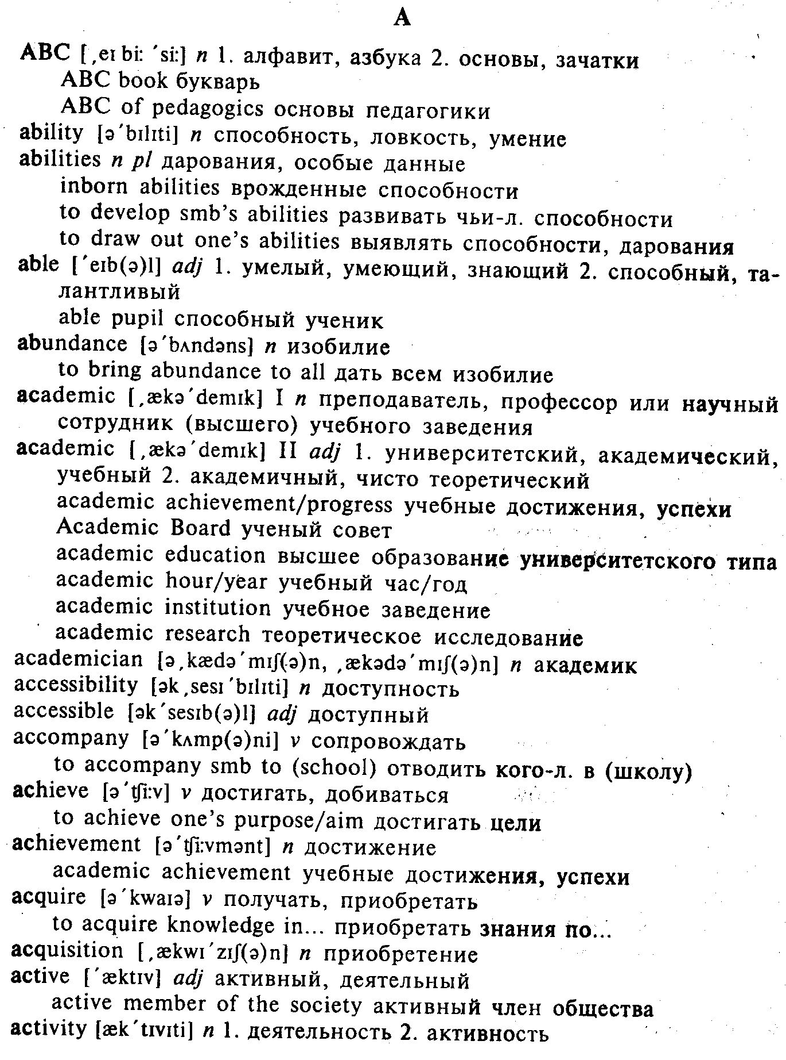

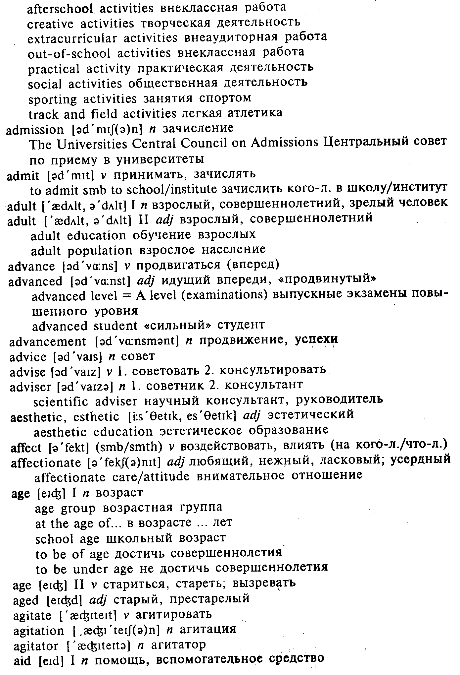

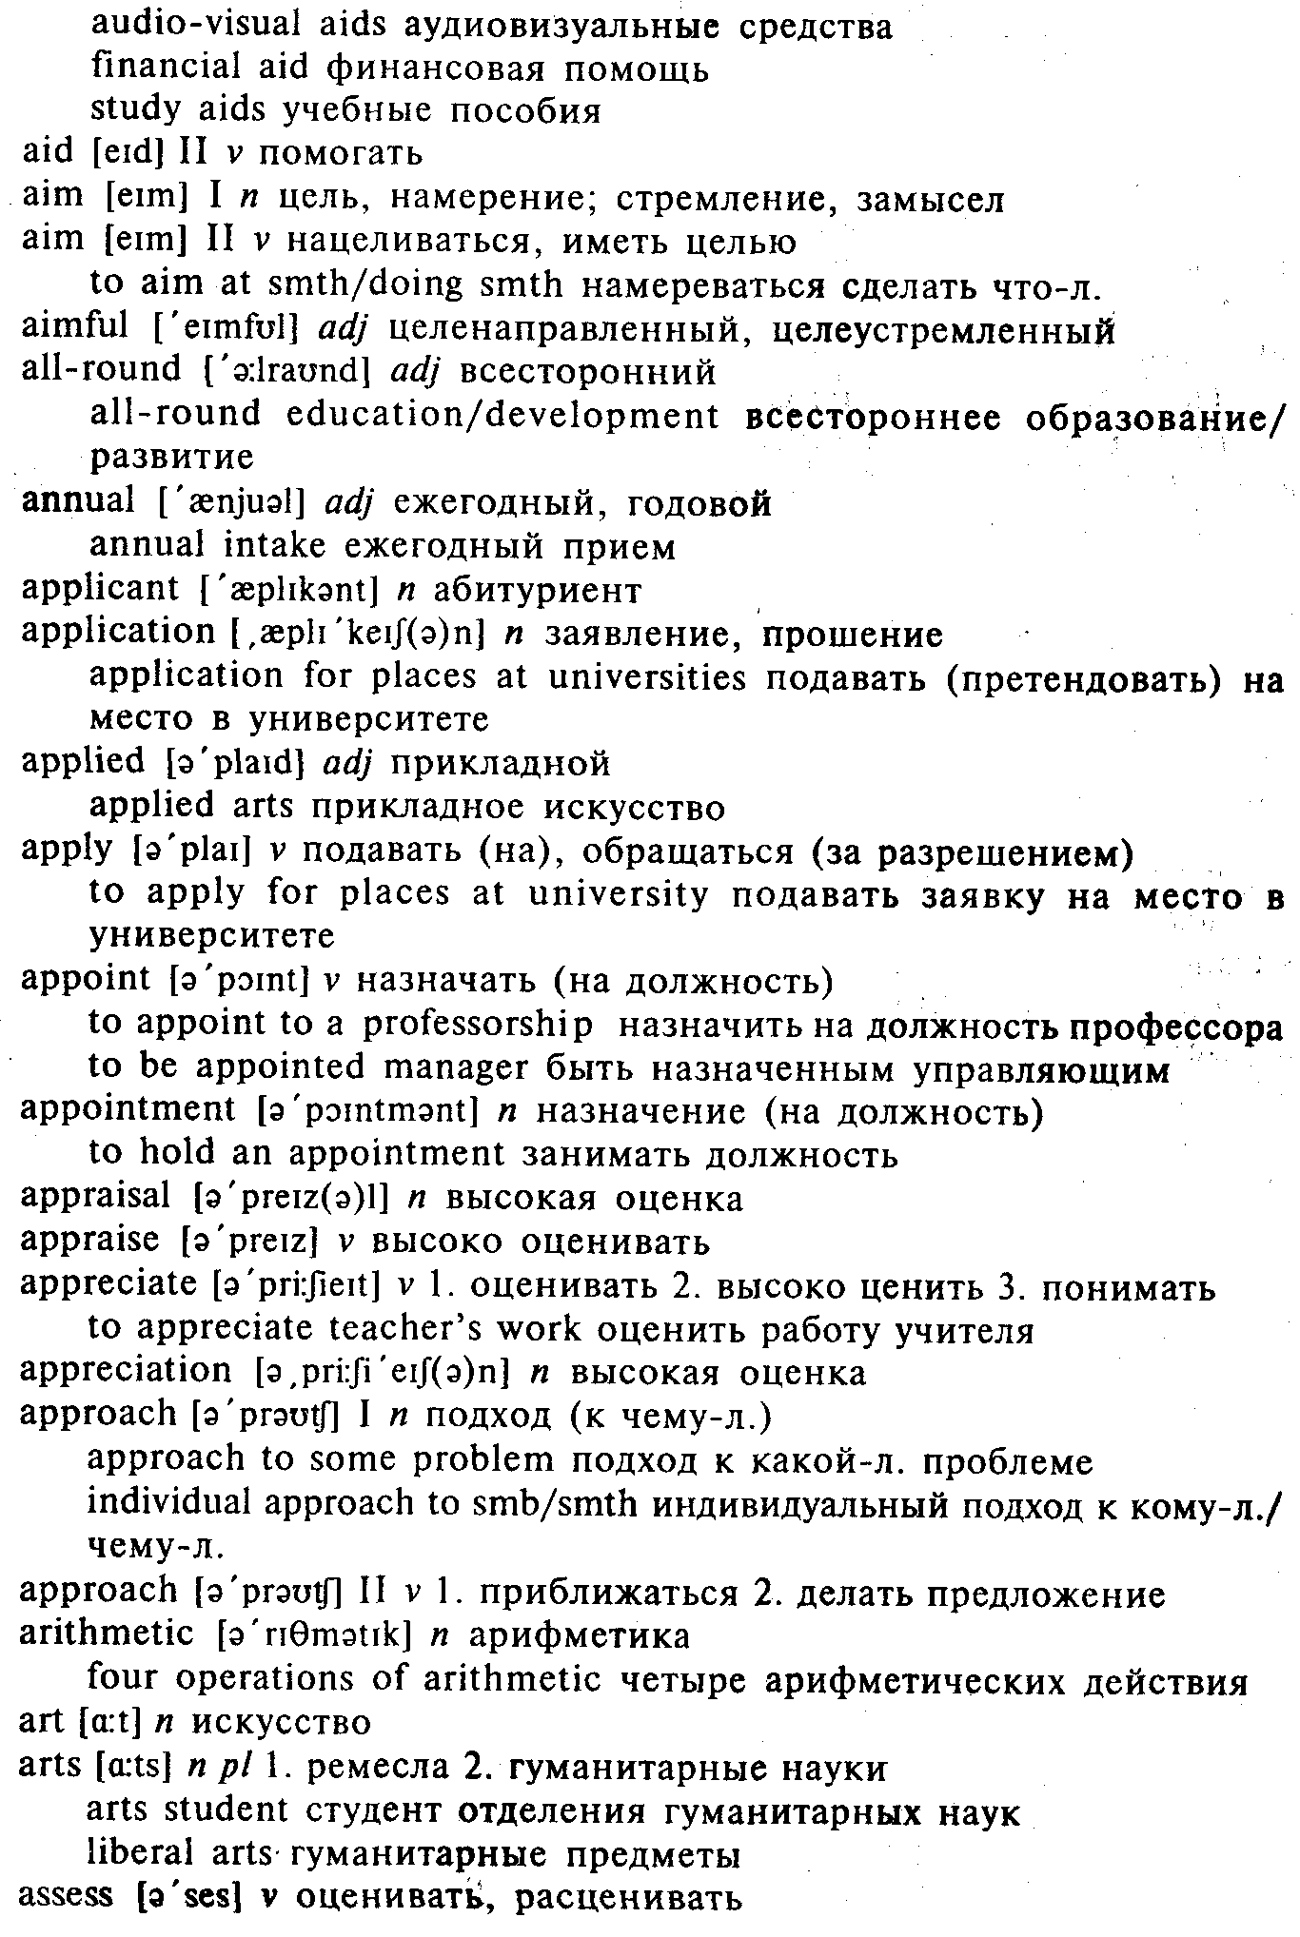

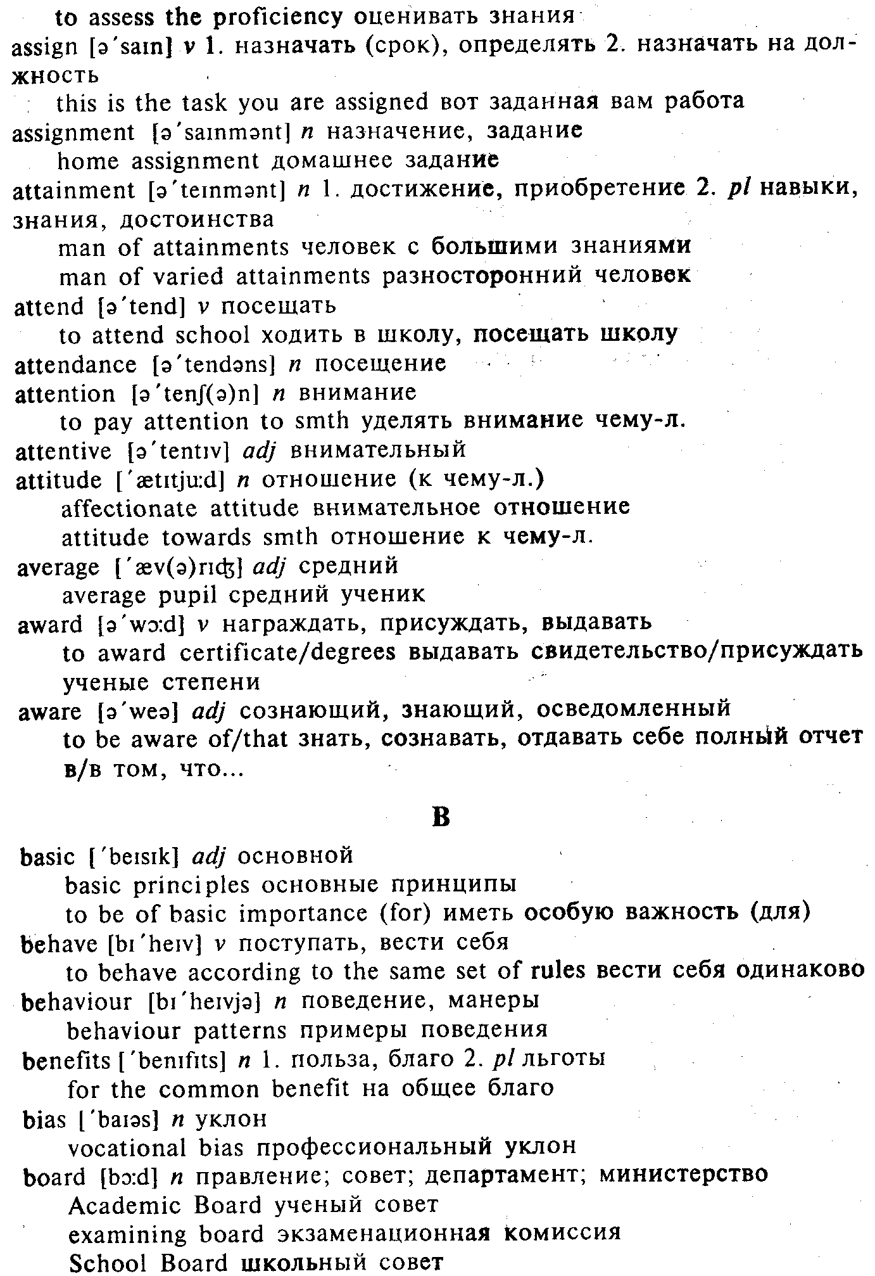

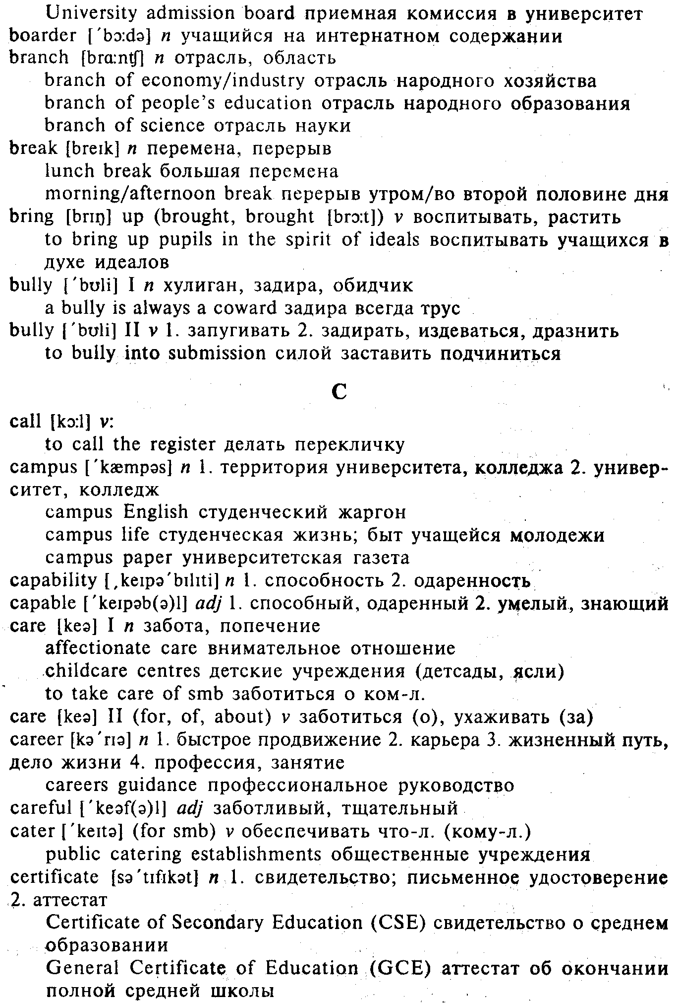

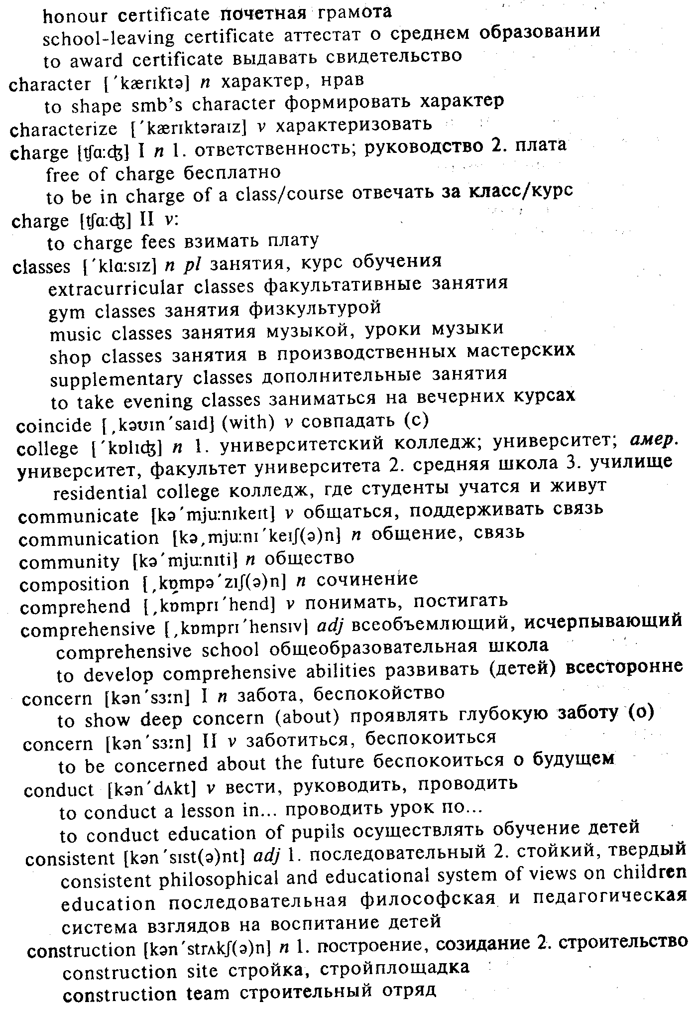

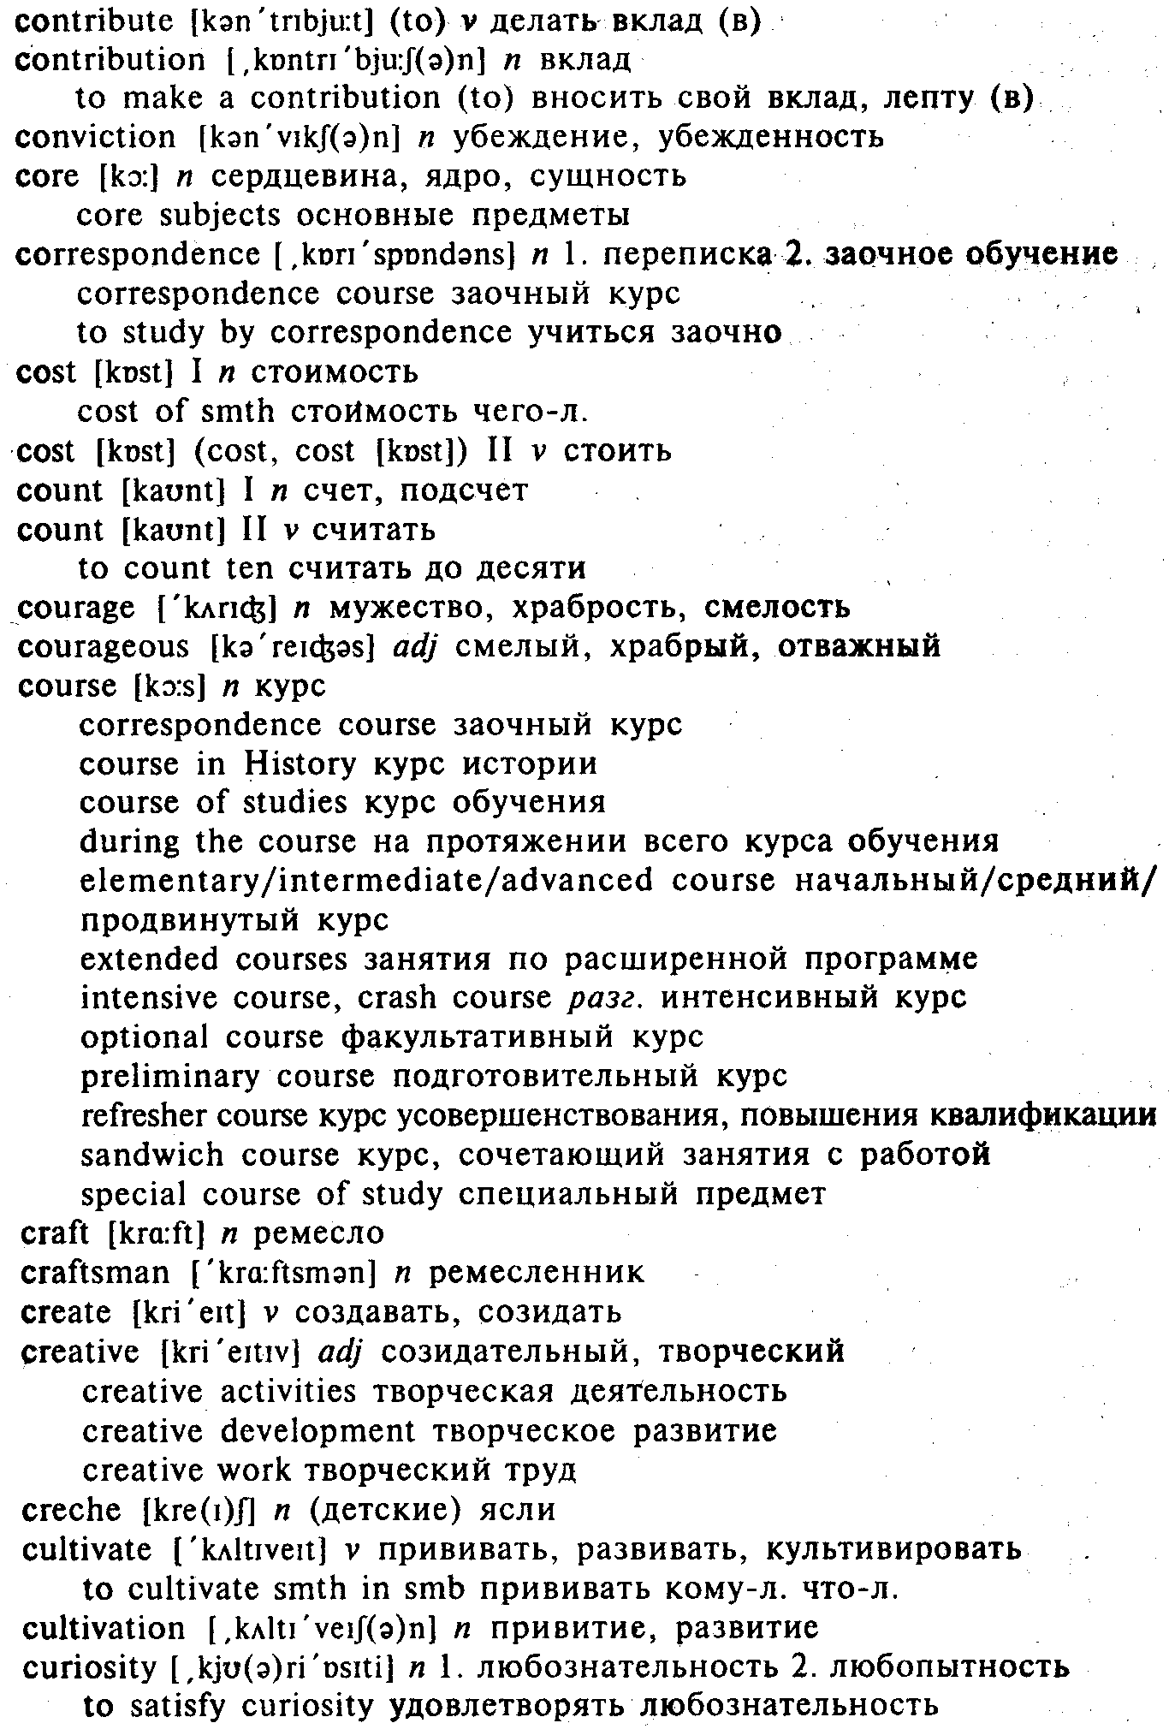

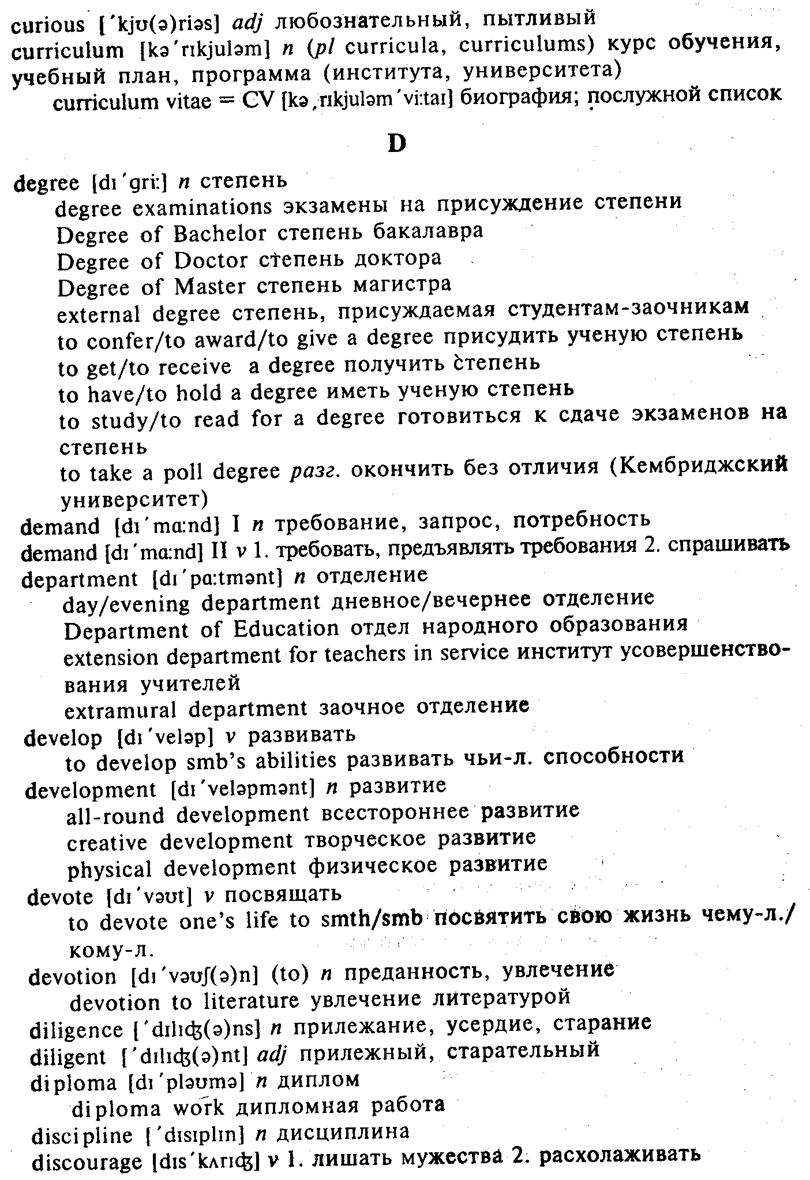

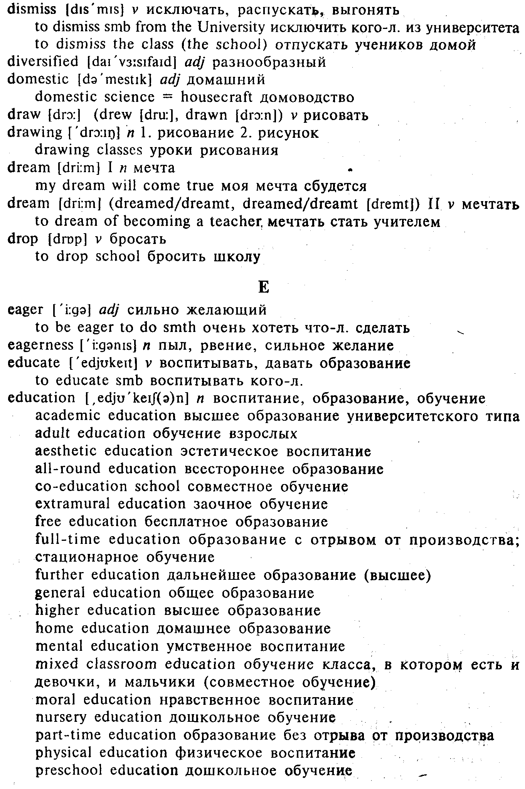

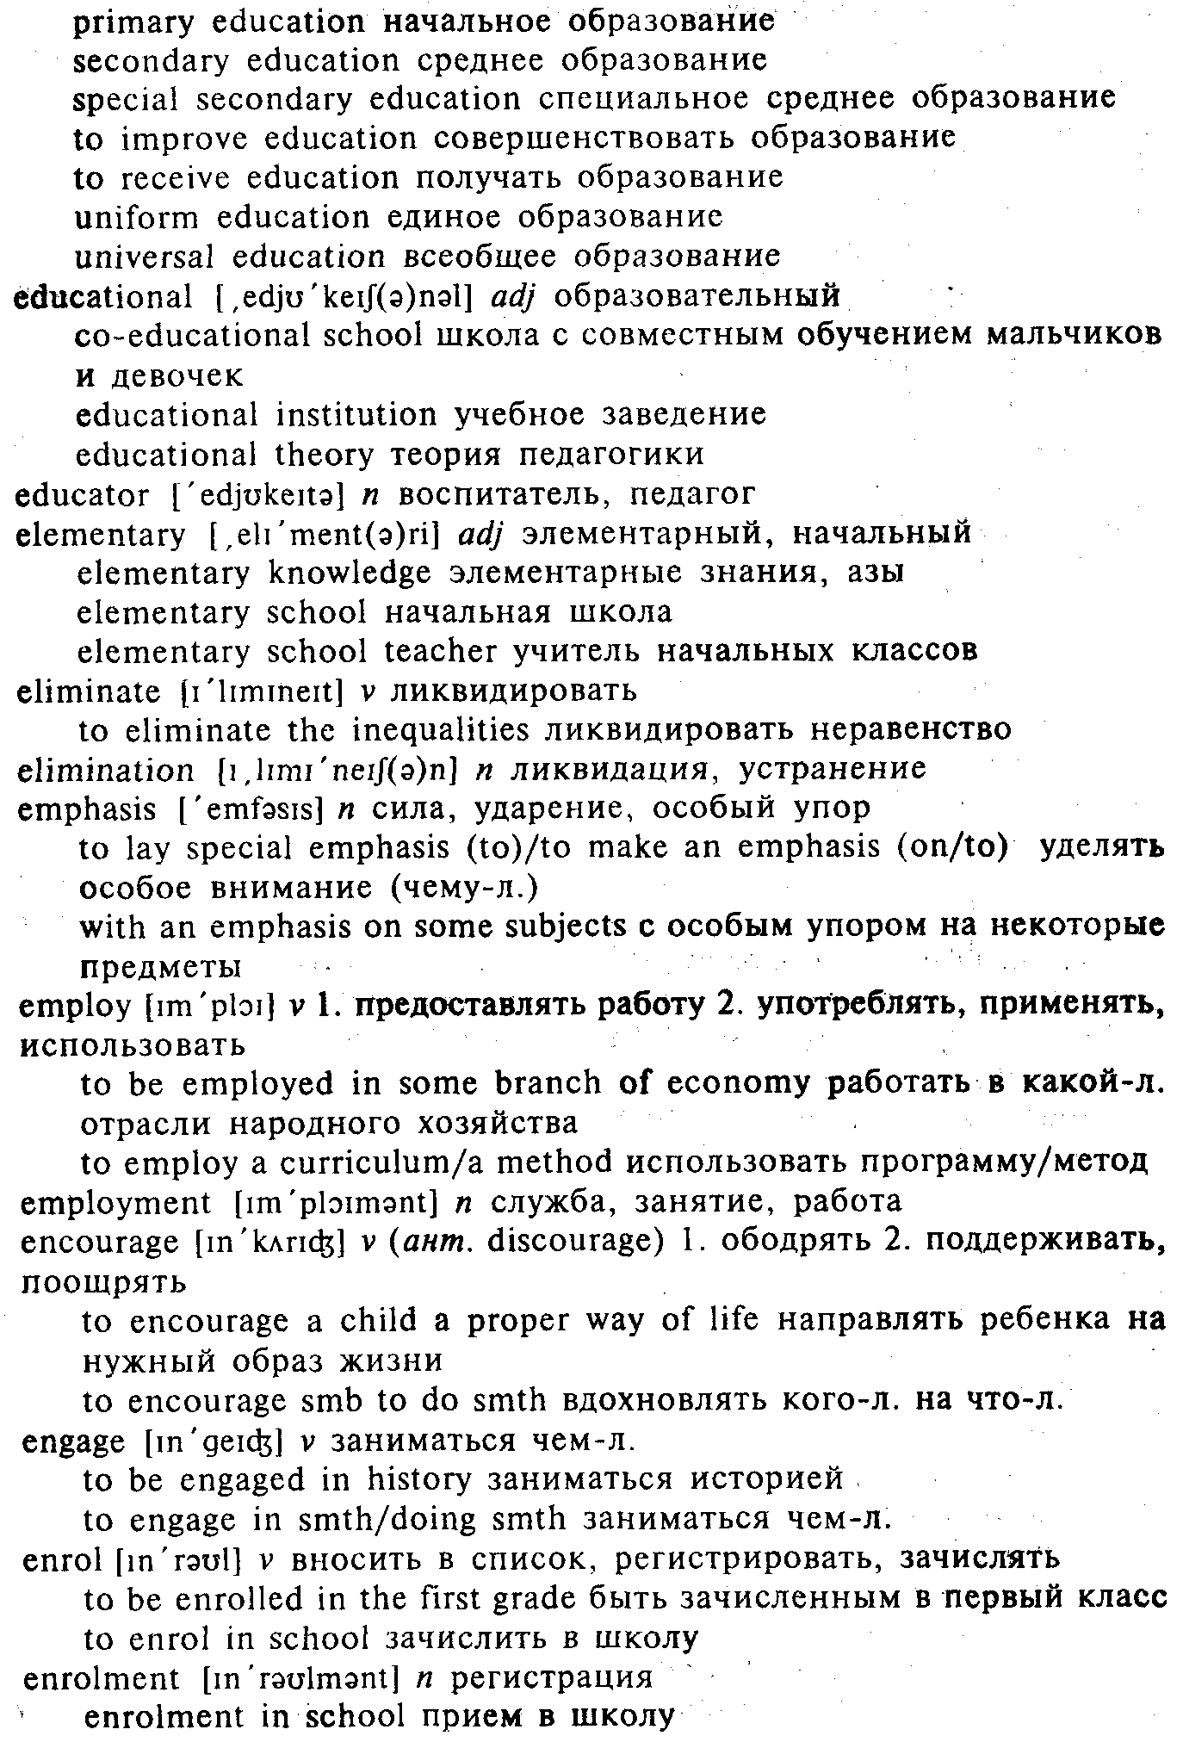

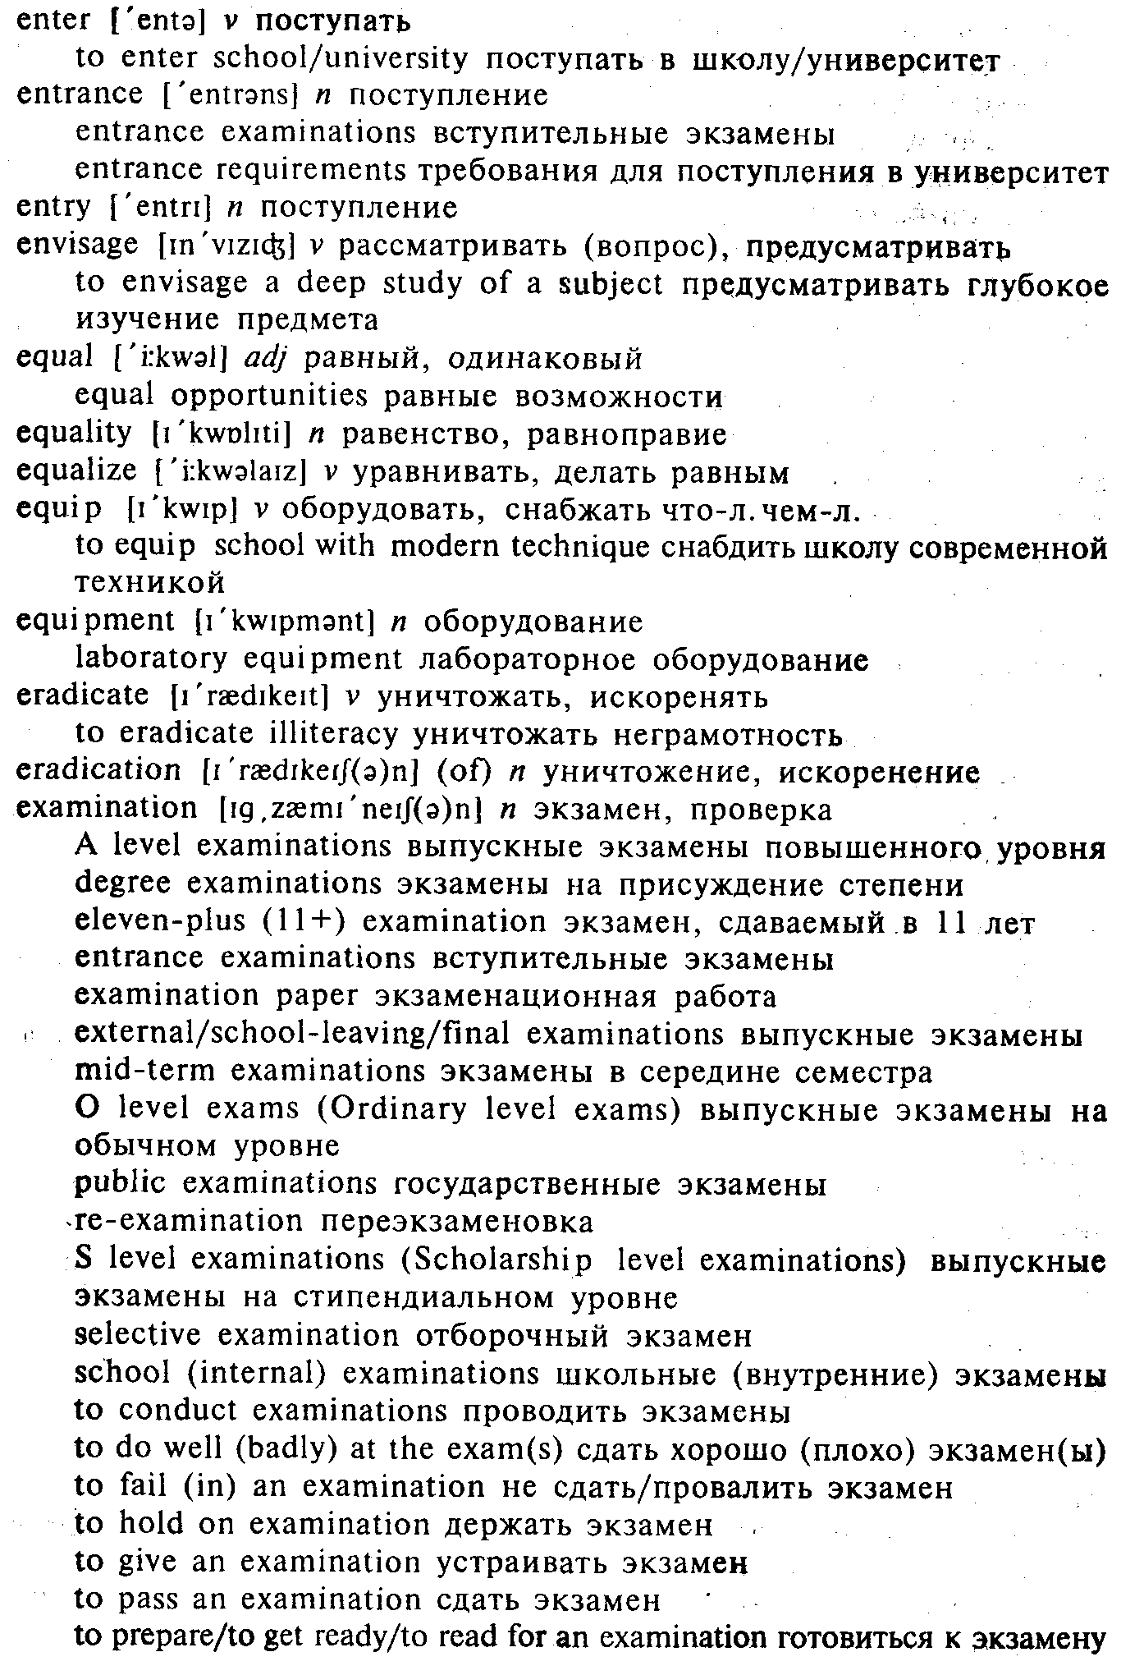

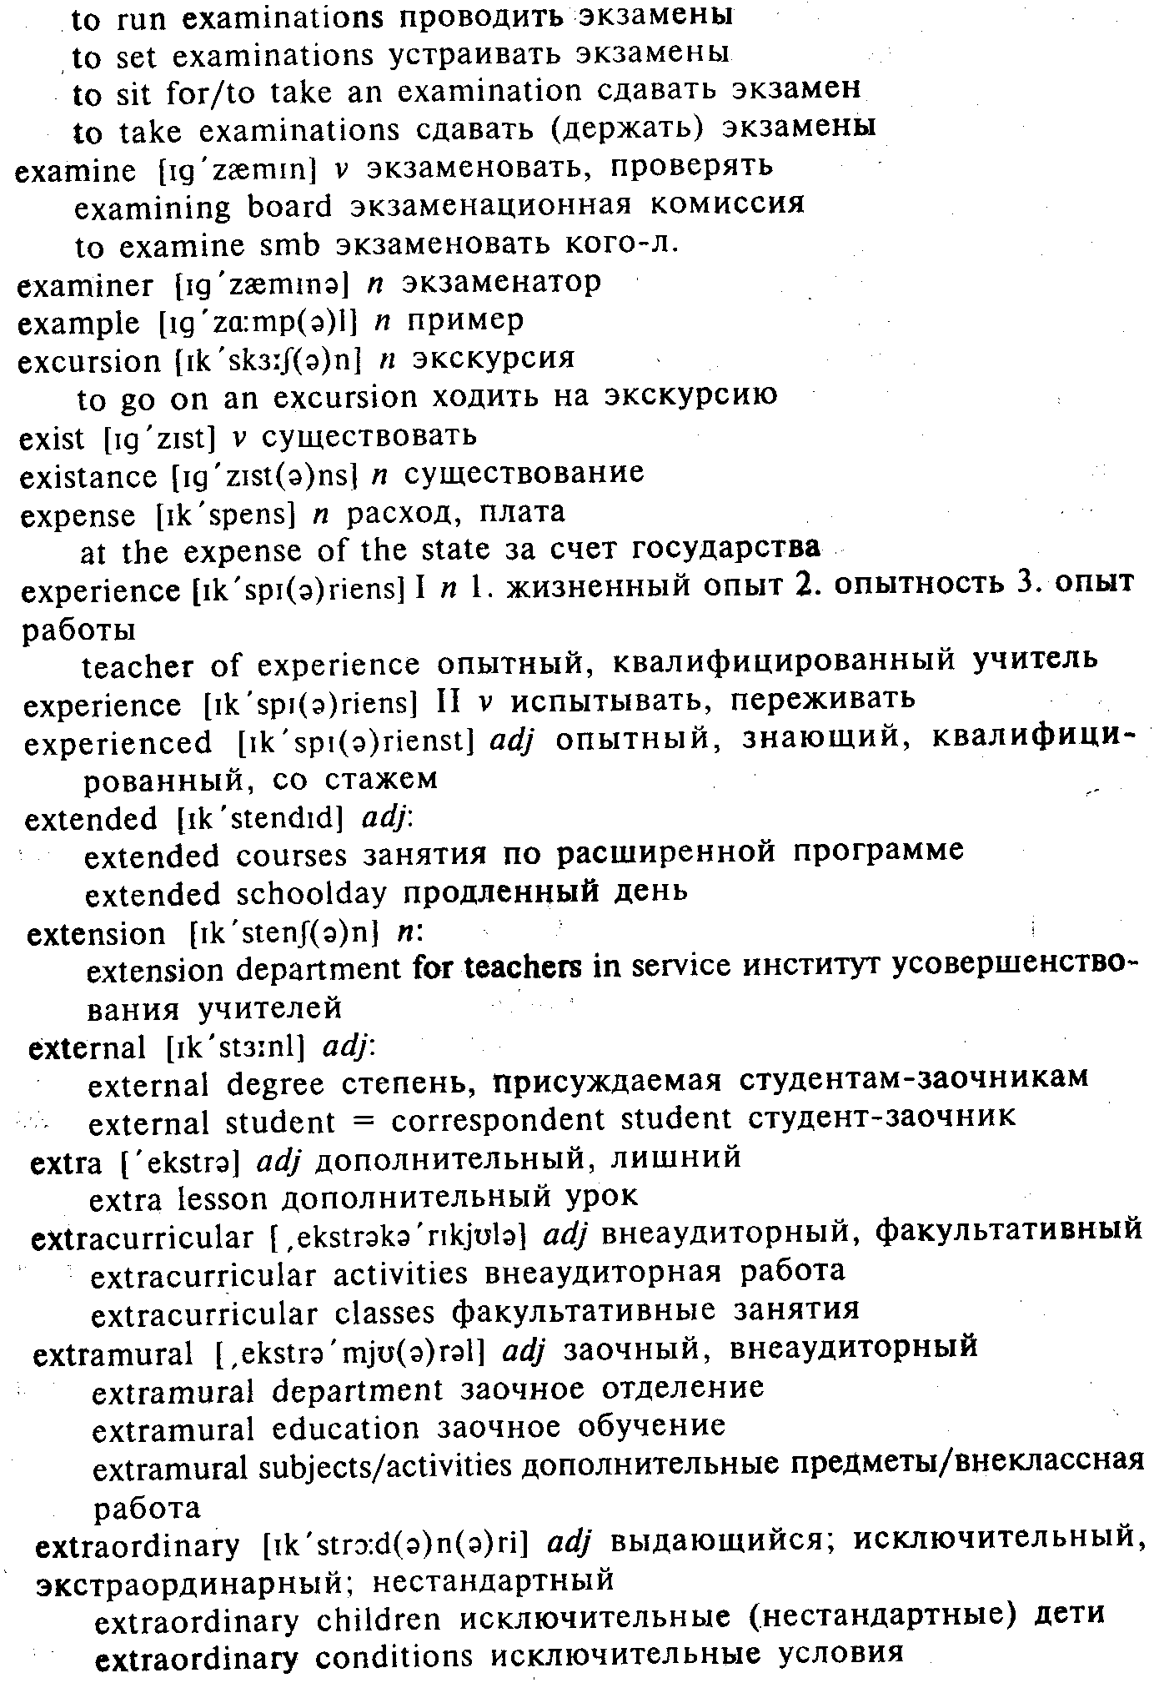

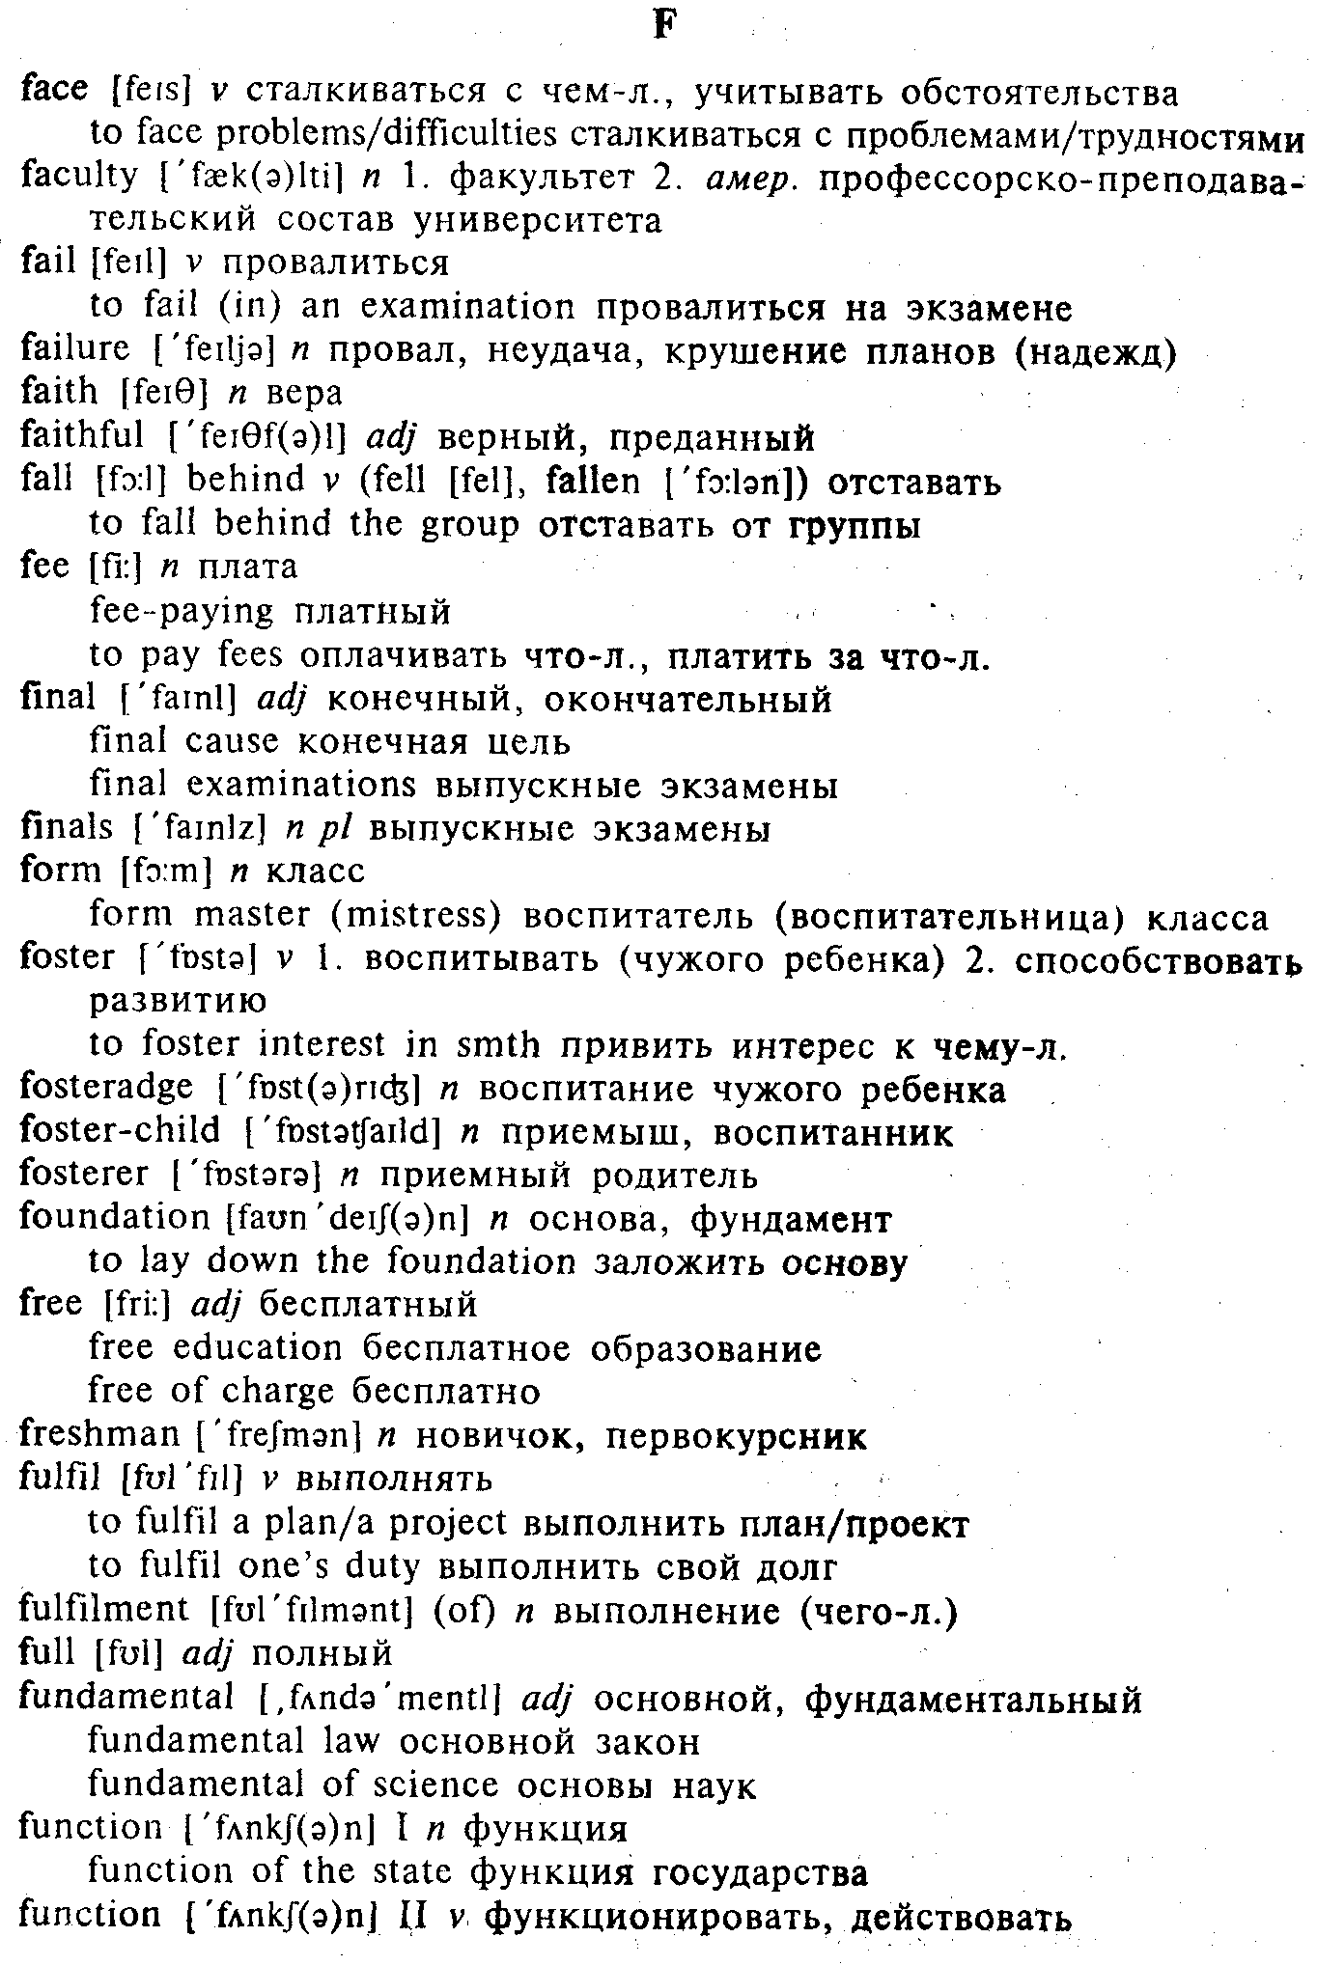

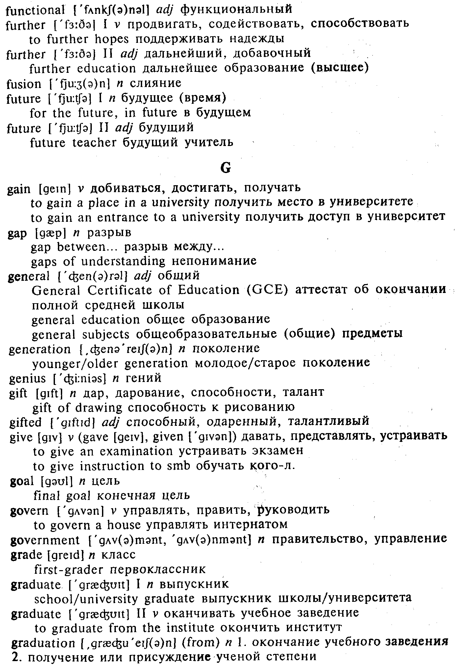

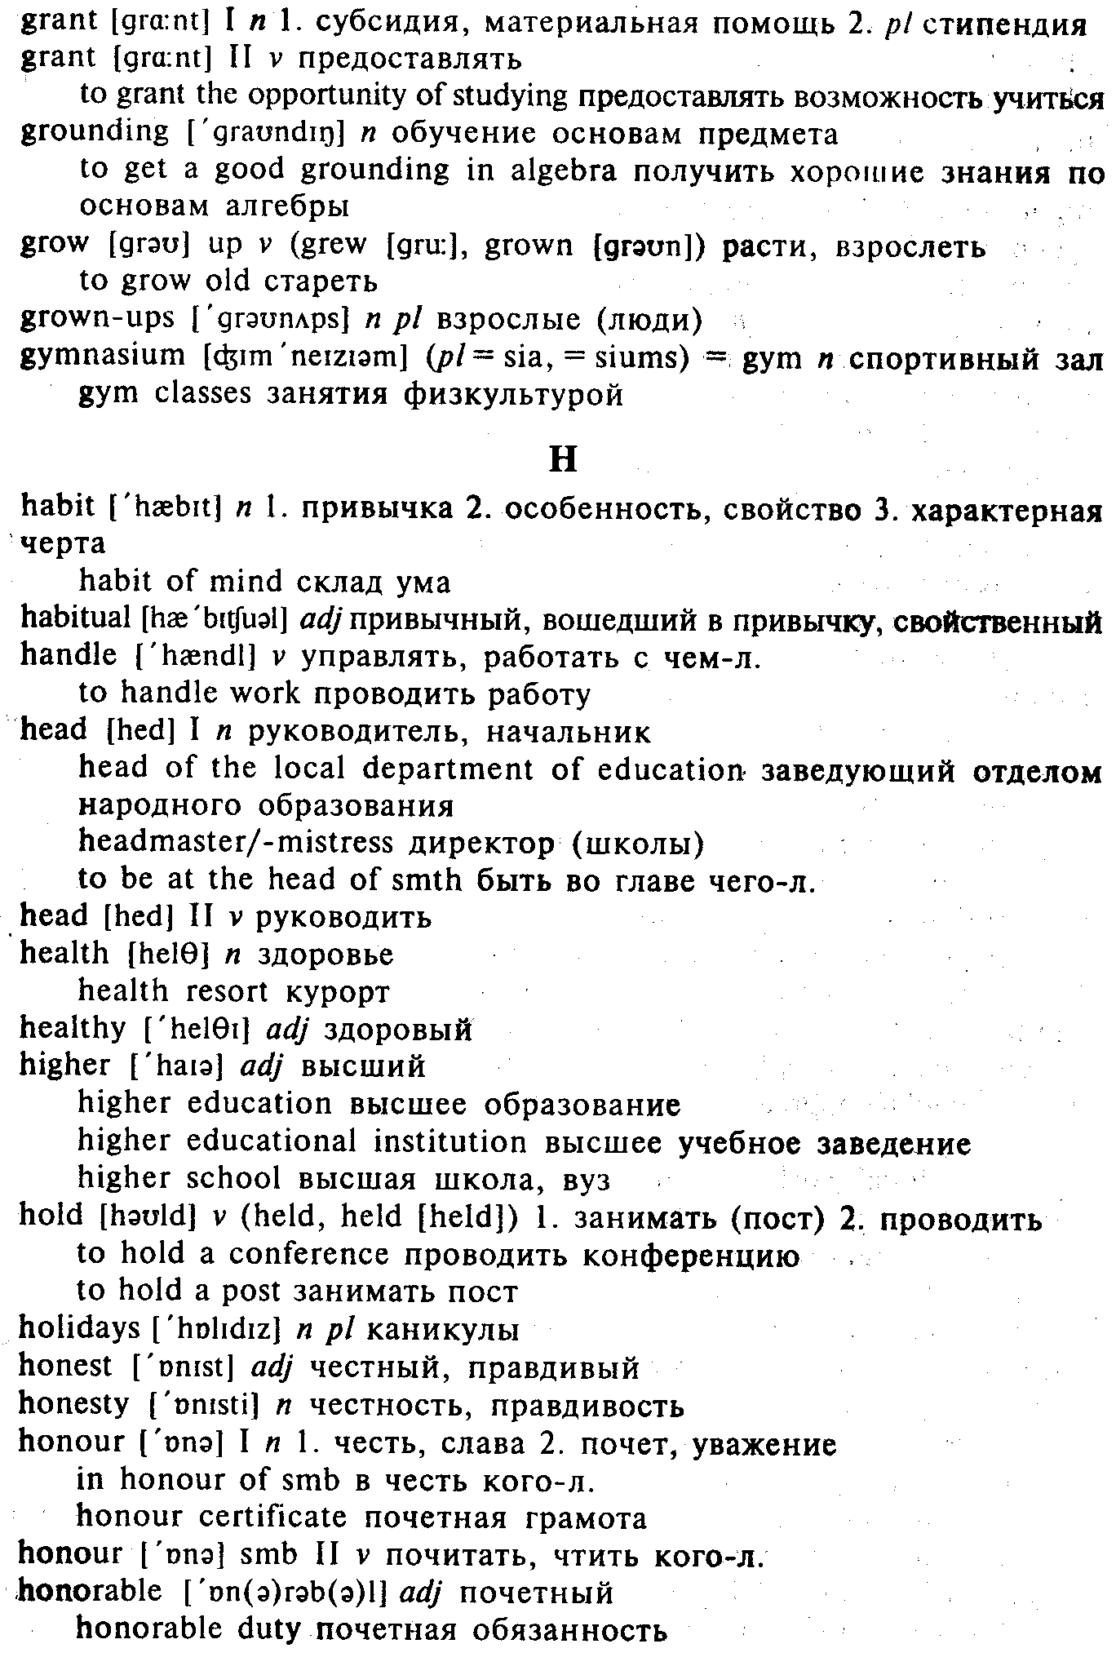

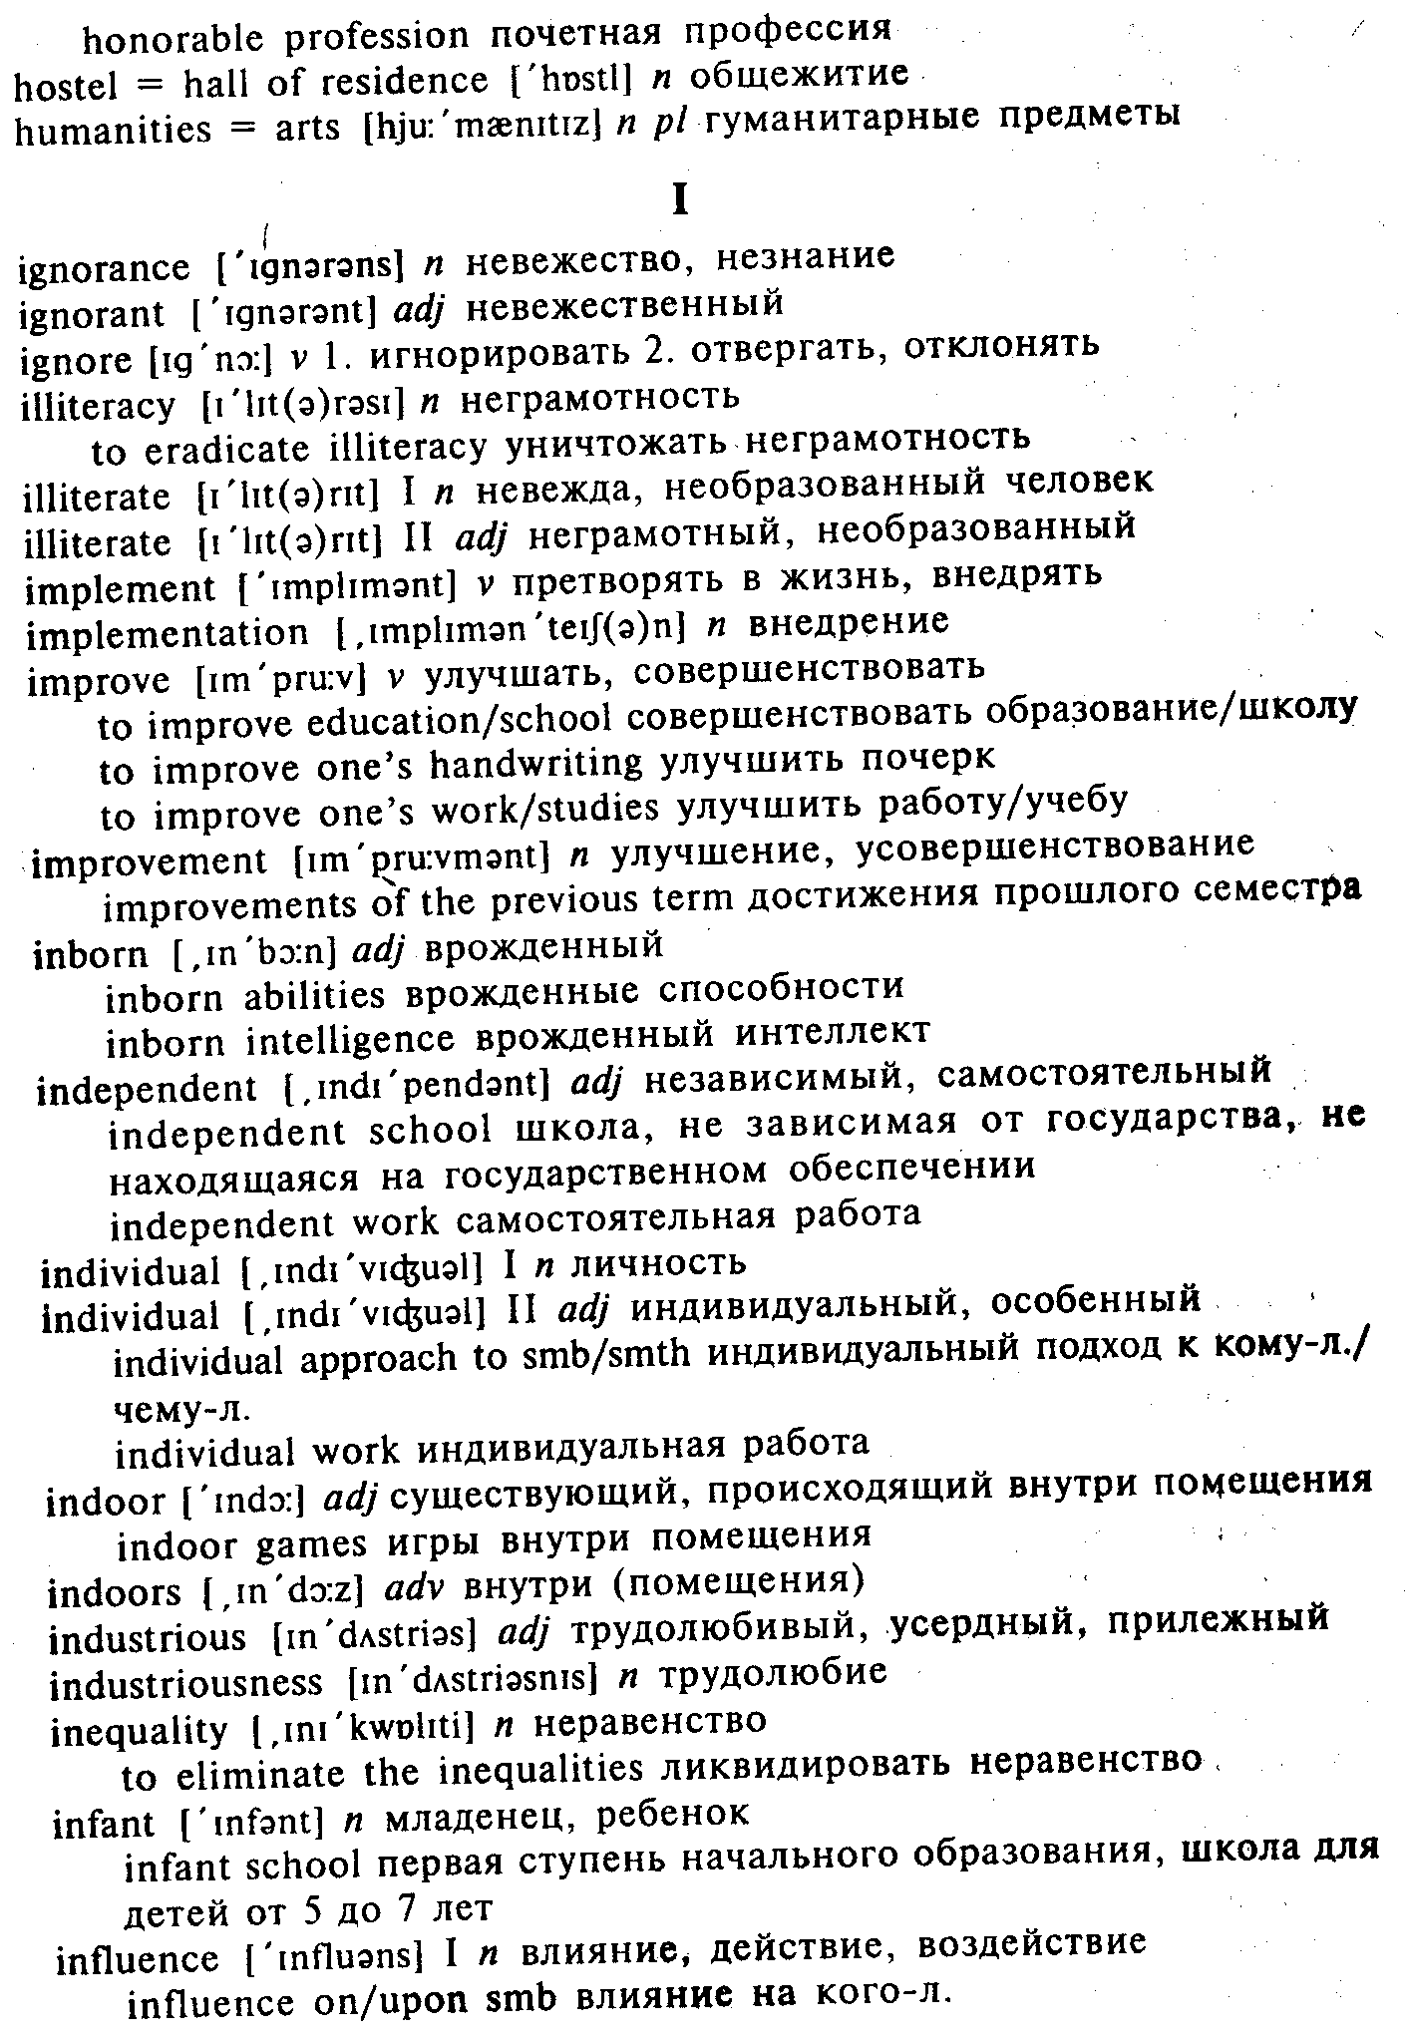

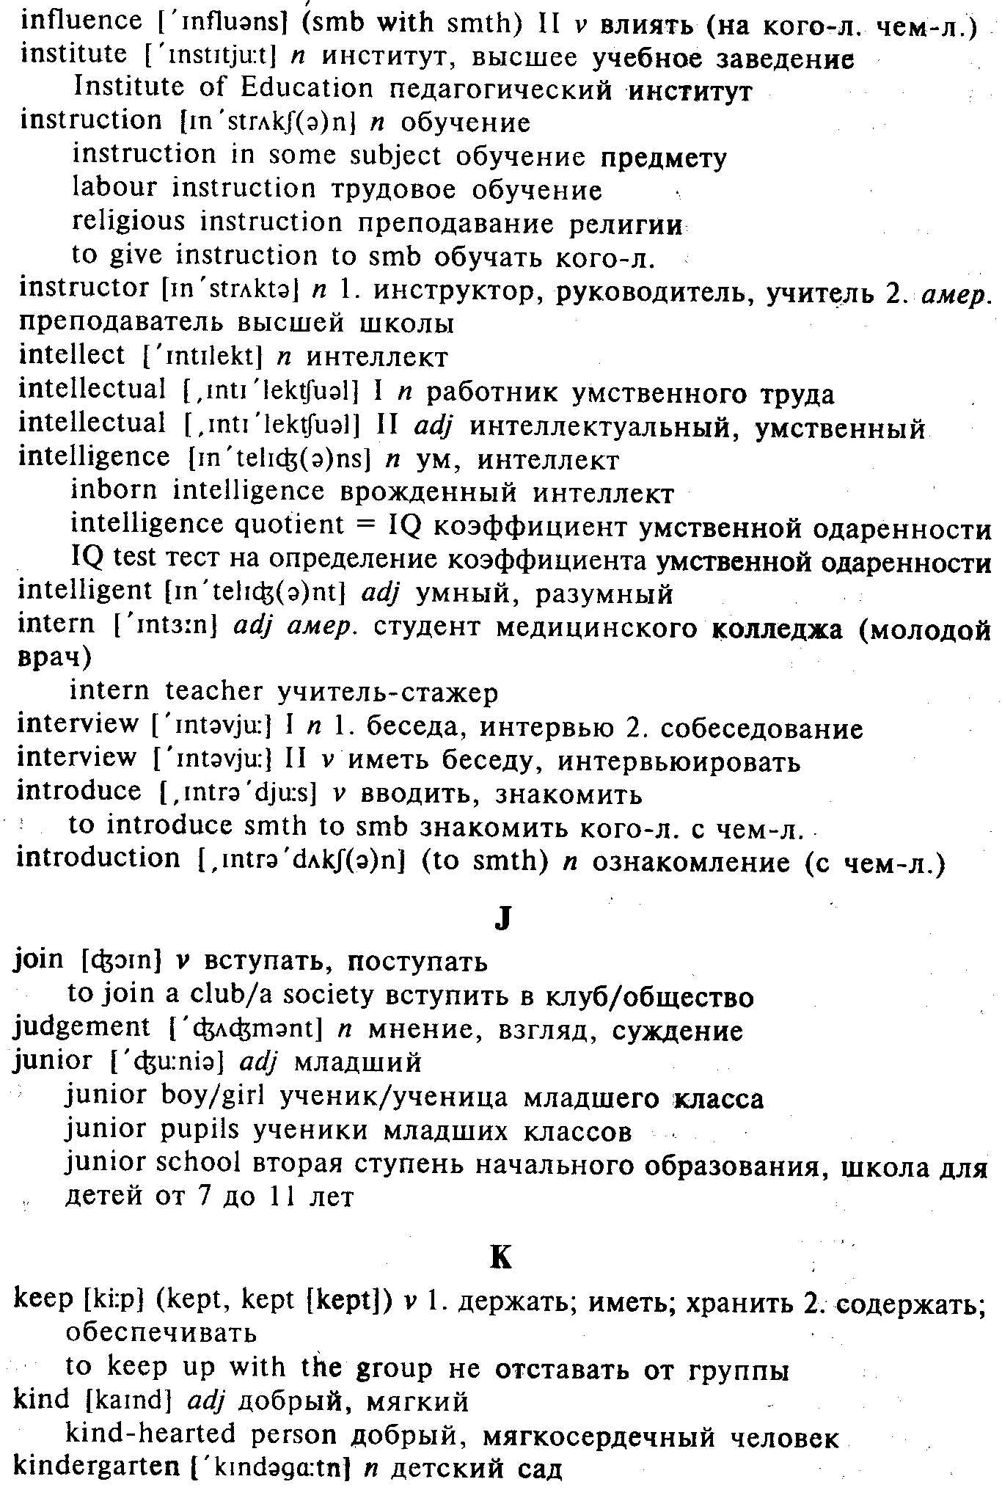

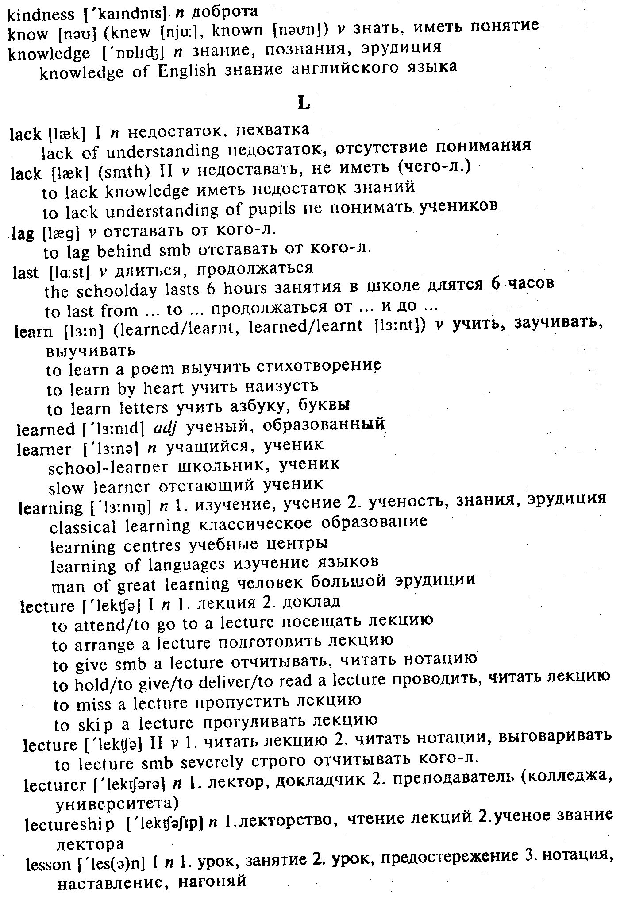

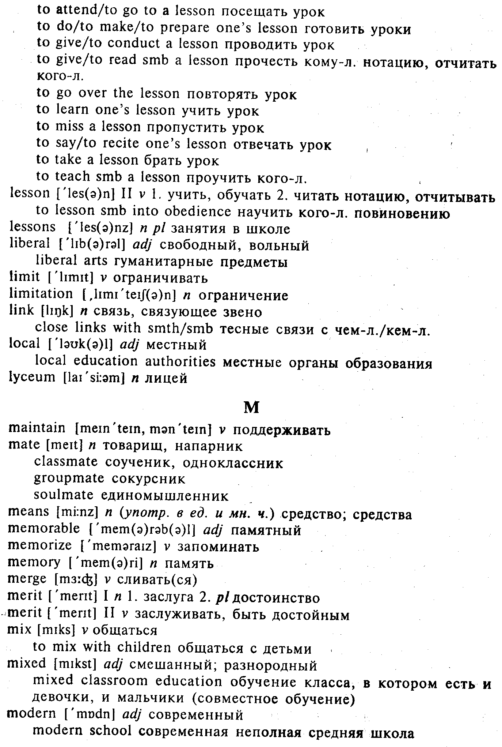

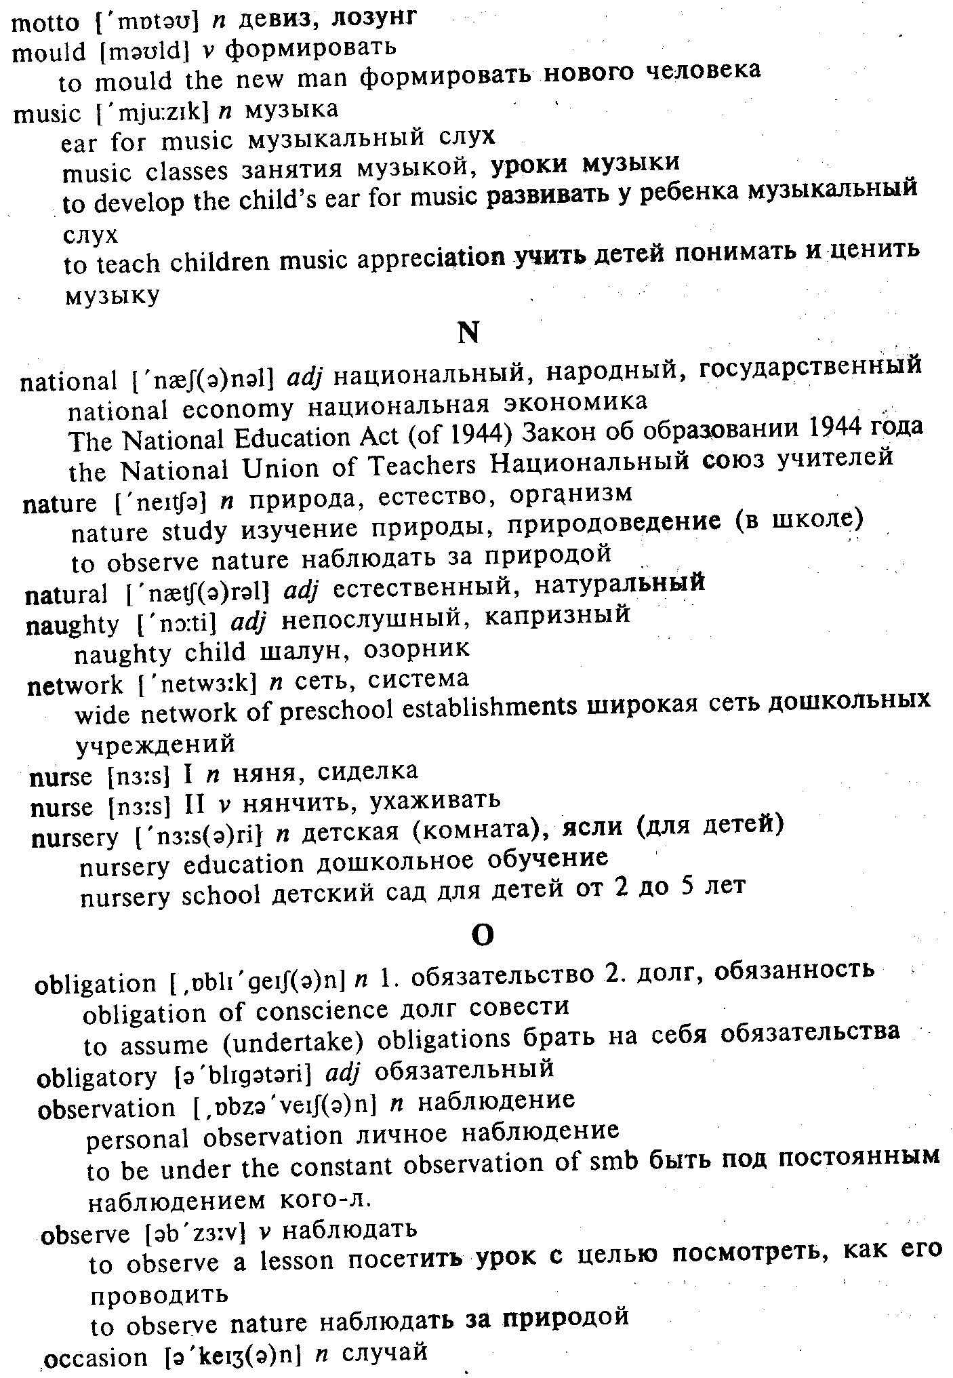

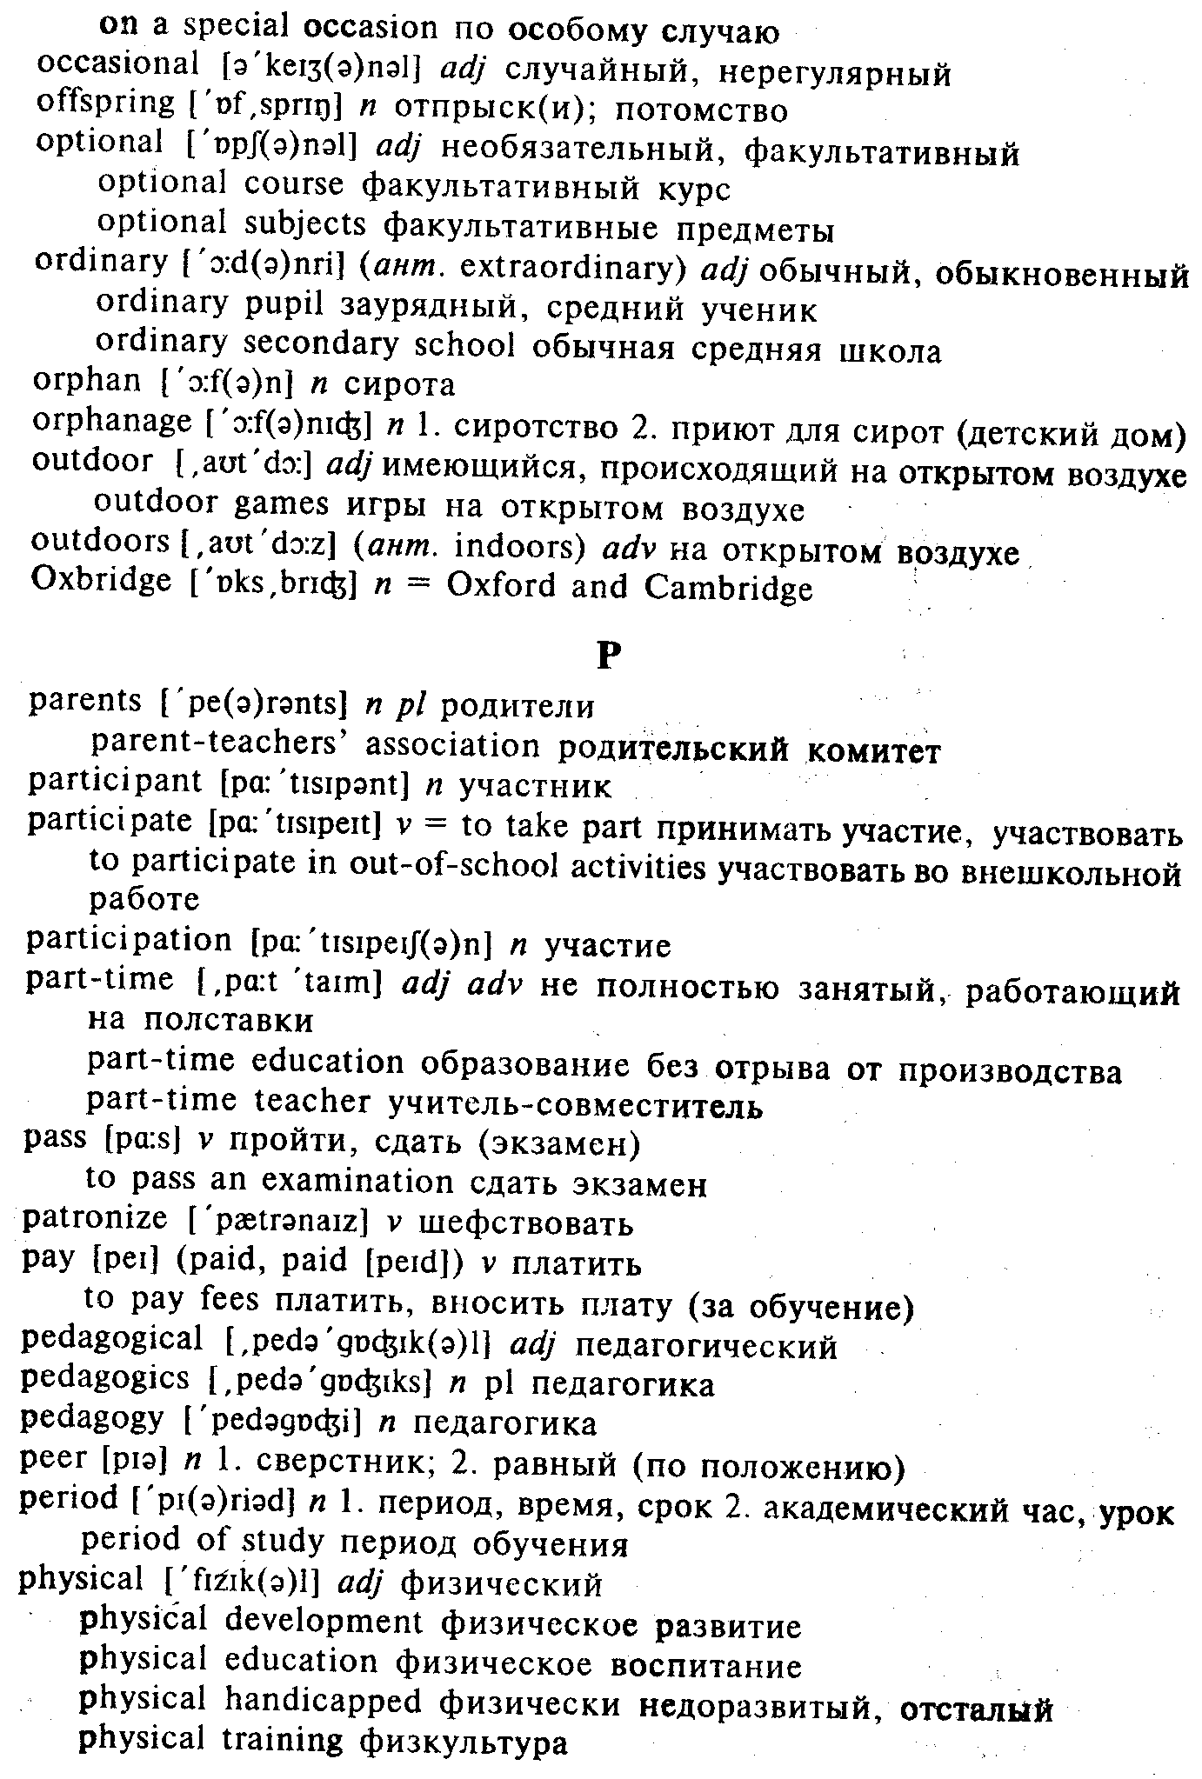

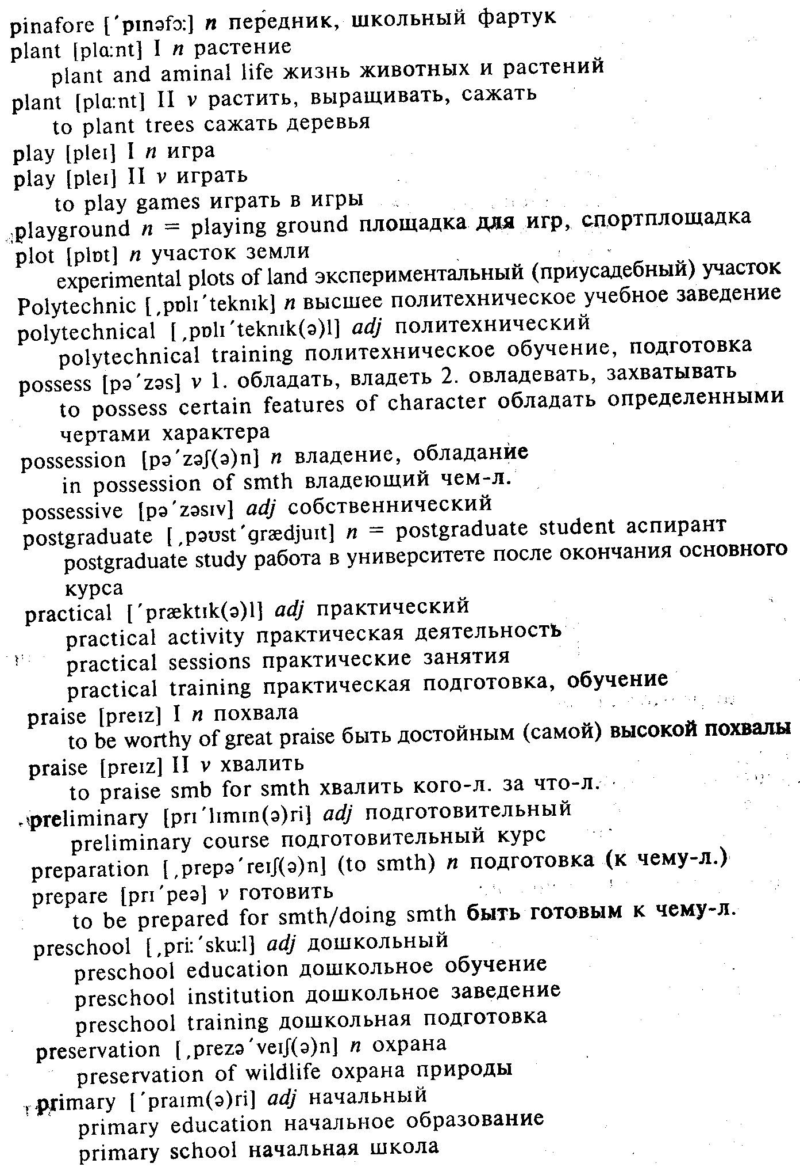

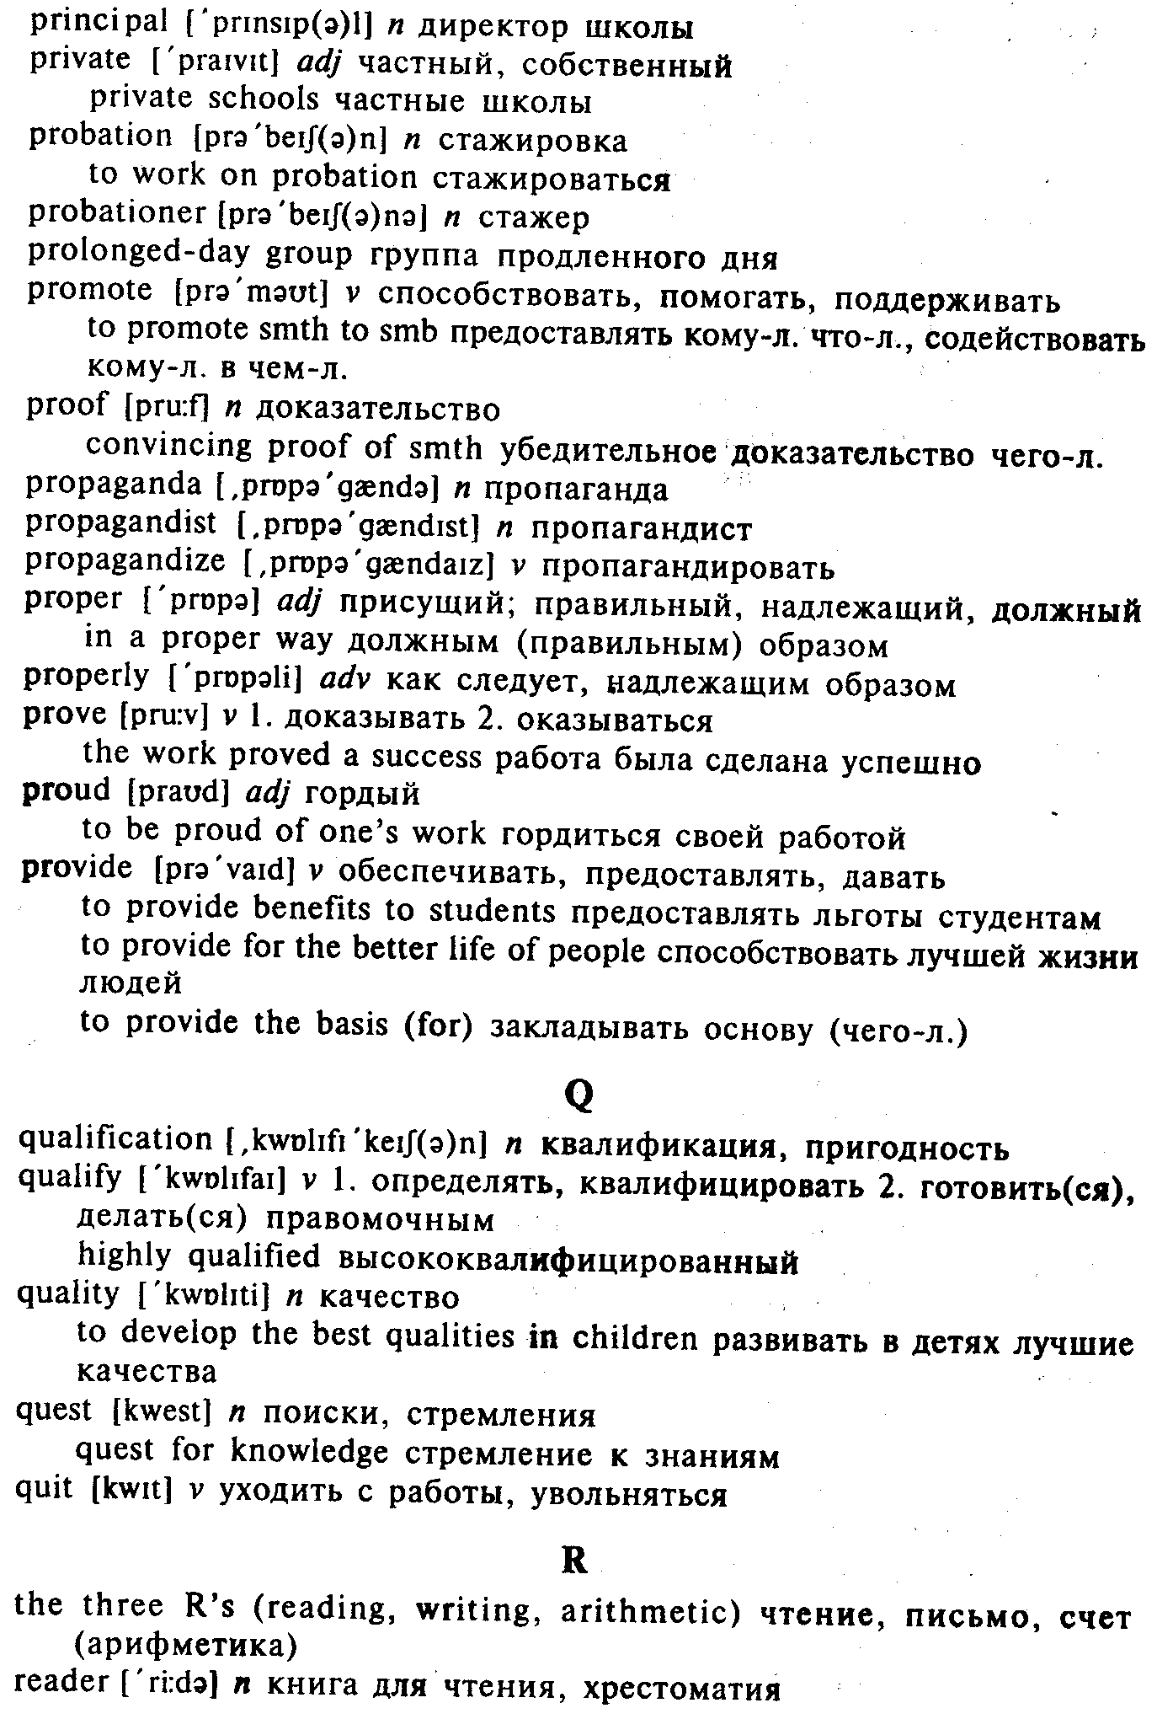

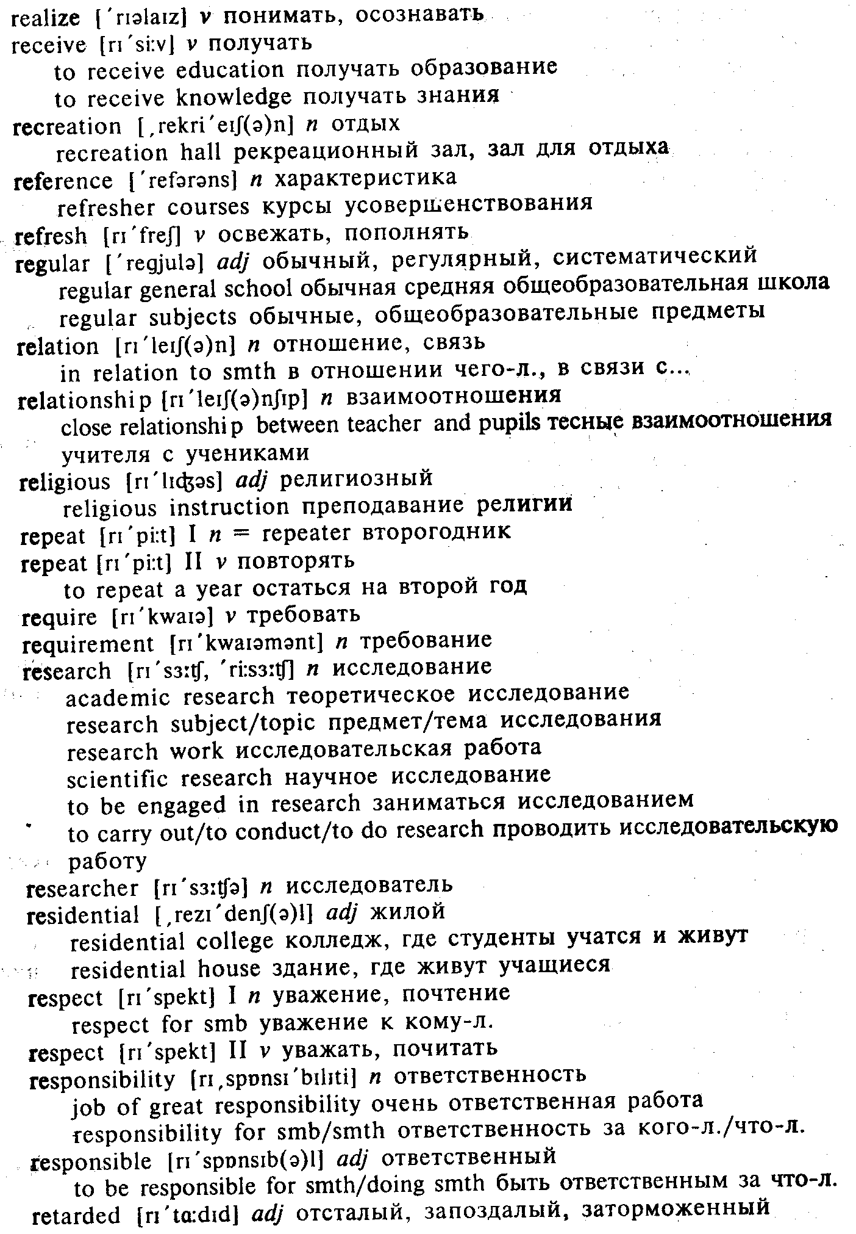

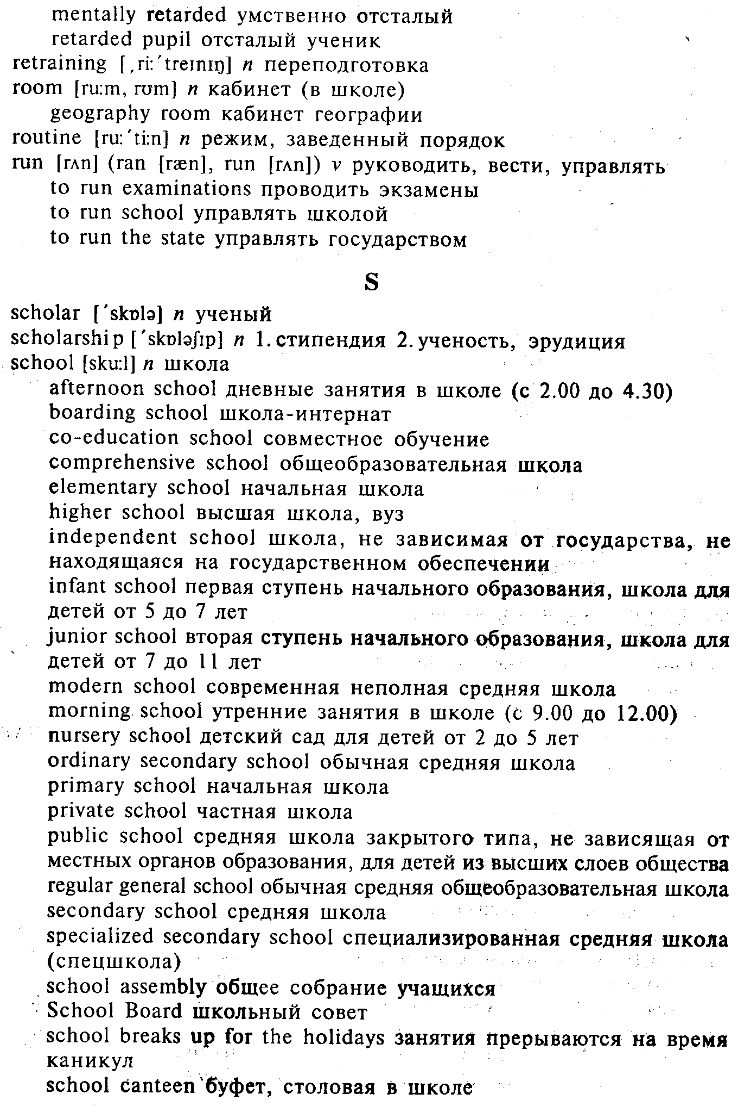

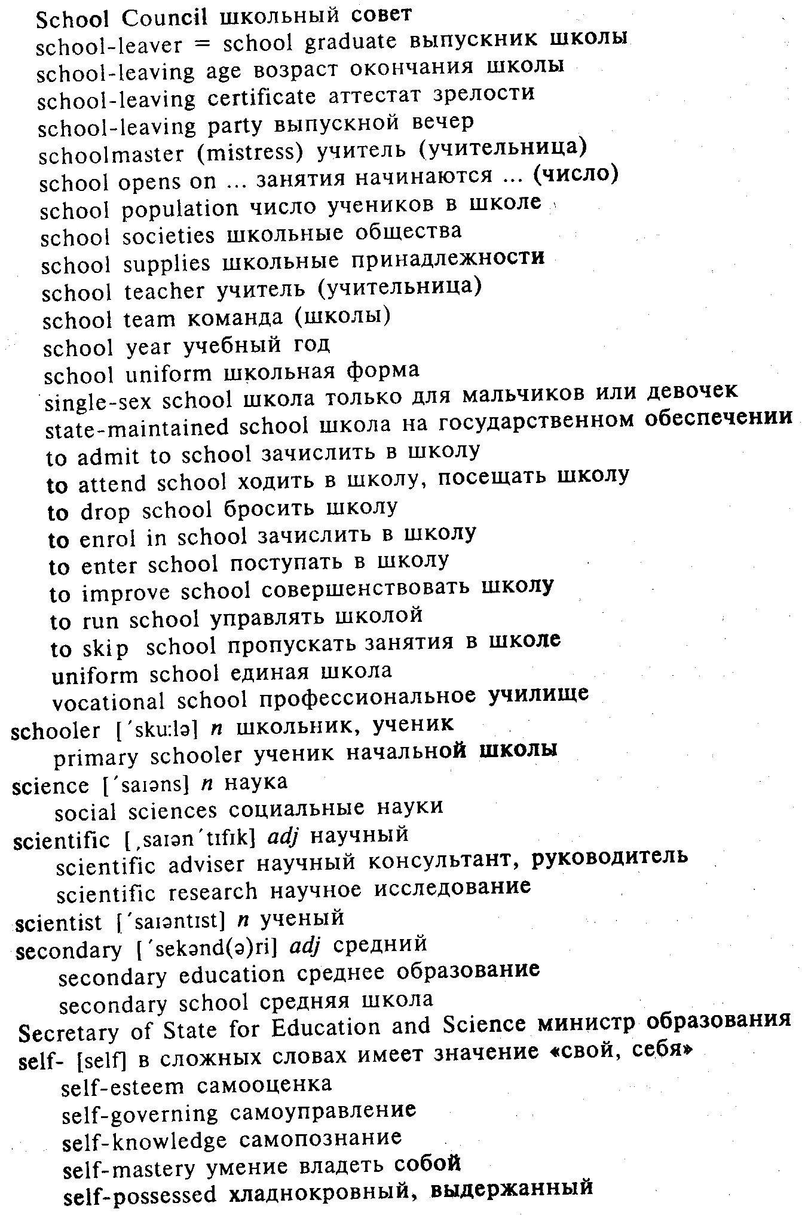

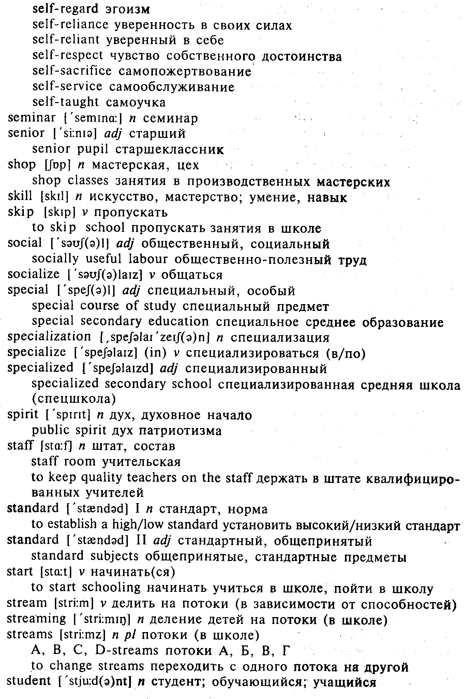

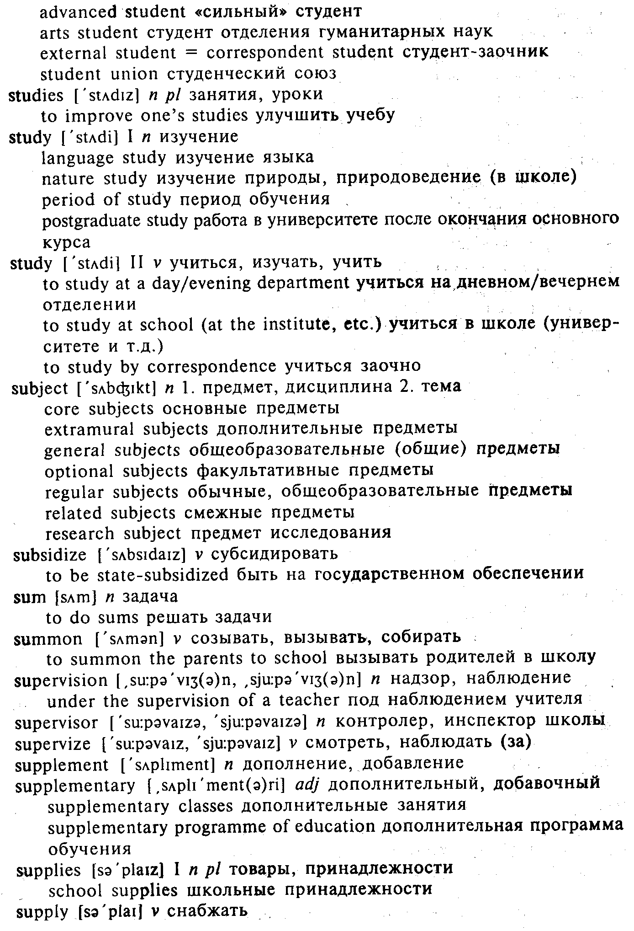

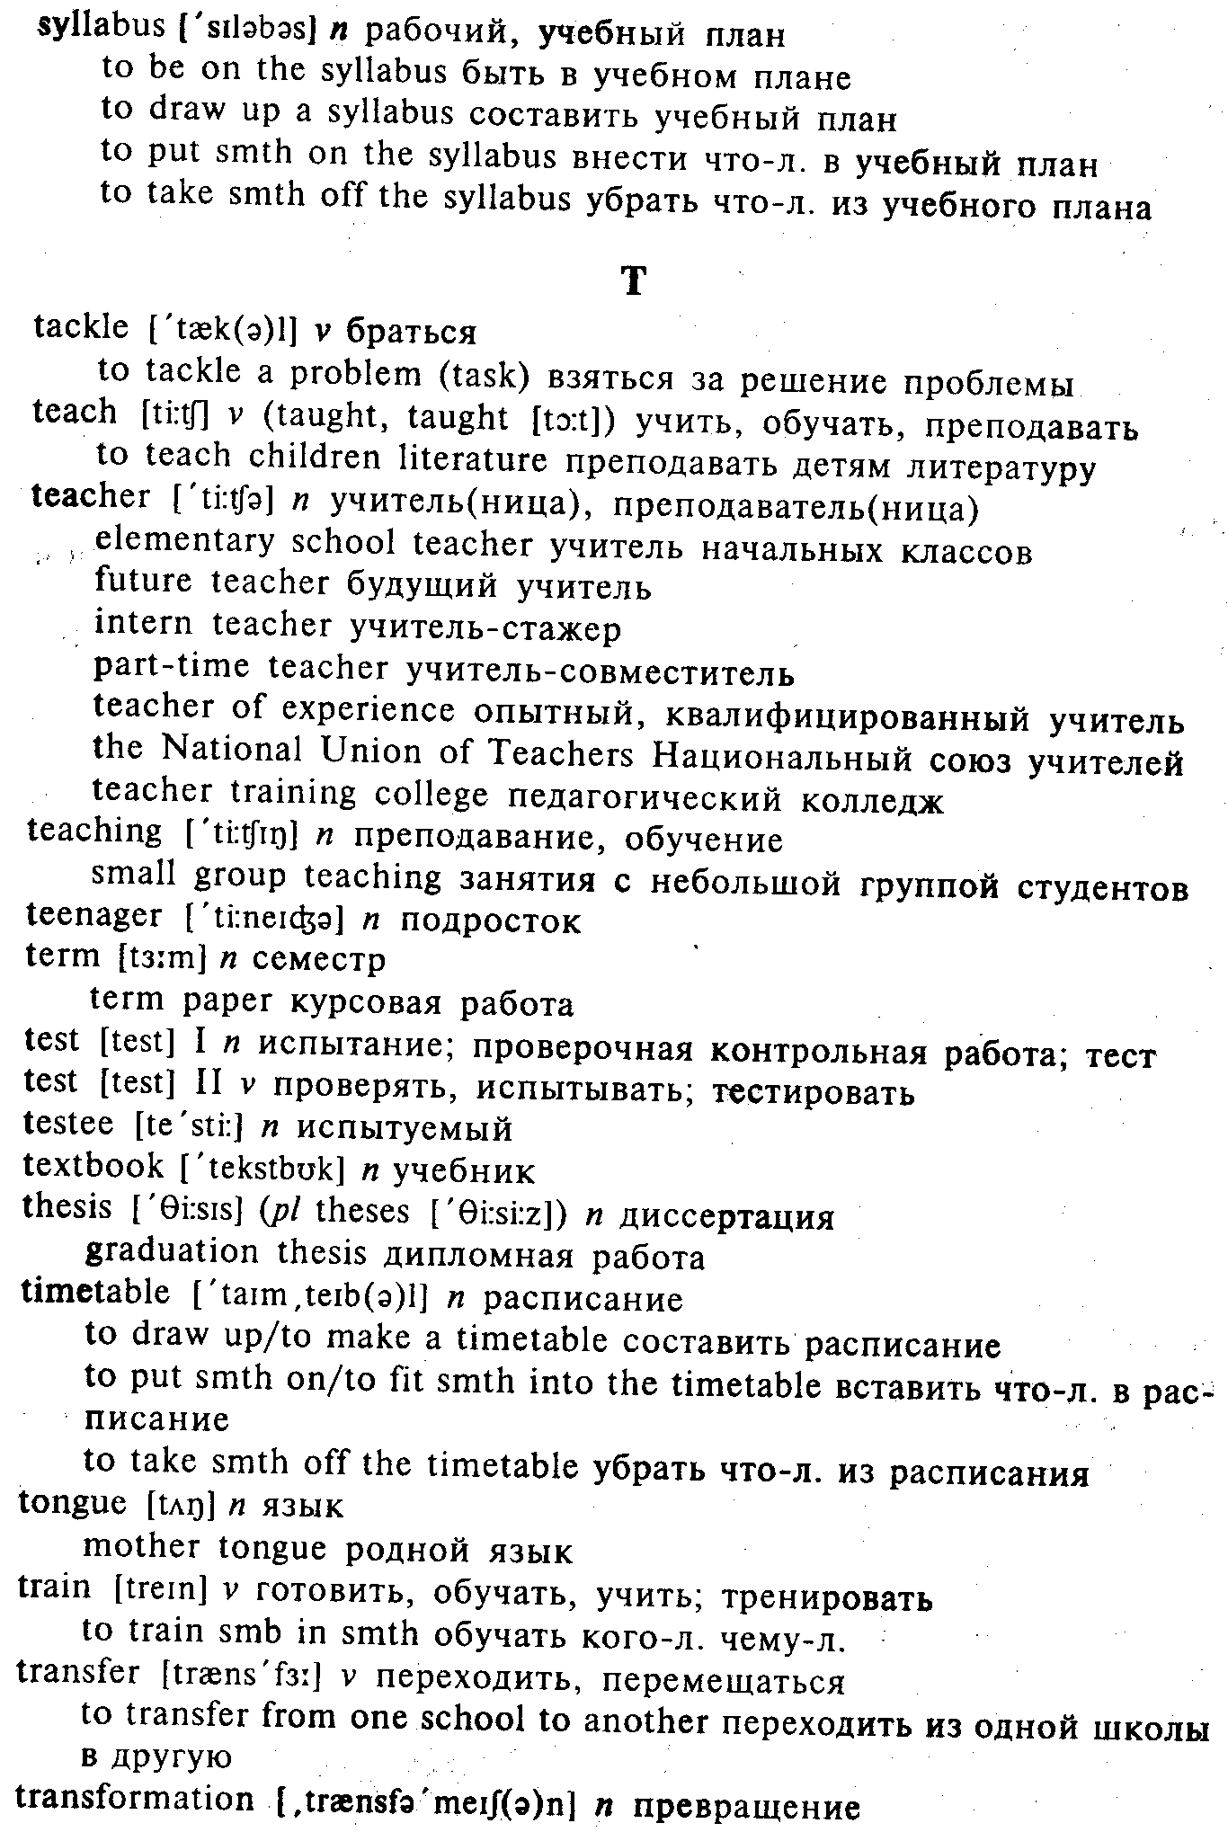

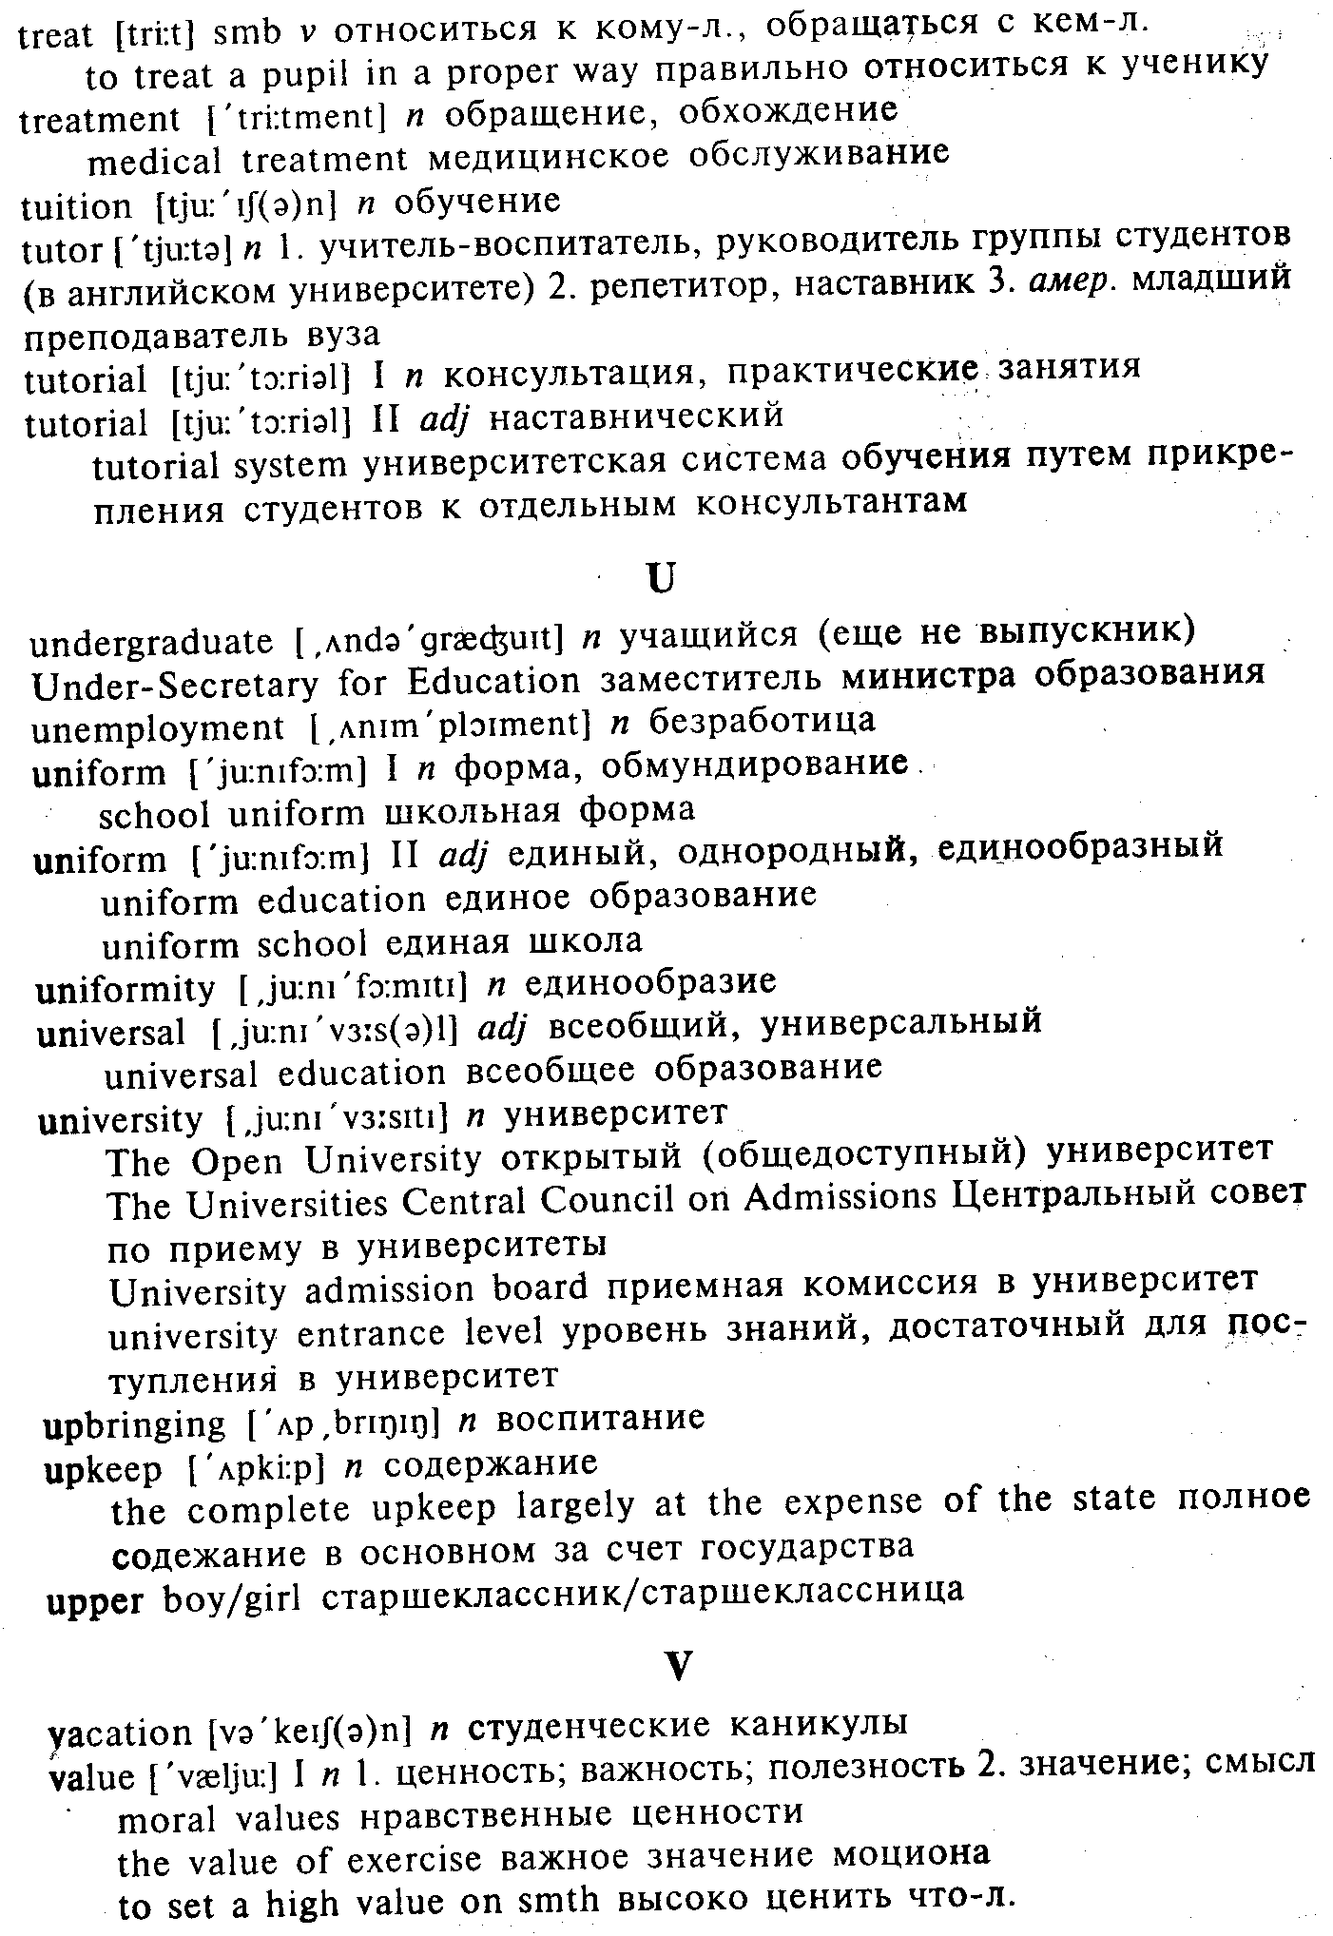

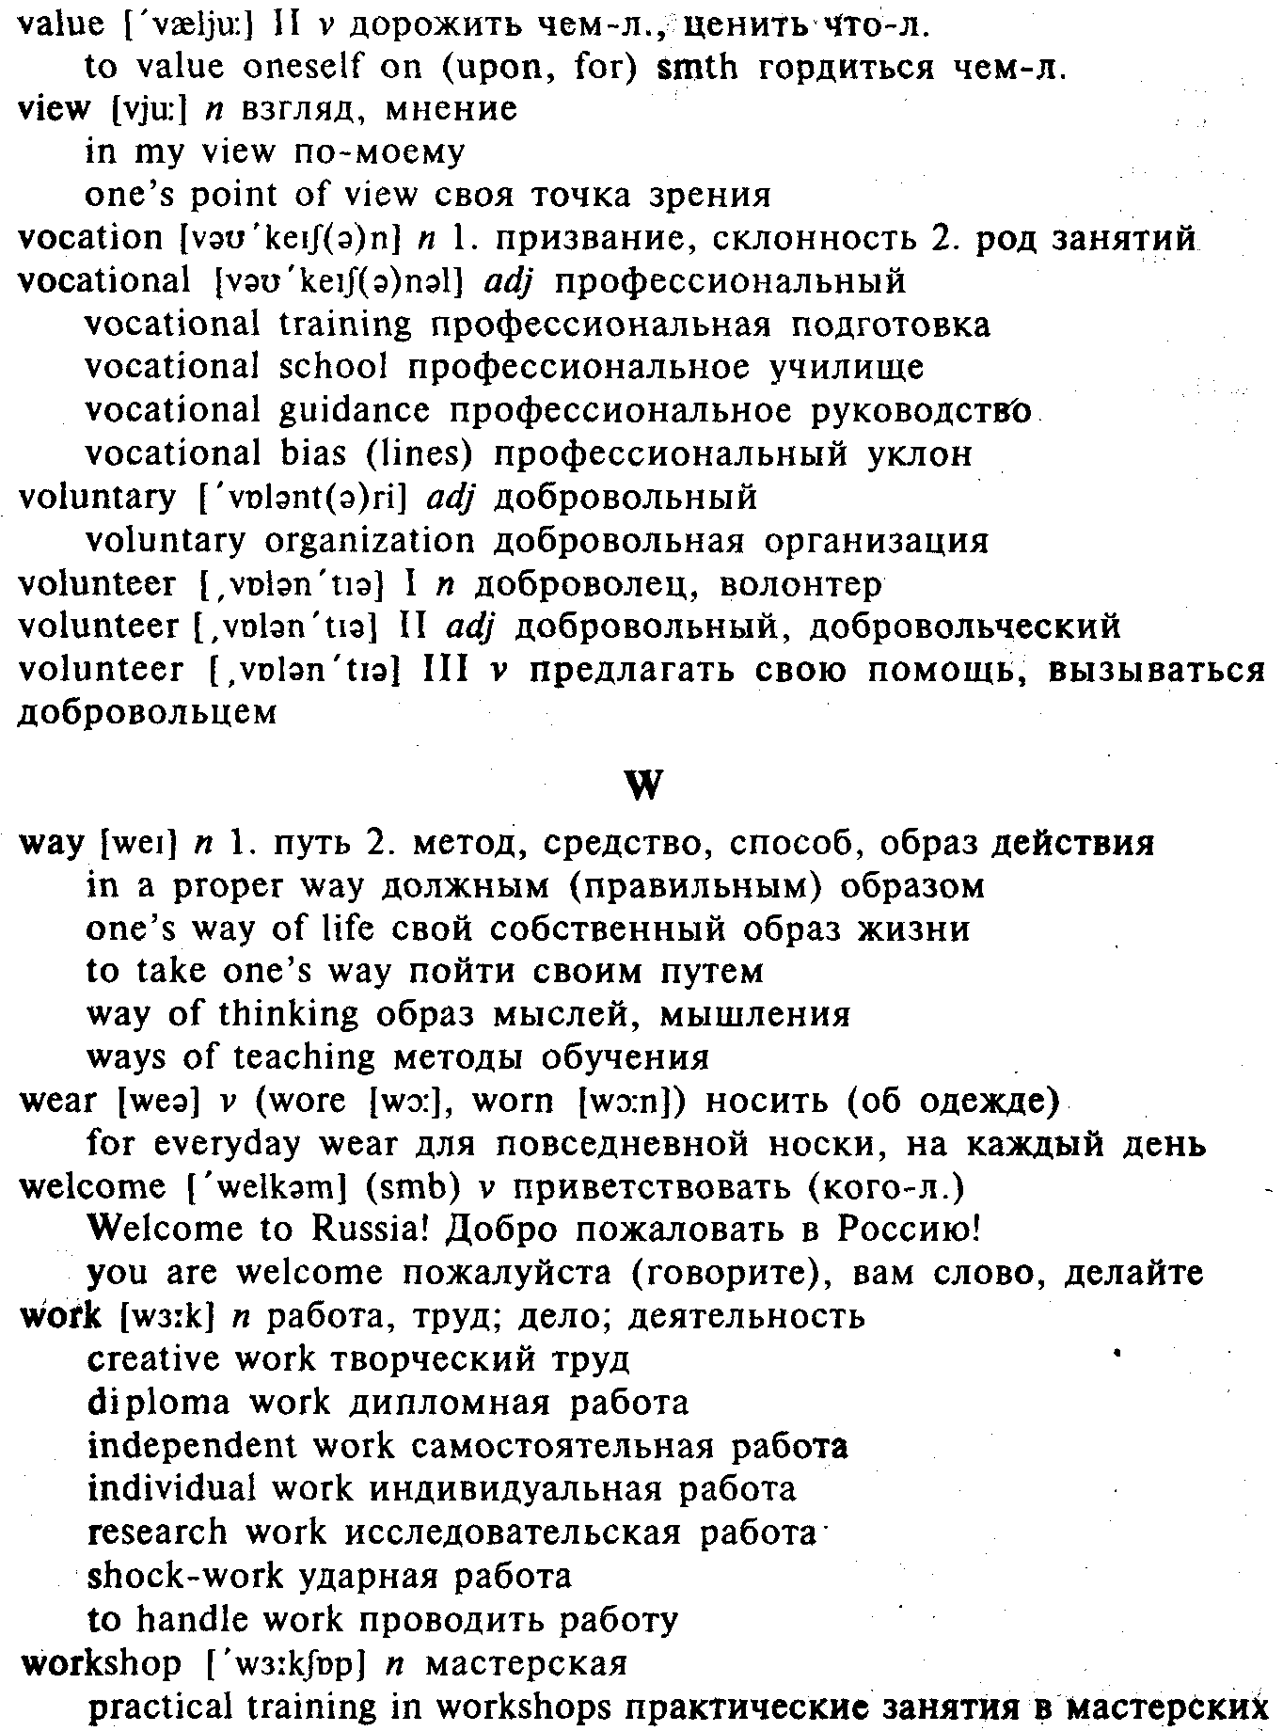

Список сокращений
п noun – существительное
v verb – глагол
adj adjective – прилагательное
adv adverb – наречие
pi plural - множественное число (или - употребляется
только во мн.ч.)
амер. – американизм
ант. – антоним
разг. – разговорное

Английский алфавит
Аа ВЬ Сс Dd Ее Ff Gg Hh Ii Jj Kk LI Mm Nn Oo Pp Qq Rr Ss Tt Uu Vv Ww Xx Yy Zz

Содержание

ПРЕДИСЛОВИЕ 4
1. HISTORY OF EDUCATION 5
2. THE PEN STORY 8
3. THE MIRACLE OF WRITING 9
4. CHILD PSYCHOLOGY DETERMINES TEACHING METHODS 10
5. LET KIDS BE KIDS 11
6. THE FIRST DAY AT SCHOOL 11
7. HOW WELL DO OUR SCHOOLS PERFORM? 13
8. SCHOOLS OF THE FUTURE 14
9. THE ILLITERACY EPIDEMIC 15
10. CULTURAL LITERACY AND THE SCHOOLS 17
11. A. AT THE ANGLO-AMERICAN SCHOOL 17
В. MAKING FRIENDS 18
12. NO PLACE LIKE HOME FOR GOING TO SCHOOL 19
13. A QUALITY EDUCATION? YES, FOR A PRICE 21
14. INDIVIDUAL EDUCATION 22
15. GRADE 3-4 24
16. WHEN YOUR CHILD COUNTS TO TEN, DOES HE HAVE TO USE HIS FINGERS? 25
17. WHAT TO DO ABOUT HOMEWORK 26
18. OYSTER MVER MIDDLE SCHOOL 28
19. CO-EDUCATION: A HIGH PRICE TO PAY 28
20. VIDEO SCREENS: ARE THEY CHANGING THE WAY CHILDREN LEARN? 30
21. CURING VIDEO ADDICTS¹ 31
22. GAMES CHILDREN PLAY 31
23. NEW DIRECTIONS IN VOCATIONAL EDUCATION 32
24. GIVE YOUR CHILD THE HAPPINESS TRAIT 34
25. COLUMBIA AND NEW YORK, NEW YORK AND COLUMBIA 36
26. TEACHERS COLLEGE 37
27. EDUCATION IN AUSTRALIA 38
28. CLAYFIELD COLLEGE 39
29. ST PATRICK'S COLLEGE 40
30. RENEWING THE TEACHING PROFESSION 41
31. TEACHER'S WORK 43
32. IDEAL TEACHER: WHAT IS HE LIKE? 45
33. (From "The Diary of a Young English Teacher" by Saw Ginsburg) 46
34. GOOD TEACHER 47
35. ALTERNATIVE CERTIFICATION DEMANDS MINIMUM STANDARDS 48
36. TEACHERS: A DYING BREED AS SCHOOL YEAR STARTS 49
37. TESTING TIMES 50
38. 50
1. Religious Teaching in British Schools 51
2. Where to Study 52
3. The University of London 52
4. The School of Language Studies 53
5. At the "Tech" 54
6. Oxford 54
7. A Trip to Cambridge and Other Recollections 54
8. Ealing College of Higher Education 55
9. US Offers Fellowships to Scholars 56
10. The Birth of Writing 56
11. Do You Speak Ancient Greek? 57
12. Study at Home 58
13. For the Young Teacher 59
14. British Teens Spend Sweetly 60
39. 60
1. Где учиться 60
2. А двойку вам поставит старшекурсник 61
3. С российским дипломом – за границу 62
4. Образование: заграница нам поможет? 63
5. Студент в тумане 64
6. Британской системе образования 700 лет – что в итоге? 65
7. Где учиться в Англии 66
8. Колледж Сент-Лоуренс в графстве Кент 67
9. Родителей не выбирают? 68
10. Хотите вырастить гения? Принимайтесь за дело накануне Рождества 69
11. Как сформировать талант 69
12. Отцы и дети 70
13. Образование, нужное всем и всегда 72
40. THINGS TO DO 73
A. Individual Work 73
B. Pair Work 75
C. Group Work 76
D. Project Work 76
41. SUPPLEMENTARY READING 78
§ 1. On Education 78
§ 2. The Kindergarten 79
§ 3. College 80
The Prime of Miss Jean Brodie¹ 81
In One Ear and Upside Down¹ 83
What's Wrong with the Kid? 84
Culture 85
Adolescence¹ 87
Clean Up Your Room 87
From "The Sandcastle"² 89
From "Oxford Life" 91
A Reporter's Account 94
Alice In Wonderland 96
Jokes 97
Poems, Limericks 104
VOCABULARY OF EDUCATIONAL TERMS AND THEIR USAGE 107

